Lancaster Seventh-Day Adventist Church
A House of Prayer for All People

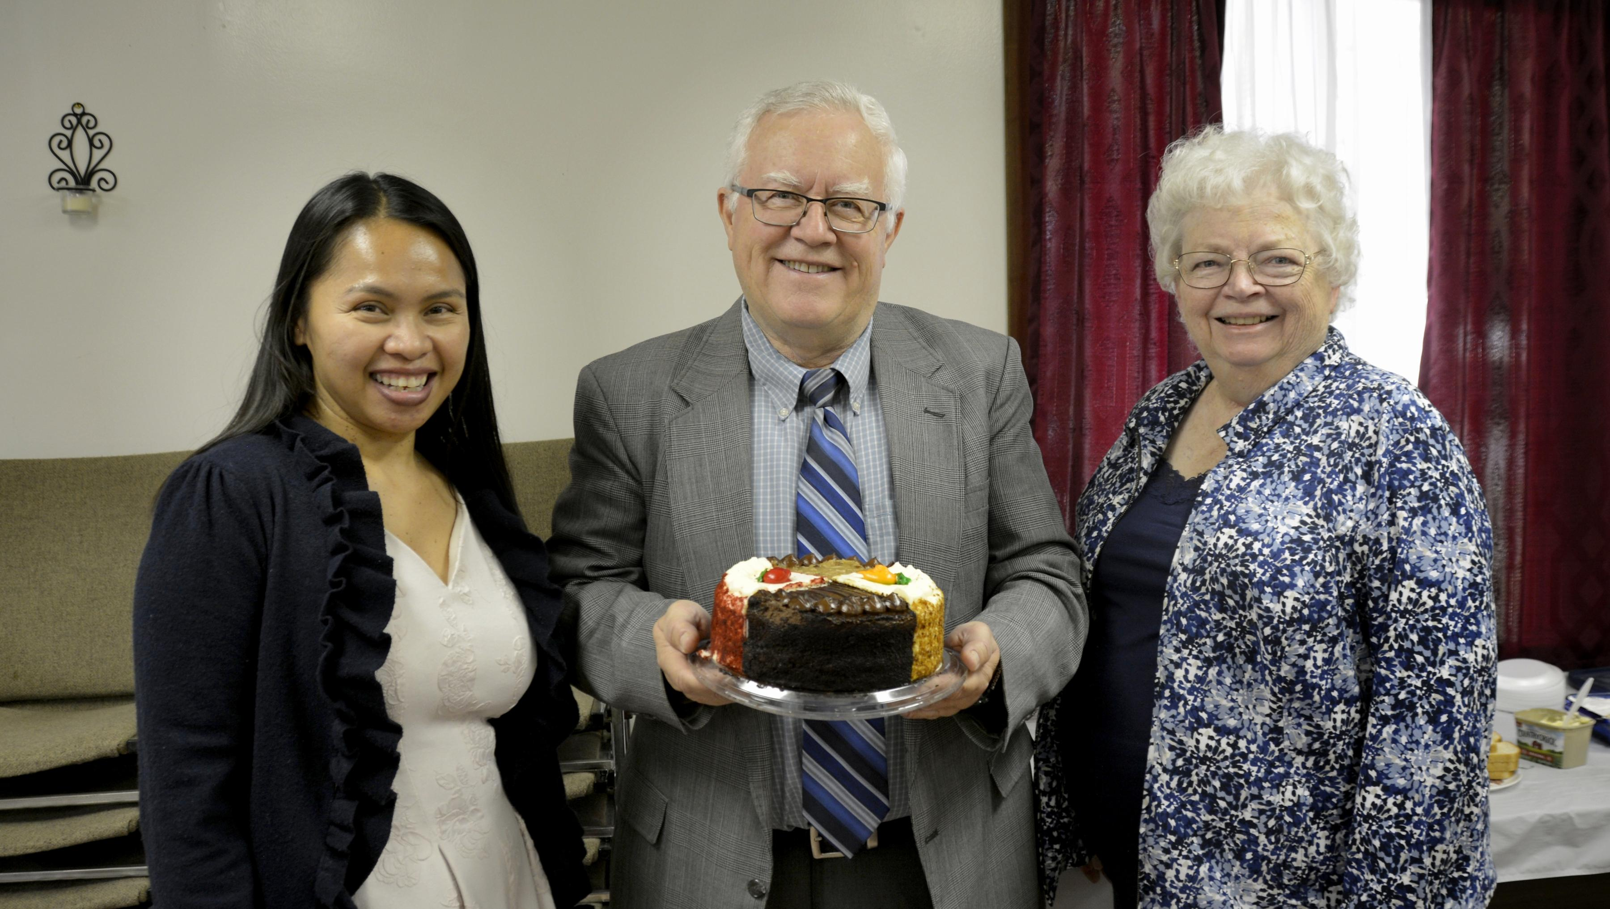

Jennie Al Sandy
October Birthdays ~ 2022

