Lancaster Seventh-Day Adventist Church
A House of Prayer for All People

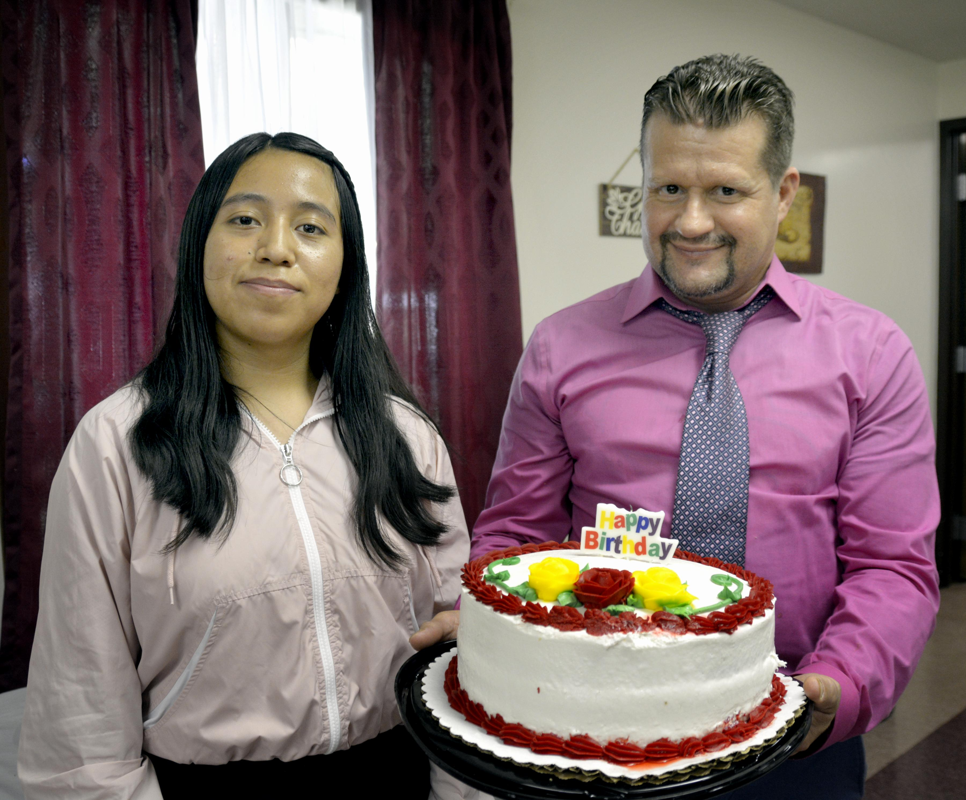
Marleny Allen
September Birthdays ~ 2022

