Lancaster Seventh-Day Adventist Church
A House of Prayer for All People

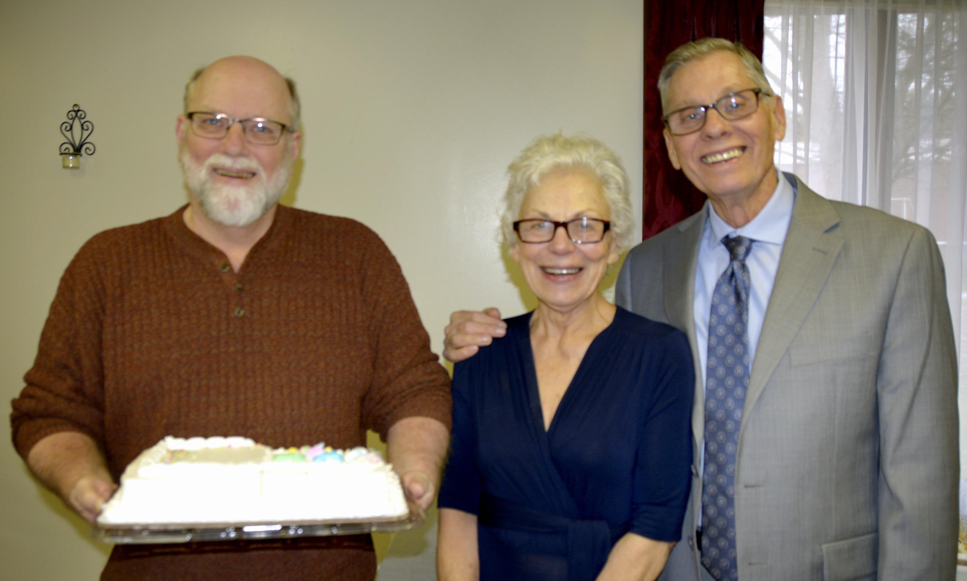

Birthday: Eldon Newly Weds: Barbara & Larry Hamilton
November Birthday and Newly Weds ~ 2021

