Lancaster Seventh-Day Adventist Church
A House of Prayer for All People

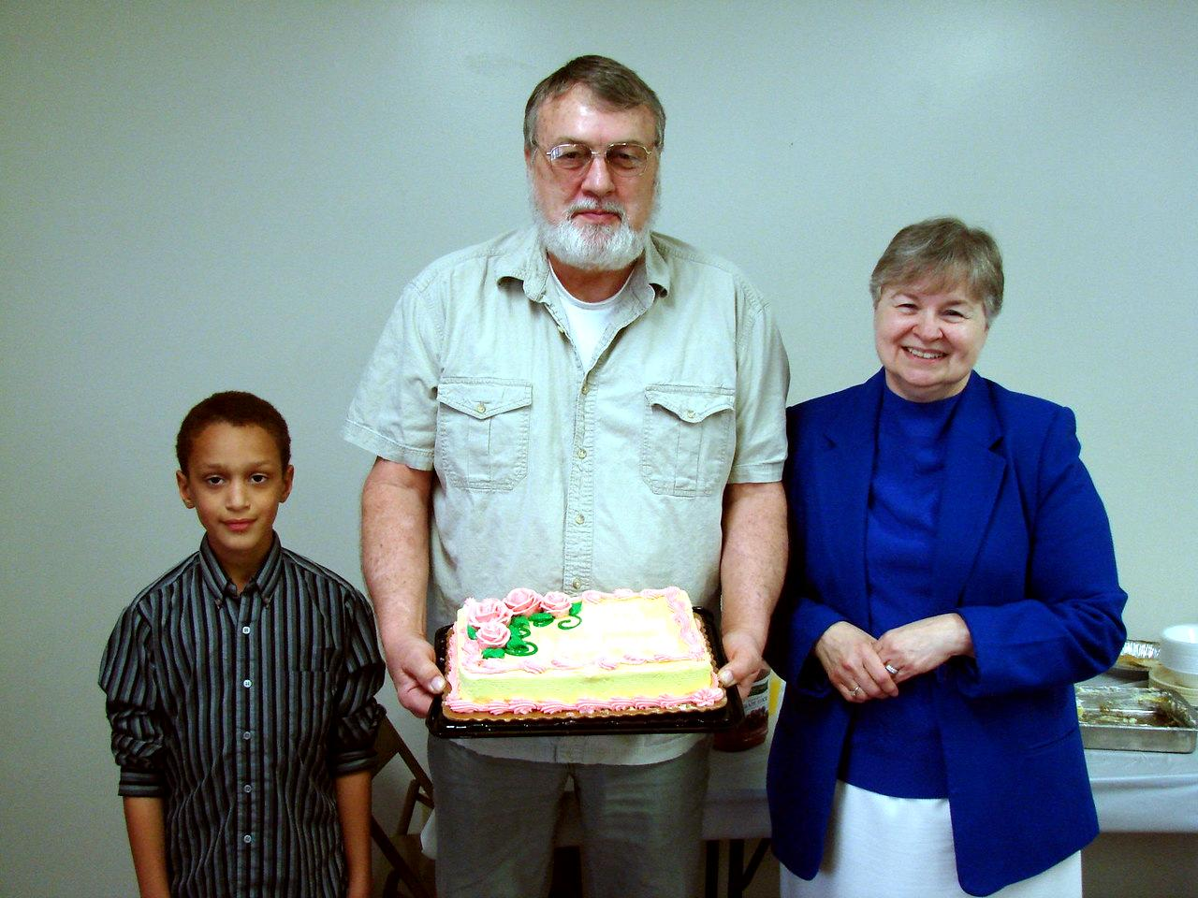
April Birthdays - 2011

