Lancaster Seventh-Day Adventist Church
A House of Prayer for All People

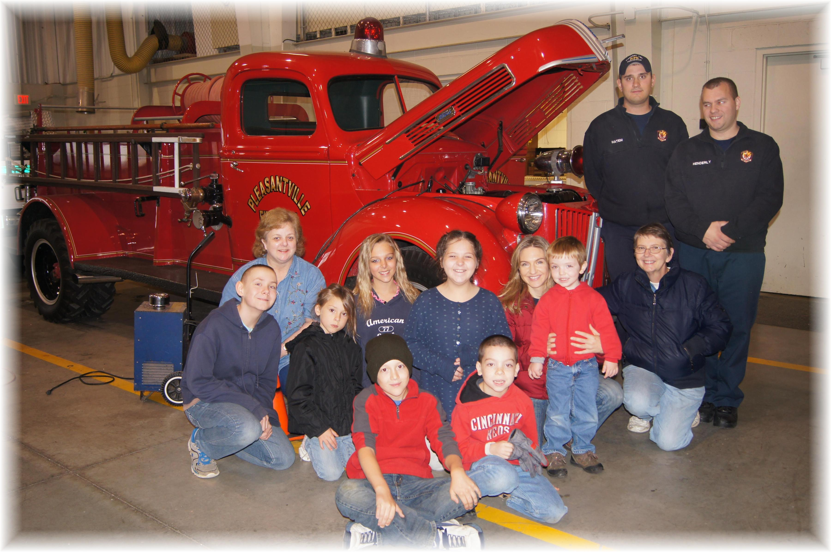
Pleasantville Fire Station Field Trip – October 30, 2013

