Lancaster Seventh-Day Adventist Church
A House of Prayer for All People

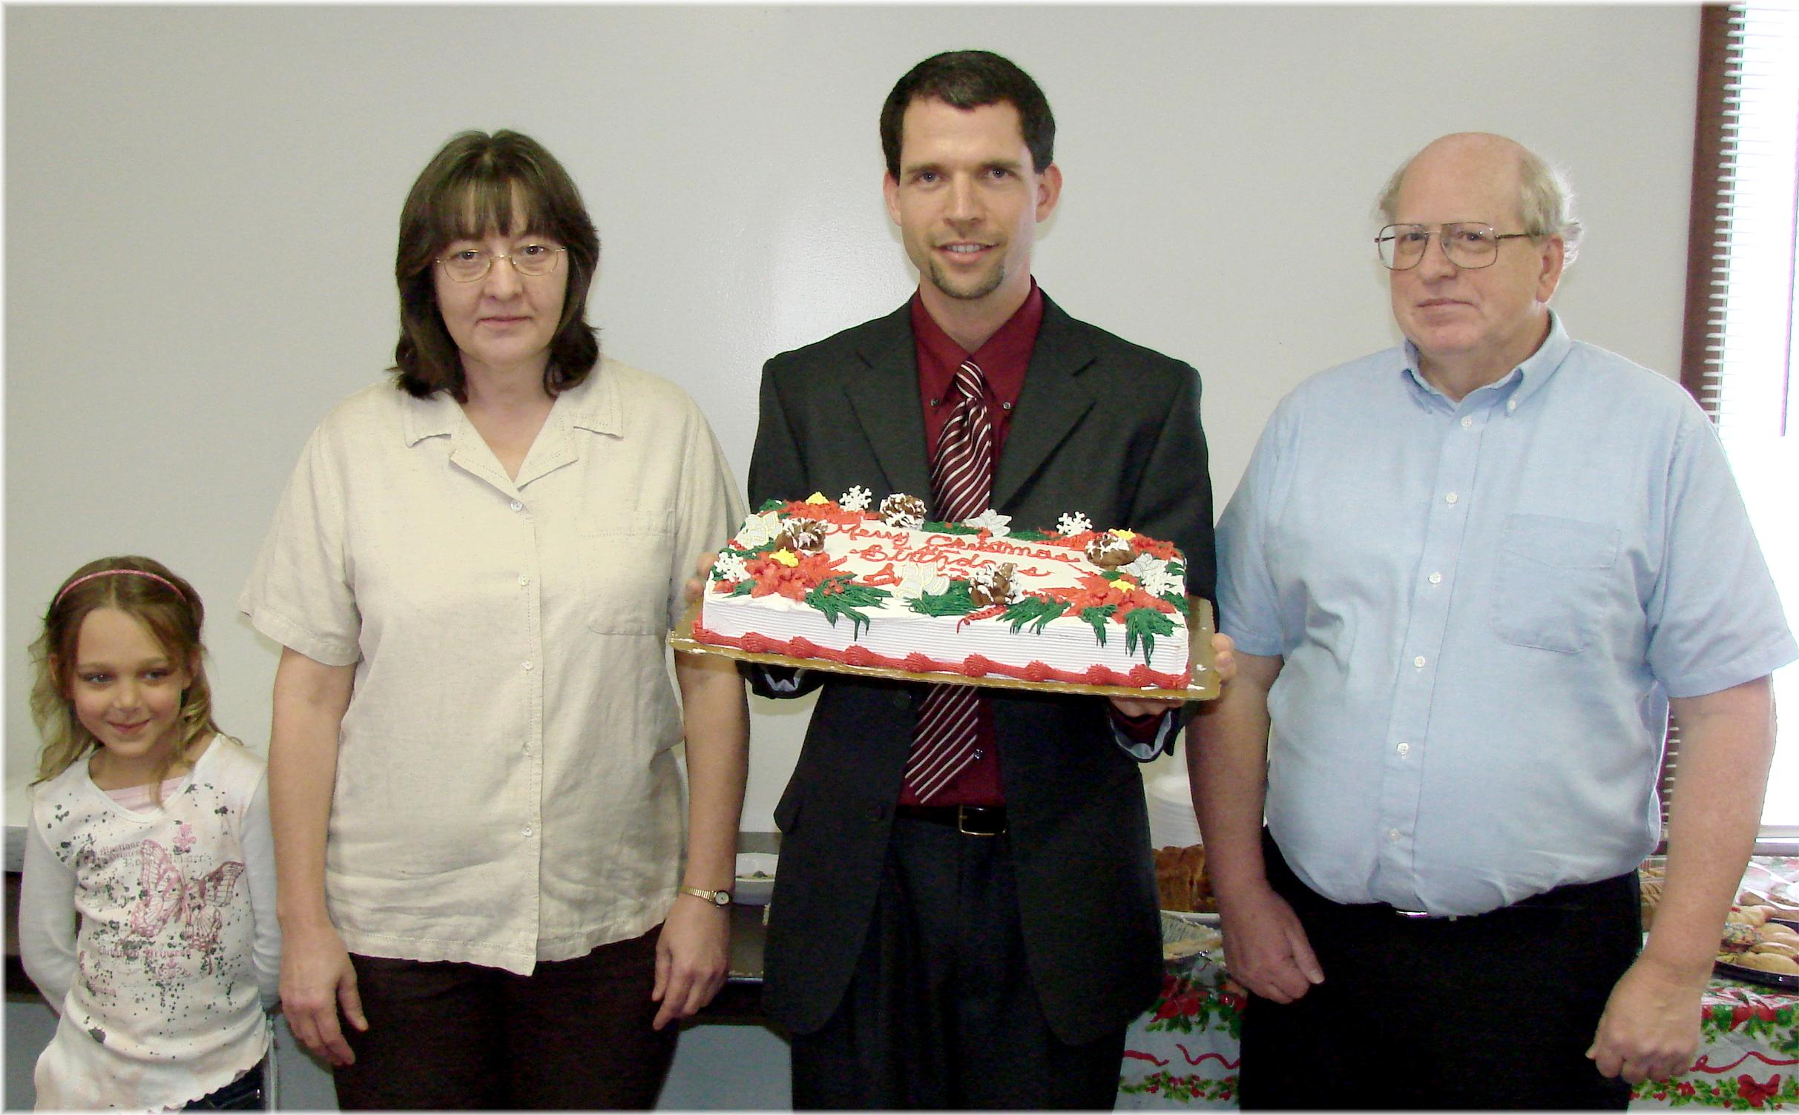
Destiny, Nancy, Pastor Travis, Bill
December Birthdays - 2009

