Lancaster Seventh-Day Adventist Church
A House of Prayer for All People

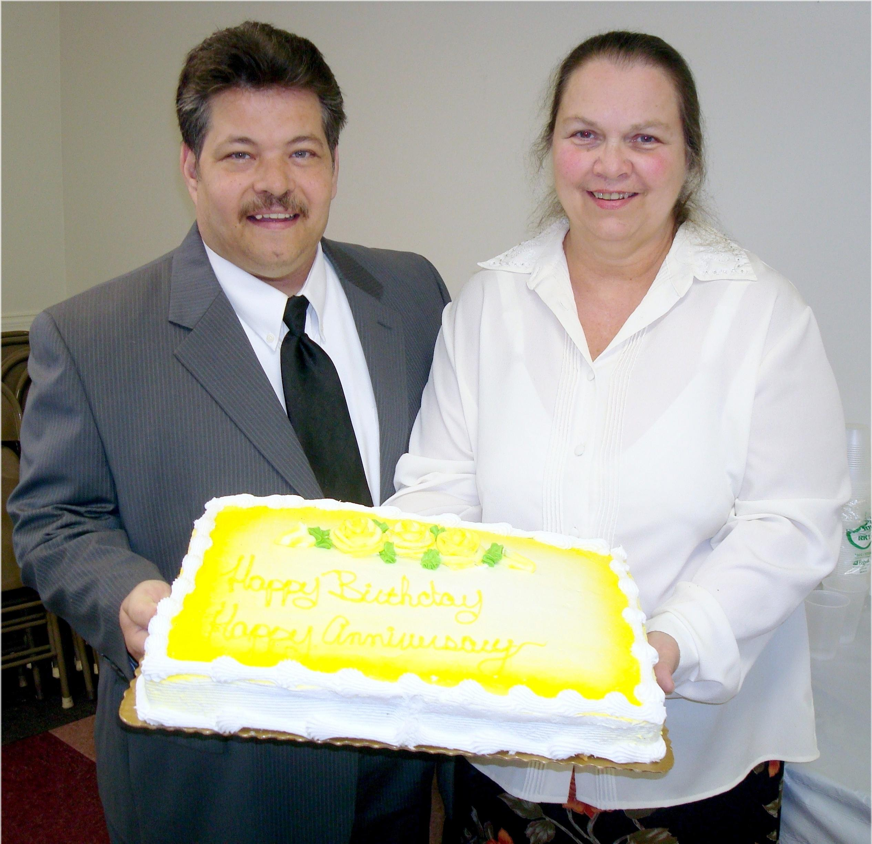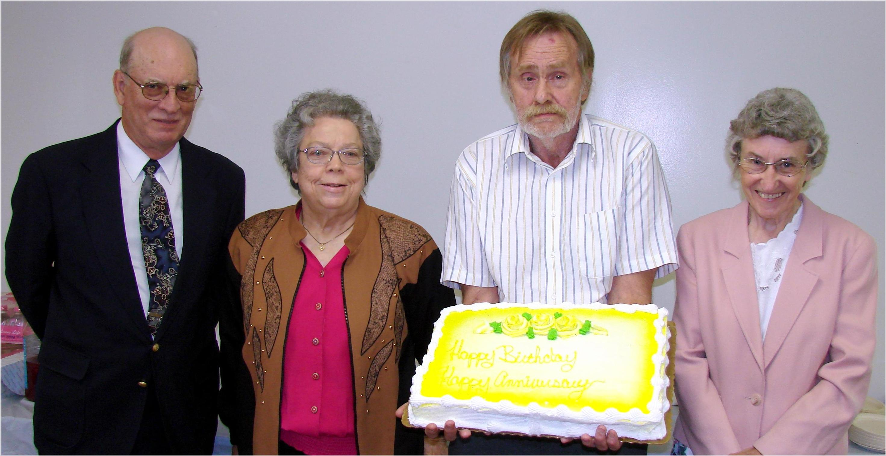
Anniversary: Roger and Debby Birthdays: Howard, Josie, Rusty, Freda .
Anniversary and Birthdays – May, 2010

