Lancaster Seventh-Day Adventist Church
A House of Prayer for All People

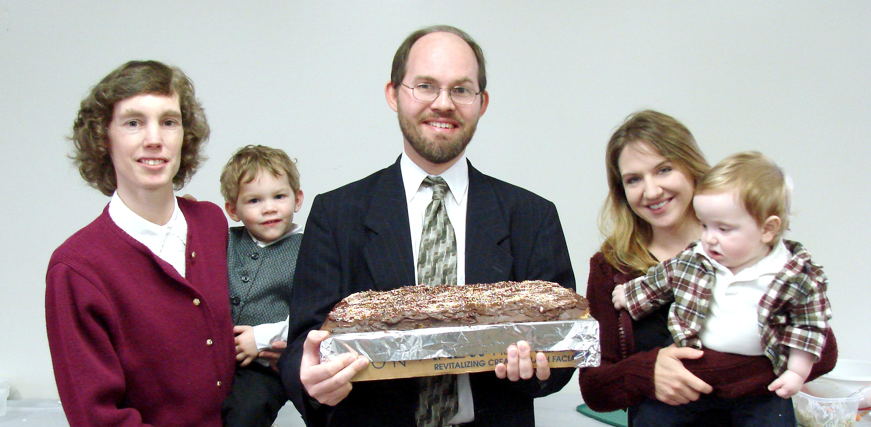

Anniversary: Connie and James (with Andrew) Birthday: Jesse (with Trina)
November Anniversary and Birthday - 2010

