Lancaster Seventh-Day Adventist Church
A House of Prayer for All People

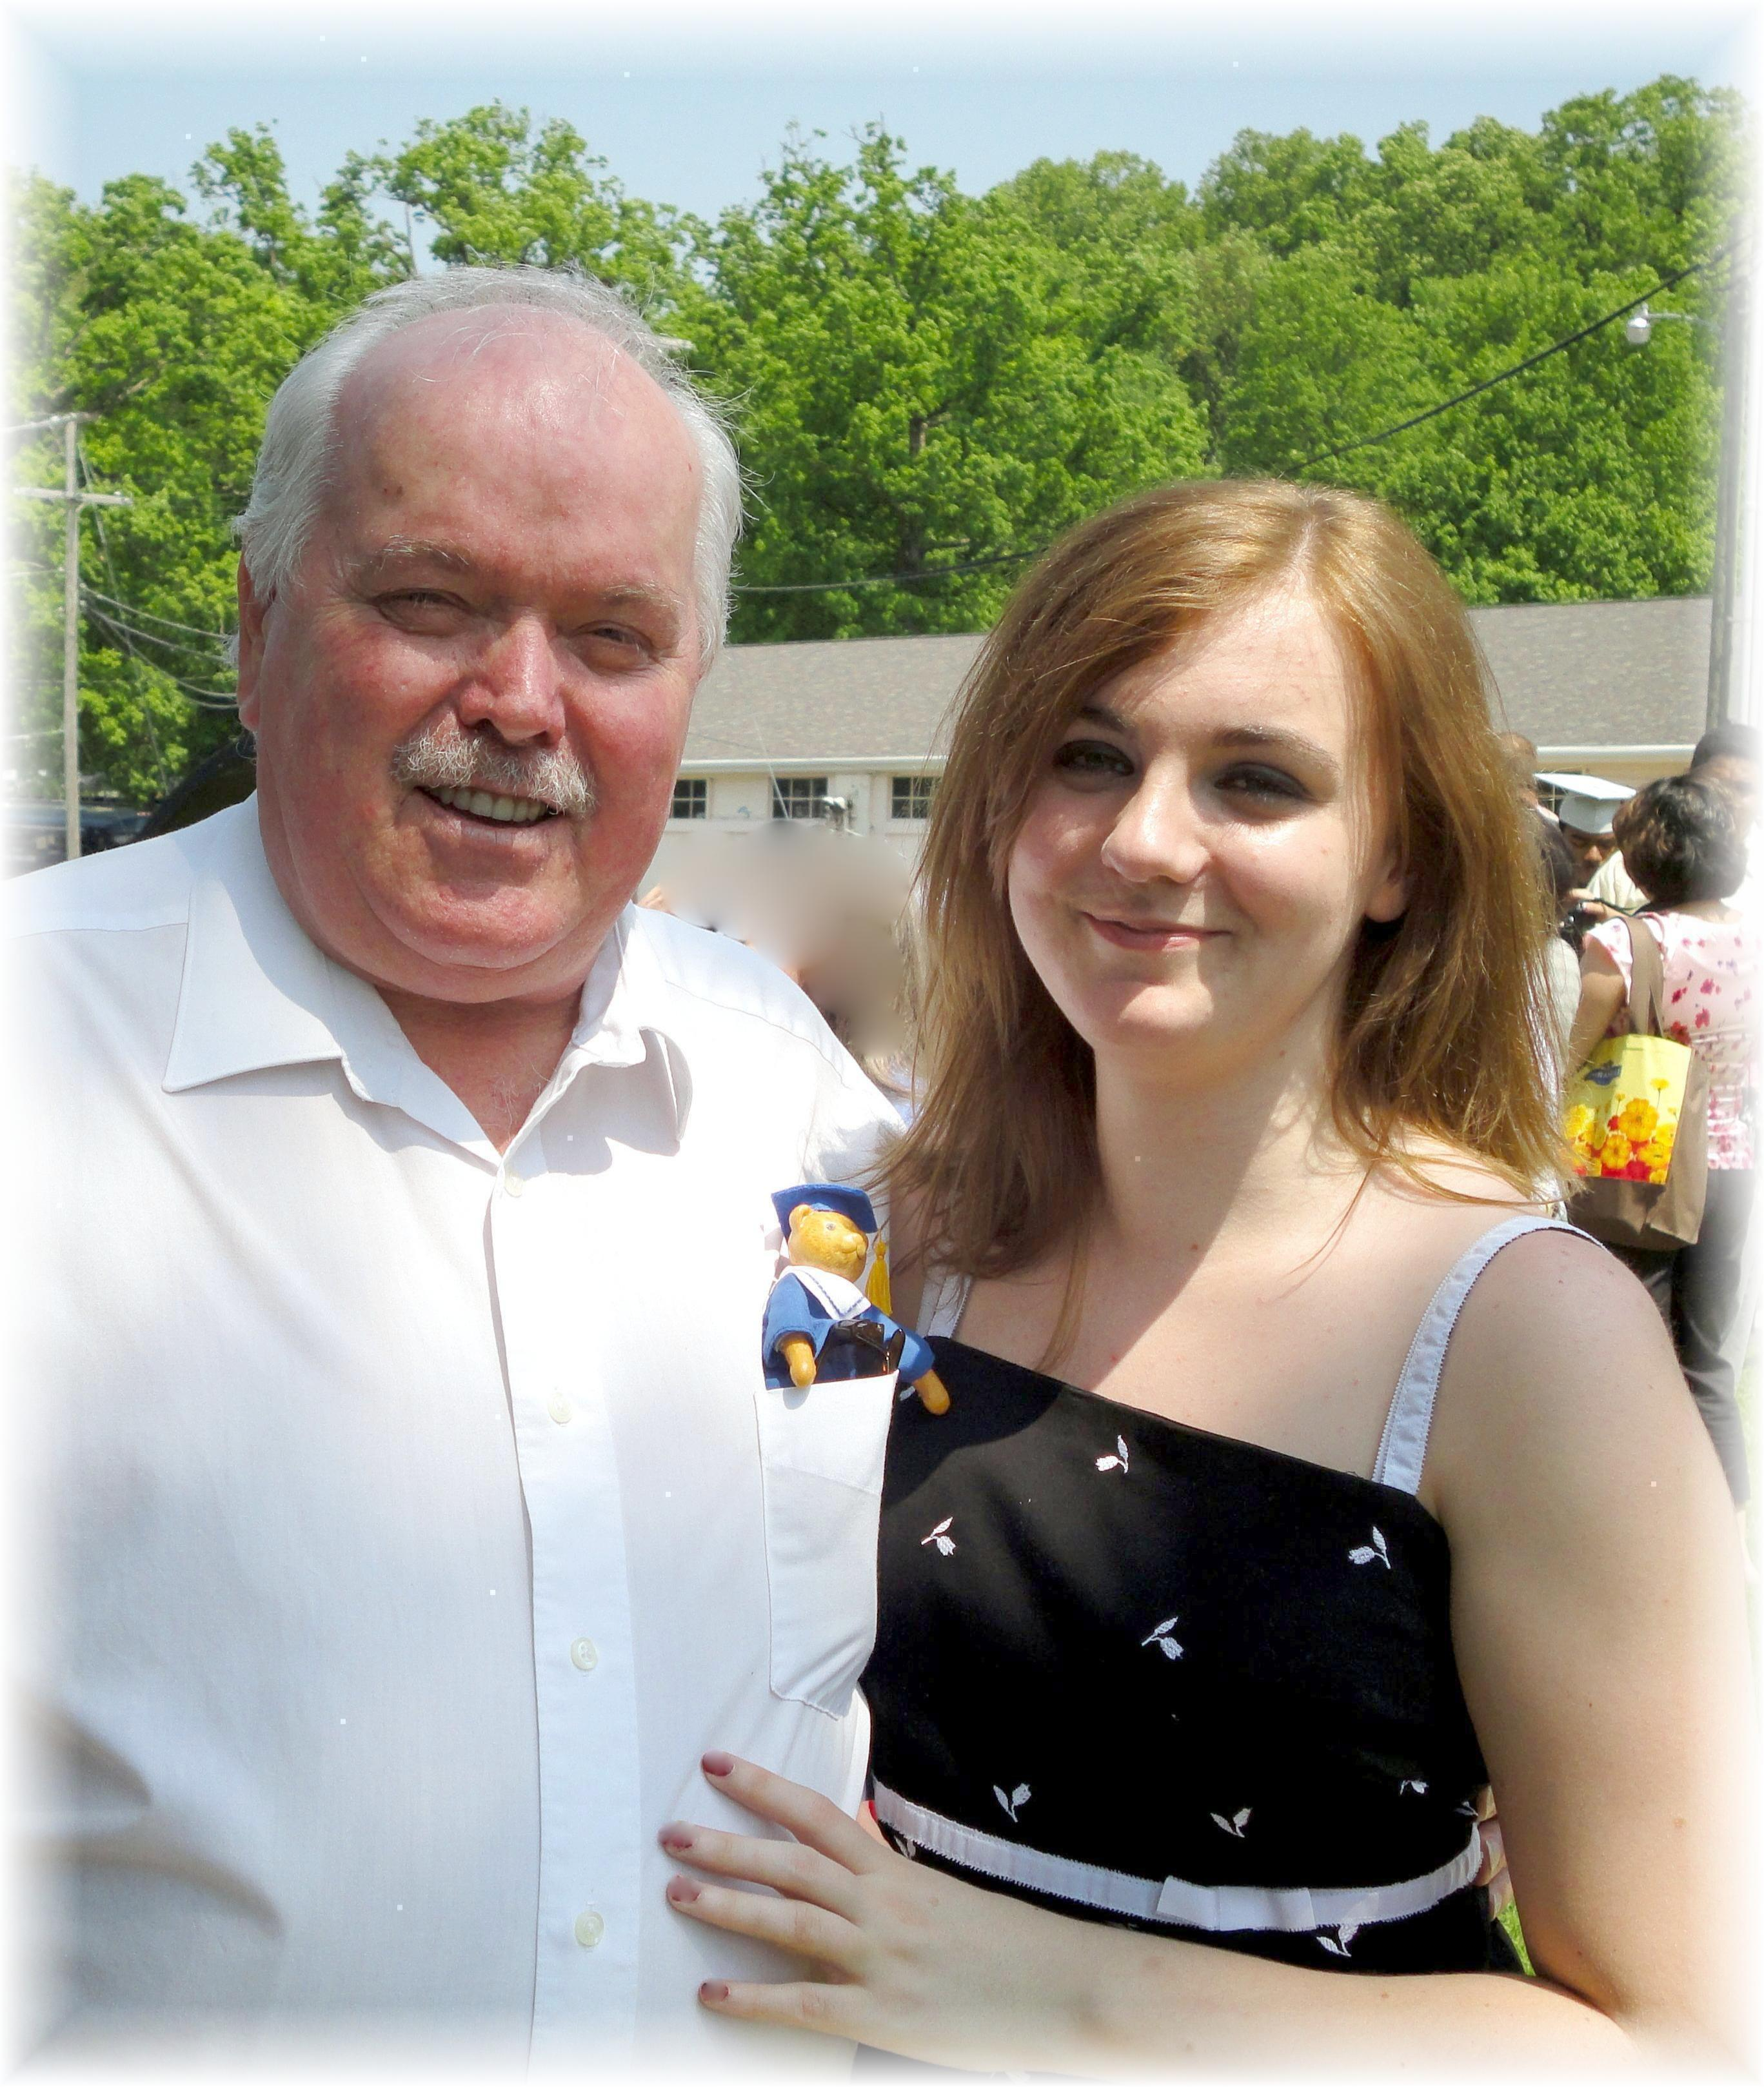
Shaina Shultz Graduation - Mount Vernon Academy - May 29, 2011

