Lancaster Seventh-Day Adventist Church
A House of Prayer for All People

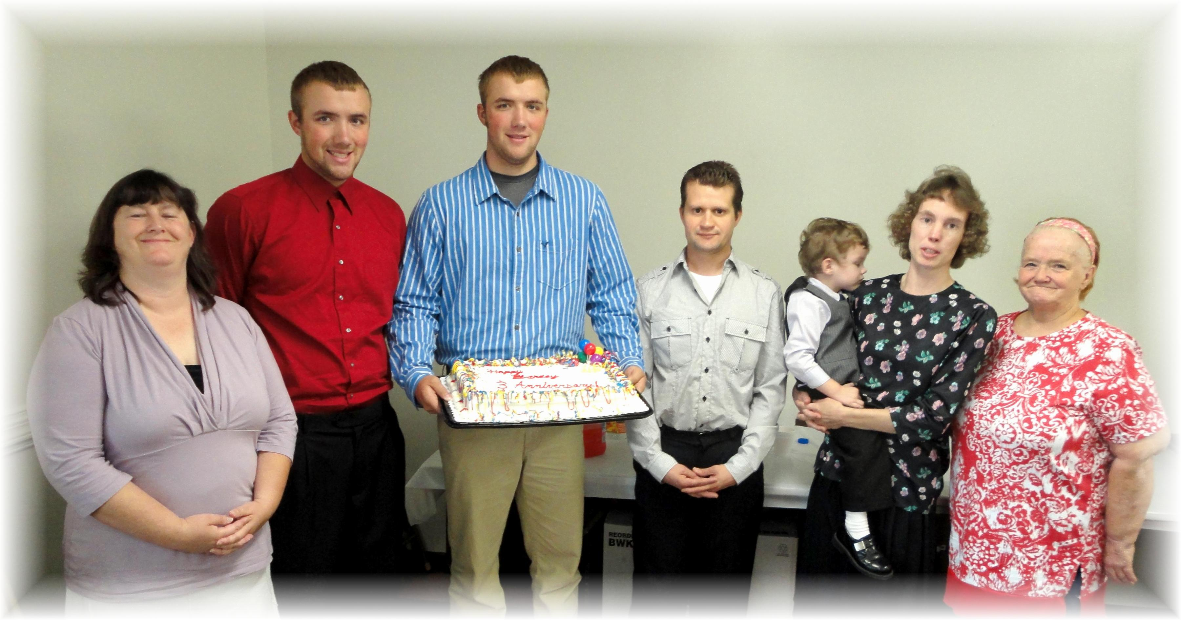
Kim Clarke, Nathan and Ethan Mathias, Allen Cramblit, Connie Duncan, Sandy Hoover
September Birthdays - 2011

