Lancaster Seventh-Day Adventist Church
A House of Prayer for All People

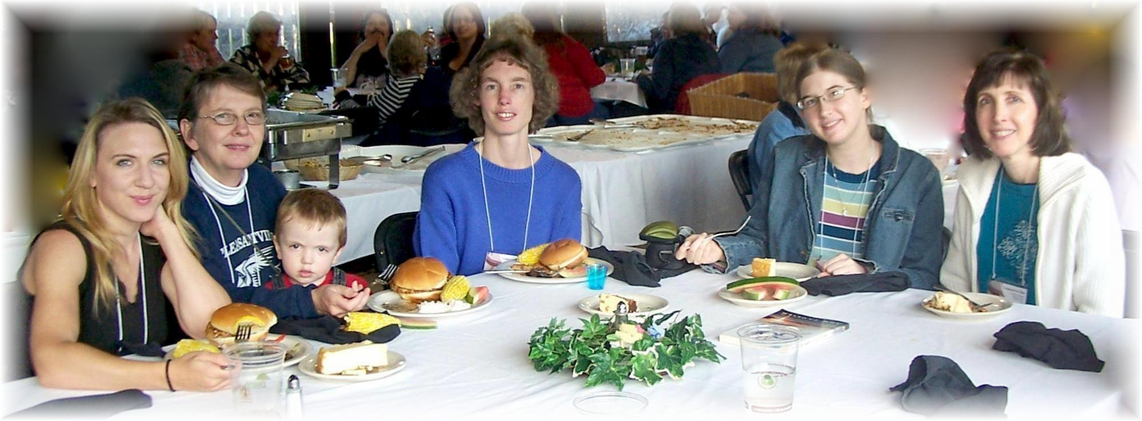
Trina, Bonnie, Jesse, Connie, Marie, Nancy
Ohio Conference Women’s Retreat - September 17, 2011

