Lancaster Seventh-Day Adventist Church
A House of Prayer for All People

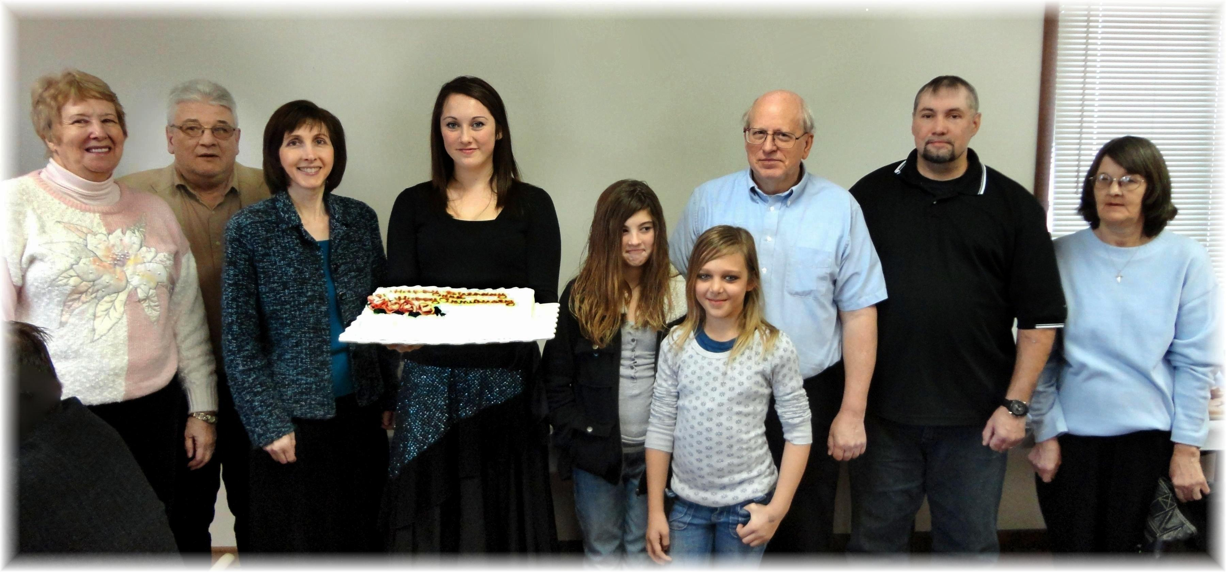
Anniversary: Diane & John Birthdays: Nancy, Corrie, Hannah, Destiny, Bill, Rob, Jenny
December Anniversary and Birthdays - 2011

