Lancaster Seventh-Day Adventist Church
A House of Prayer for All People

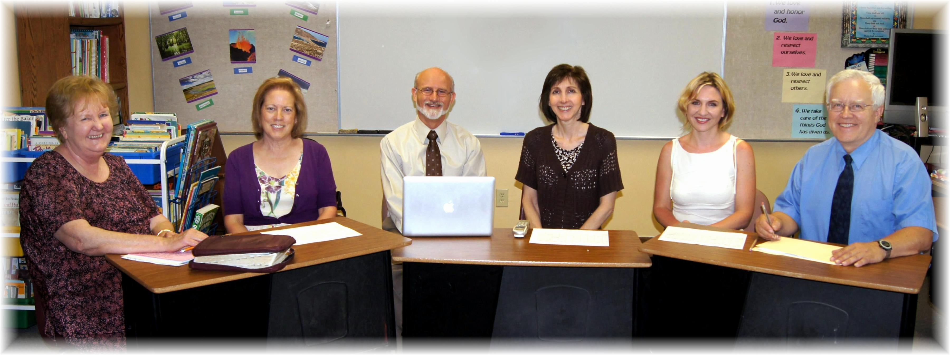
Linda, Geri, Pastor Mike, Nancy, Trina, Al
Not Pictured: Bob
The Worship Team - 2012

