Lancaster Seventh-Day Adventist Church
A House of Prayer for All People
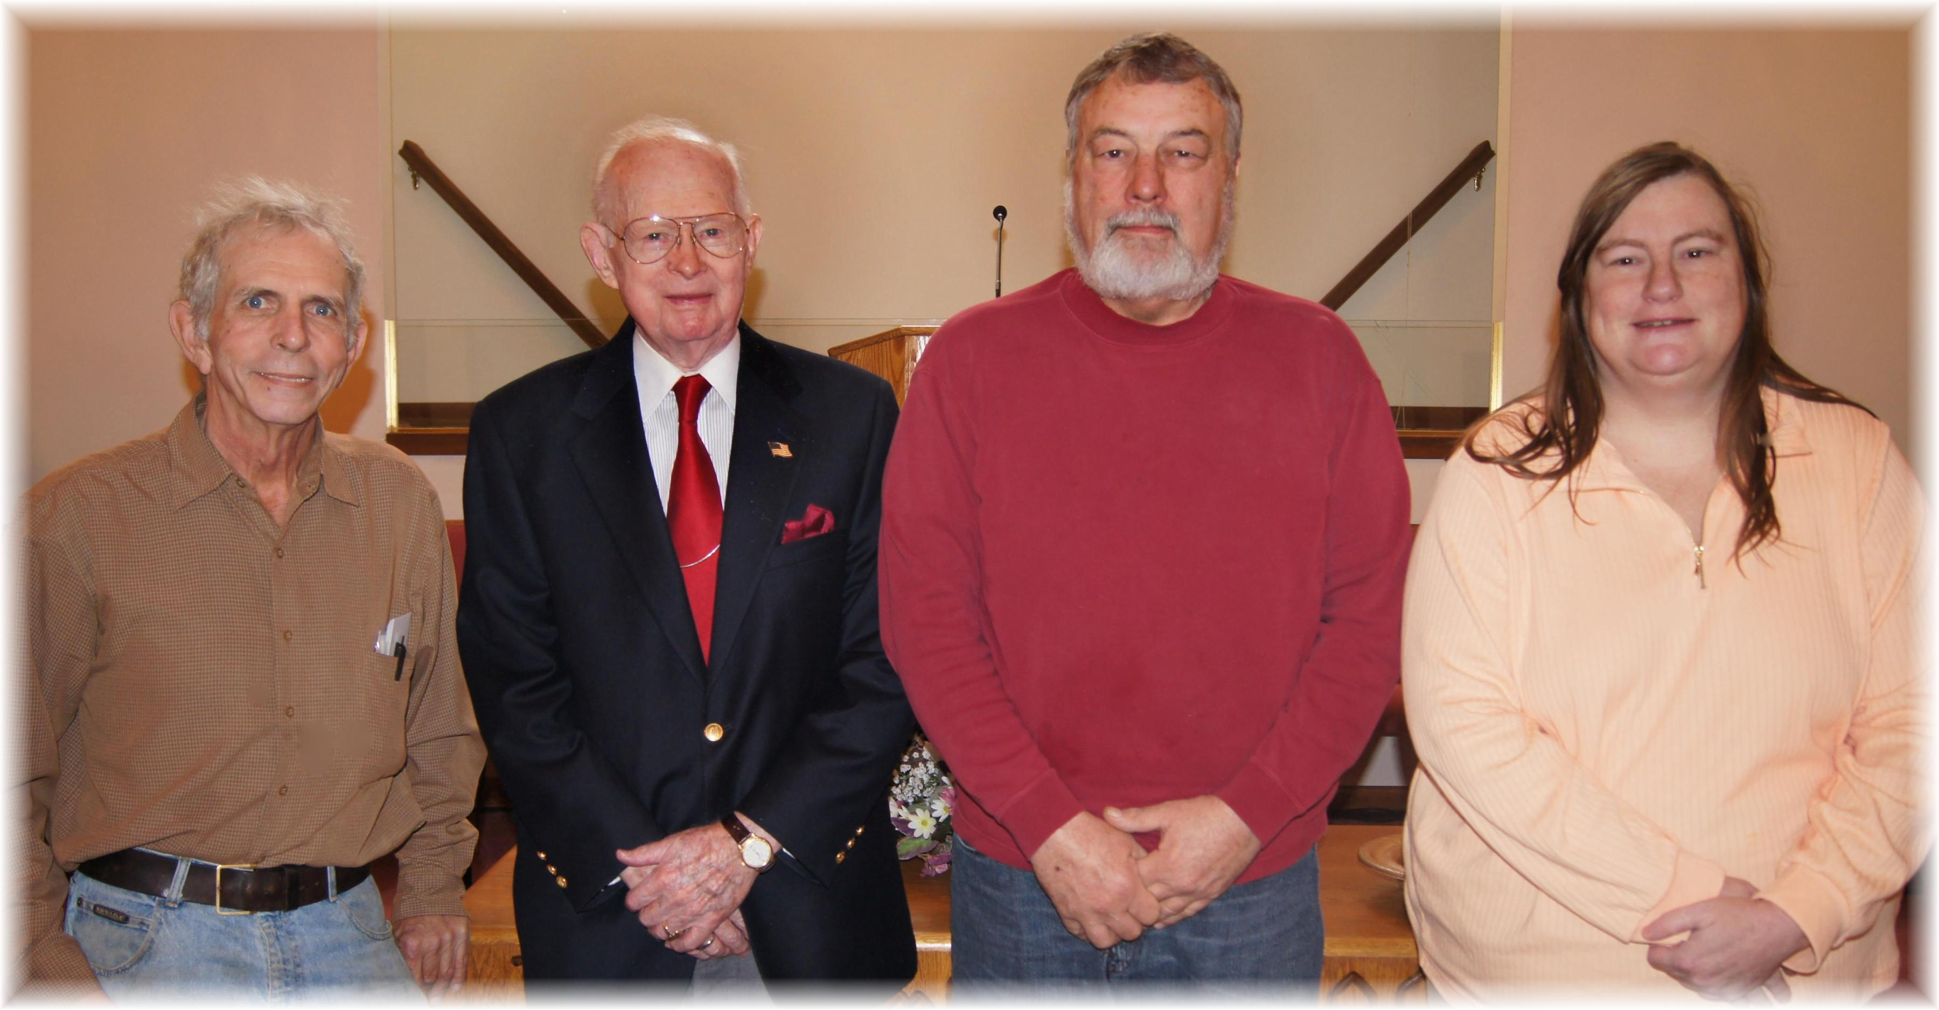
Thank you for your service: John Mathias, Ralph Aldenderfer, Mike Arehart, Stacey Hemmingway
Veterans Day – November 2012

