Lancaster Seventh-Day Adventist Church
A House of Prayer for All People

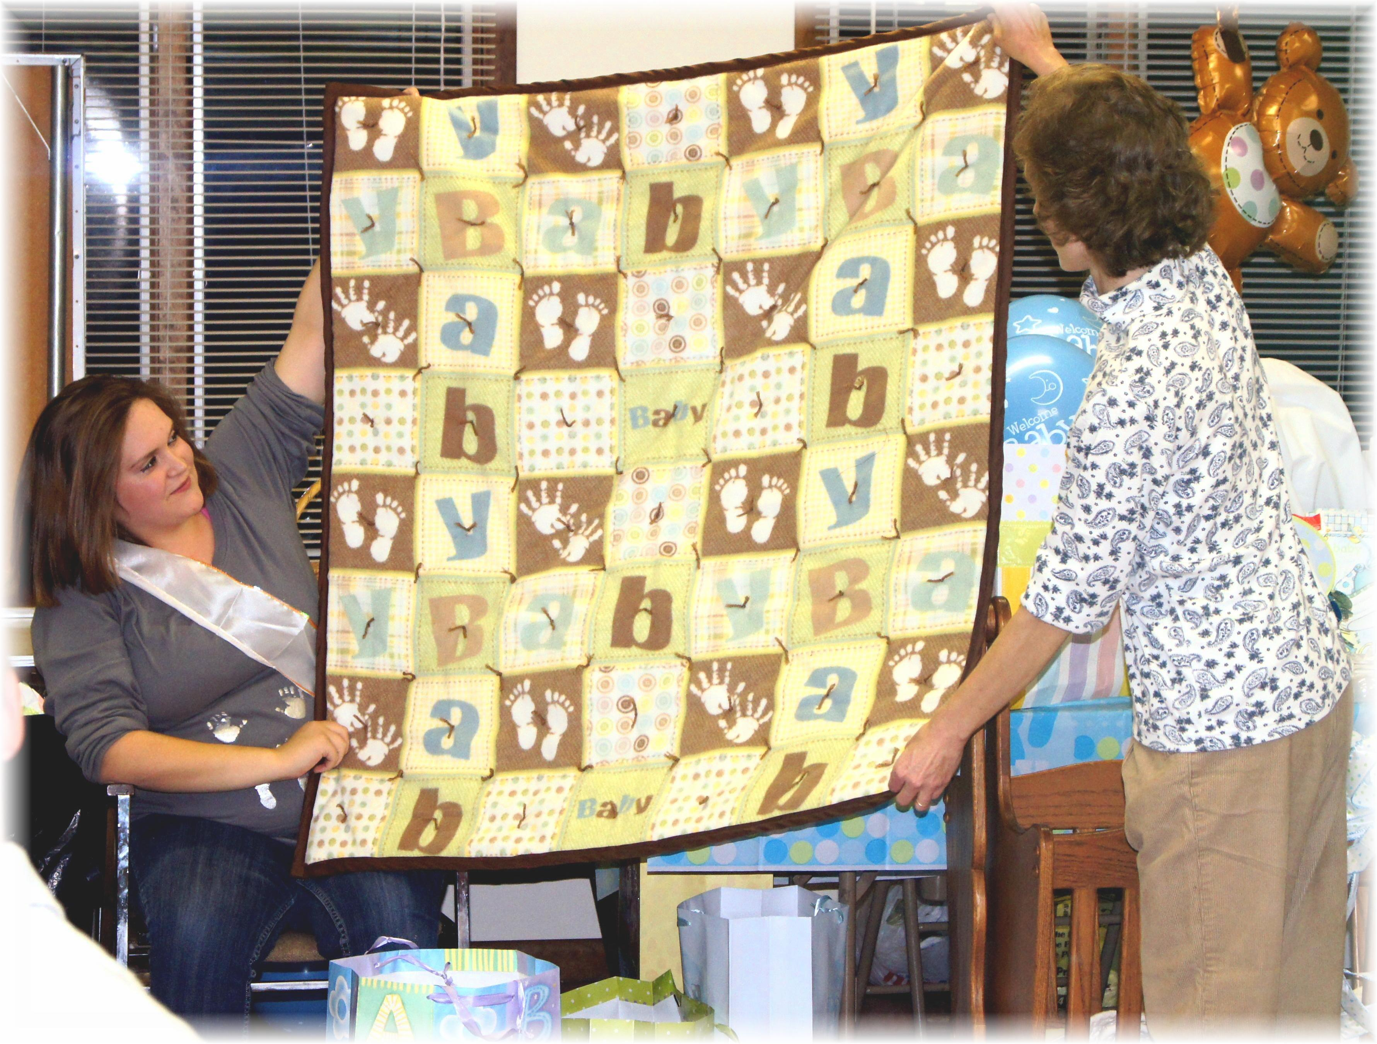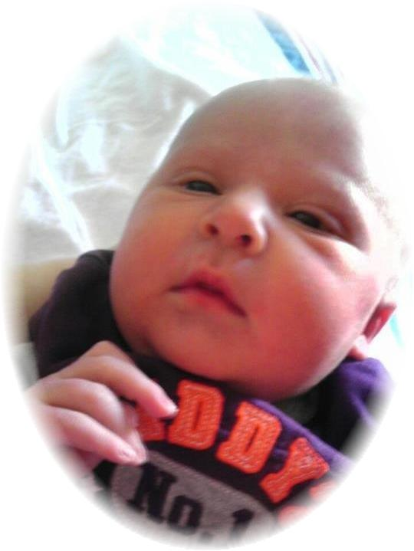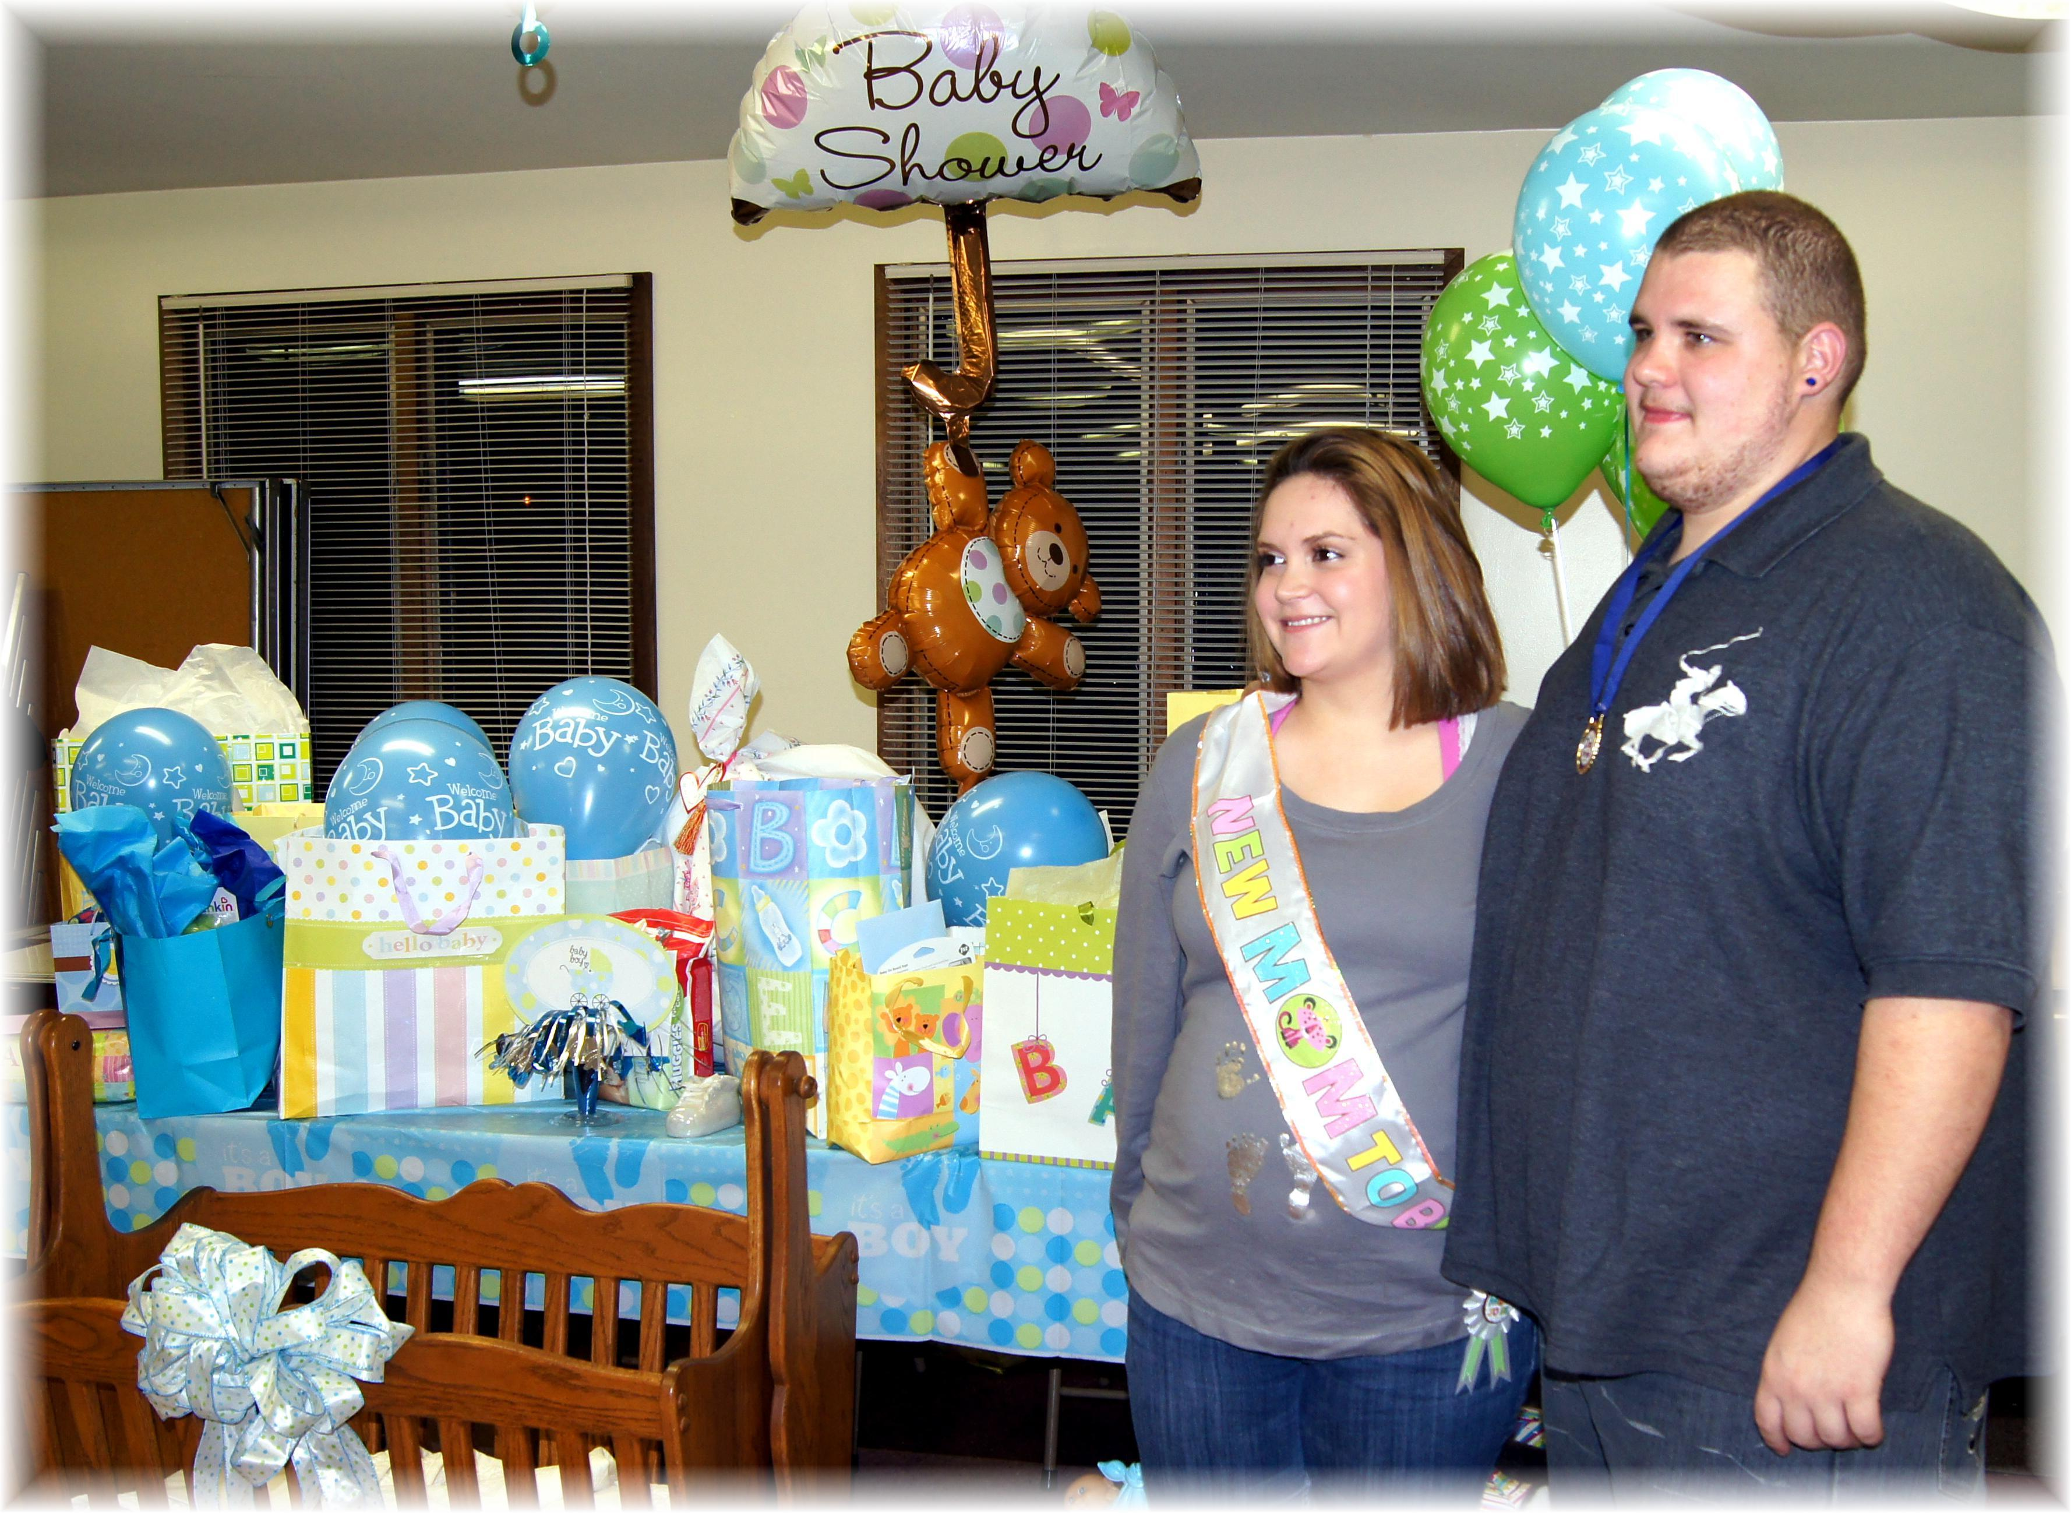

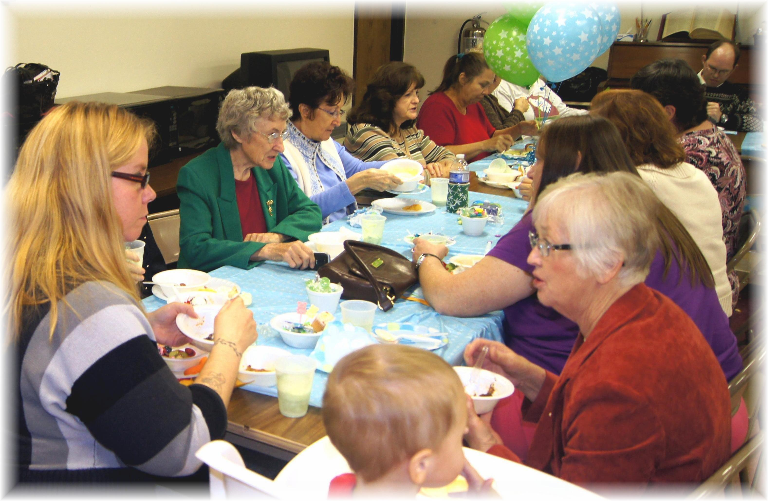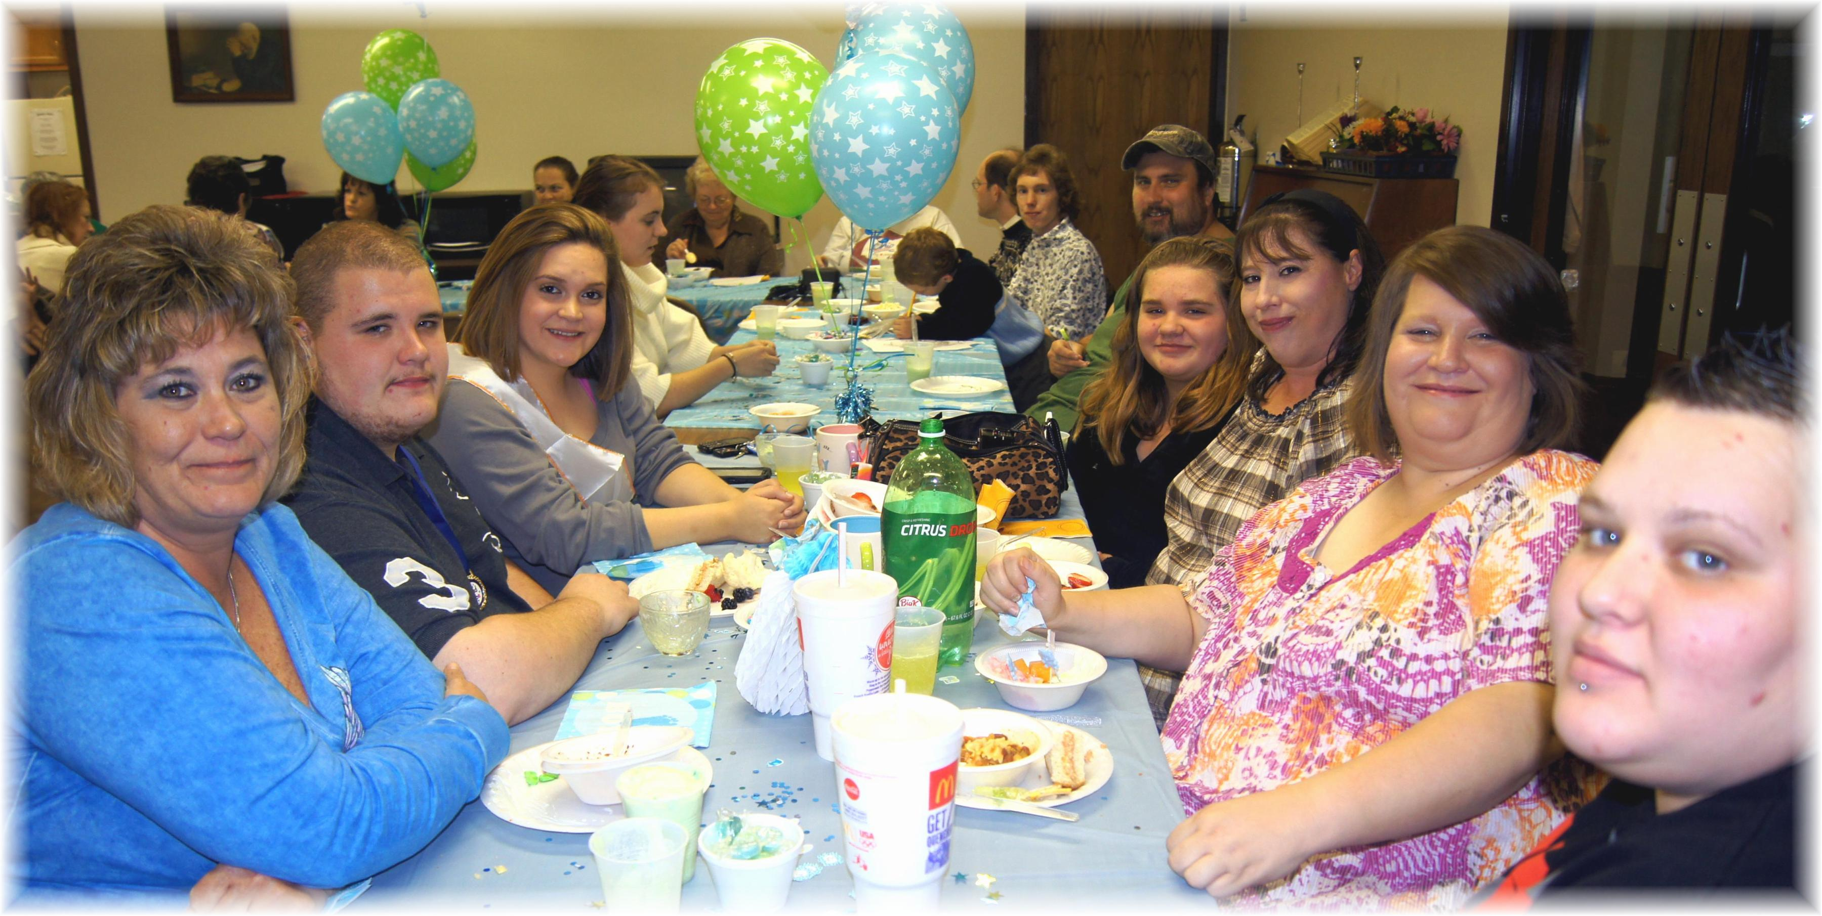
Jaydayle’s Baby Shower 11-3-12 and Baby Waylon Taylor Daniel born 1-6-13

