Lancaster Seventh-Day Adventist Church
A House of Prayer for All People

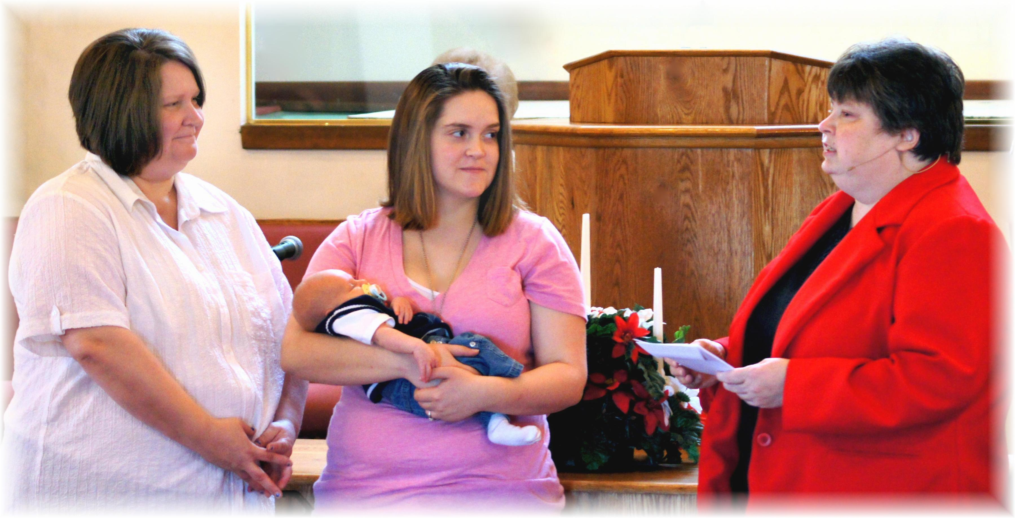
Twila, Jaydayle with baby Waylan Tyler Daniel, and Pam
Baby Dedication – January 19, 2013

