Lancaster Seventh-Day Adventist Church
A House of Prayer for All People
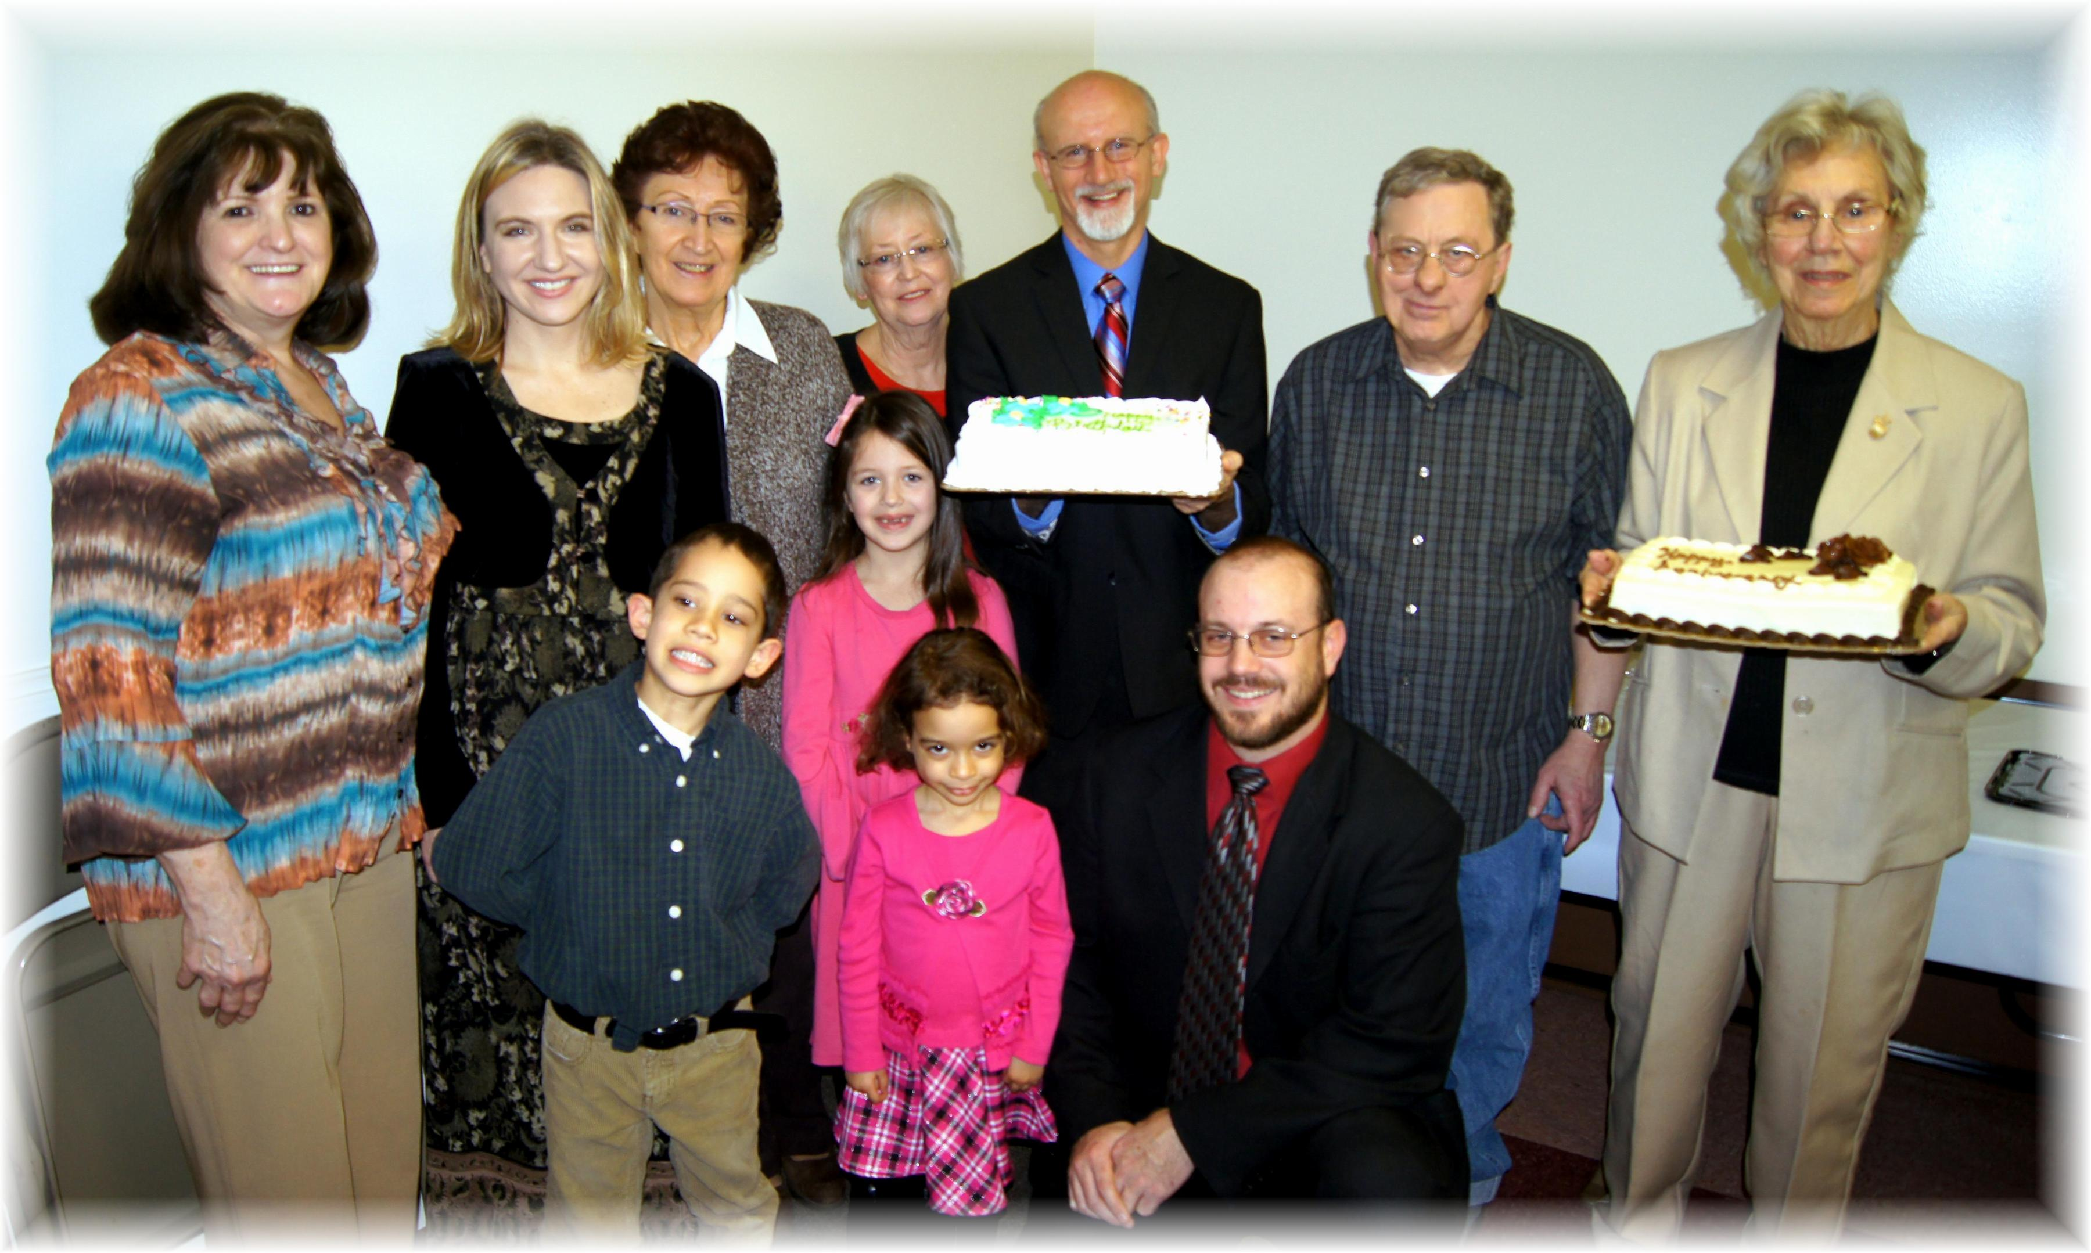
Back Row: Linda, Trina, Alice, Sharon, Pastor Mike, David Anniversary: Betty
Front: Elijah, Callie, Abigail, Anthony
February Birthdays and Anniversary - 2013

