Lancaster Seventh-Day Adventist Church
A House of Prayer for All People

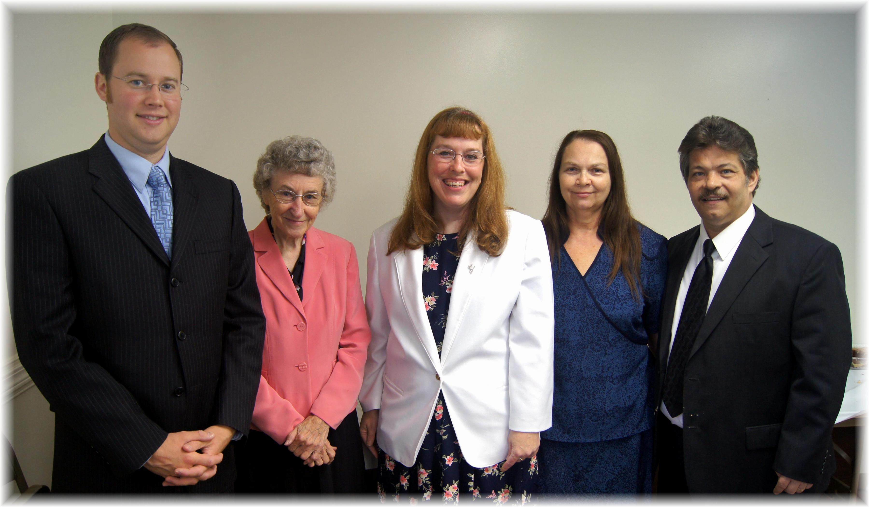
Birthdays: Joel, Freda Anniversaries: Carol, Debby & Roger
Birthdays and Anniversaries – May, 2013

