Lancaster Seventh-Day Adventist Church
A House of Prayer for All People
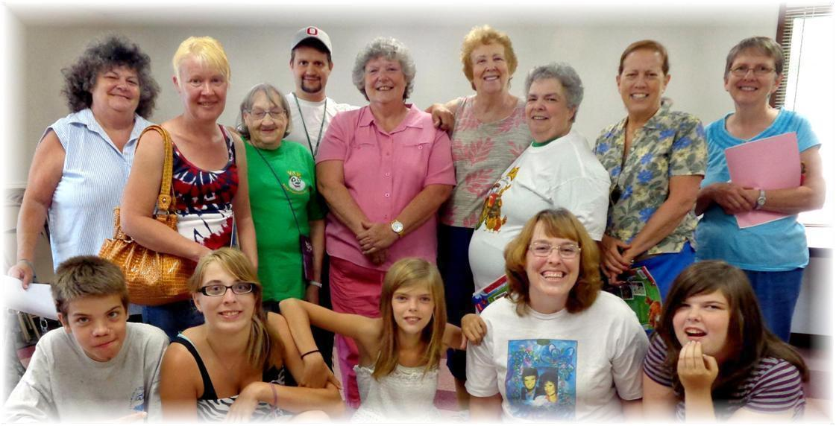
Back: Beverly, Deena, Linda, Allen, Nadean, Diane, Evelyn, Geri, Bonnie
Front: Jacob, Sarah, Tabby, Carol, Tiffany
Vacation Bible School Planning Session #1 - June 23, 2013

