Lancaster Seventh-Day Adventist Church
A House of Prayer for All People

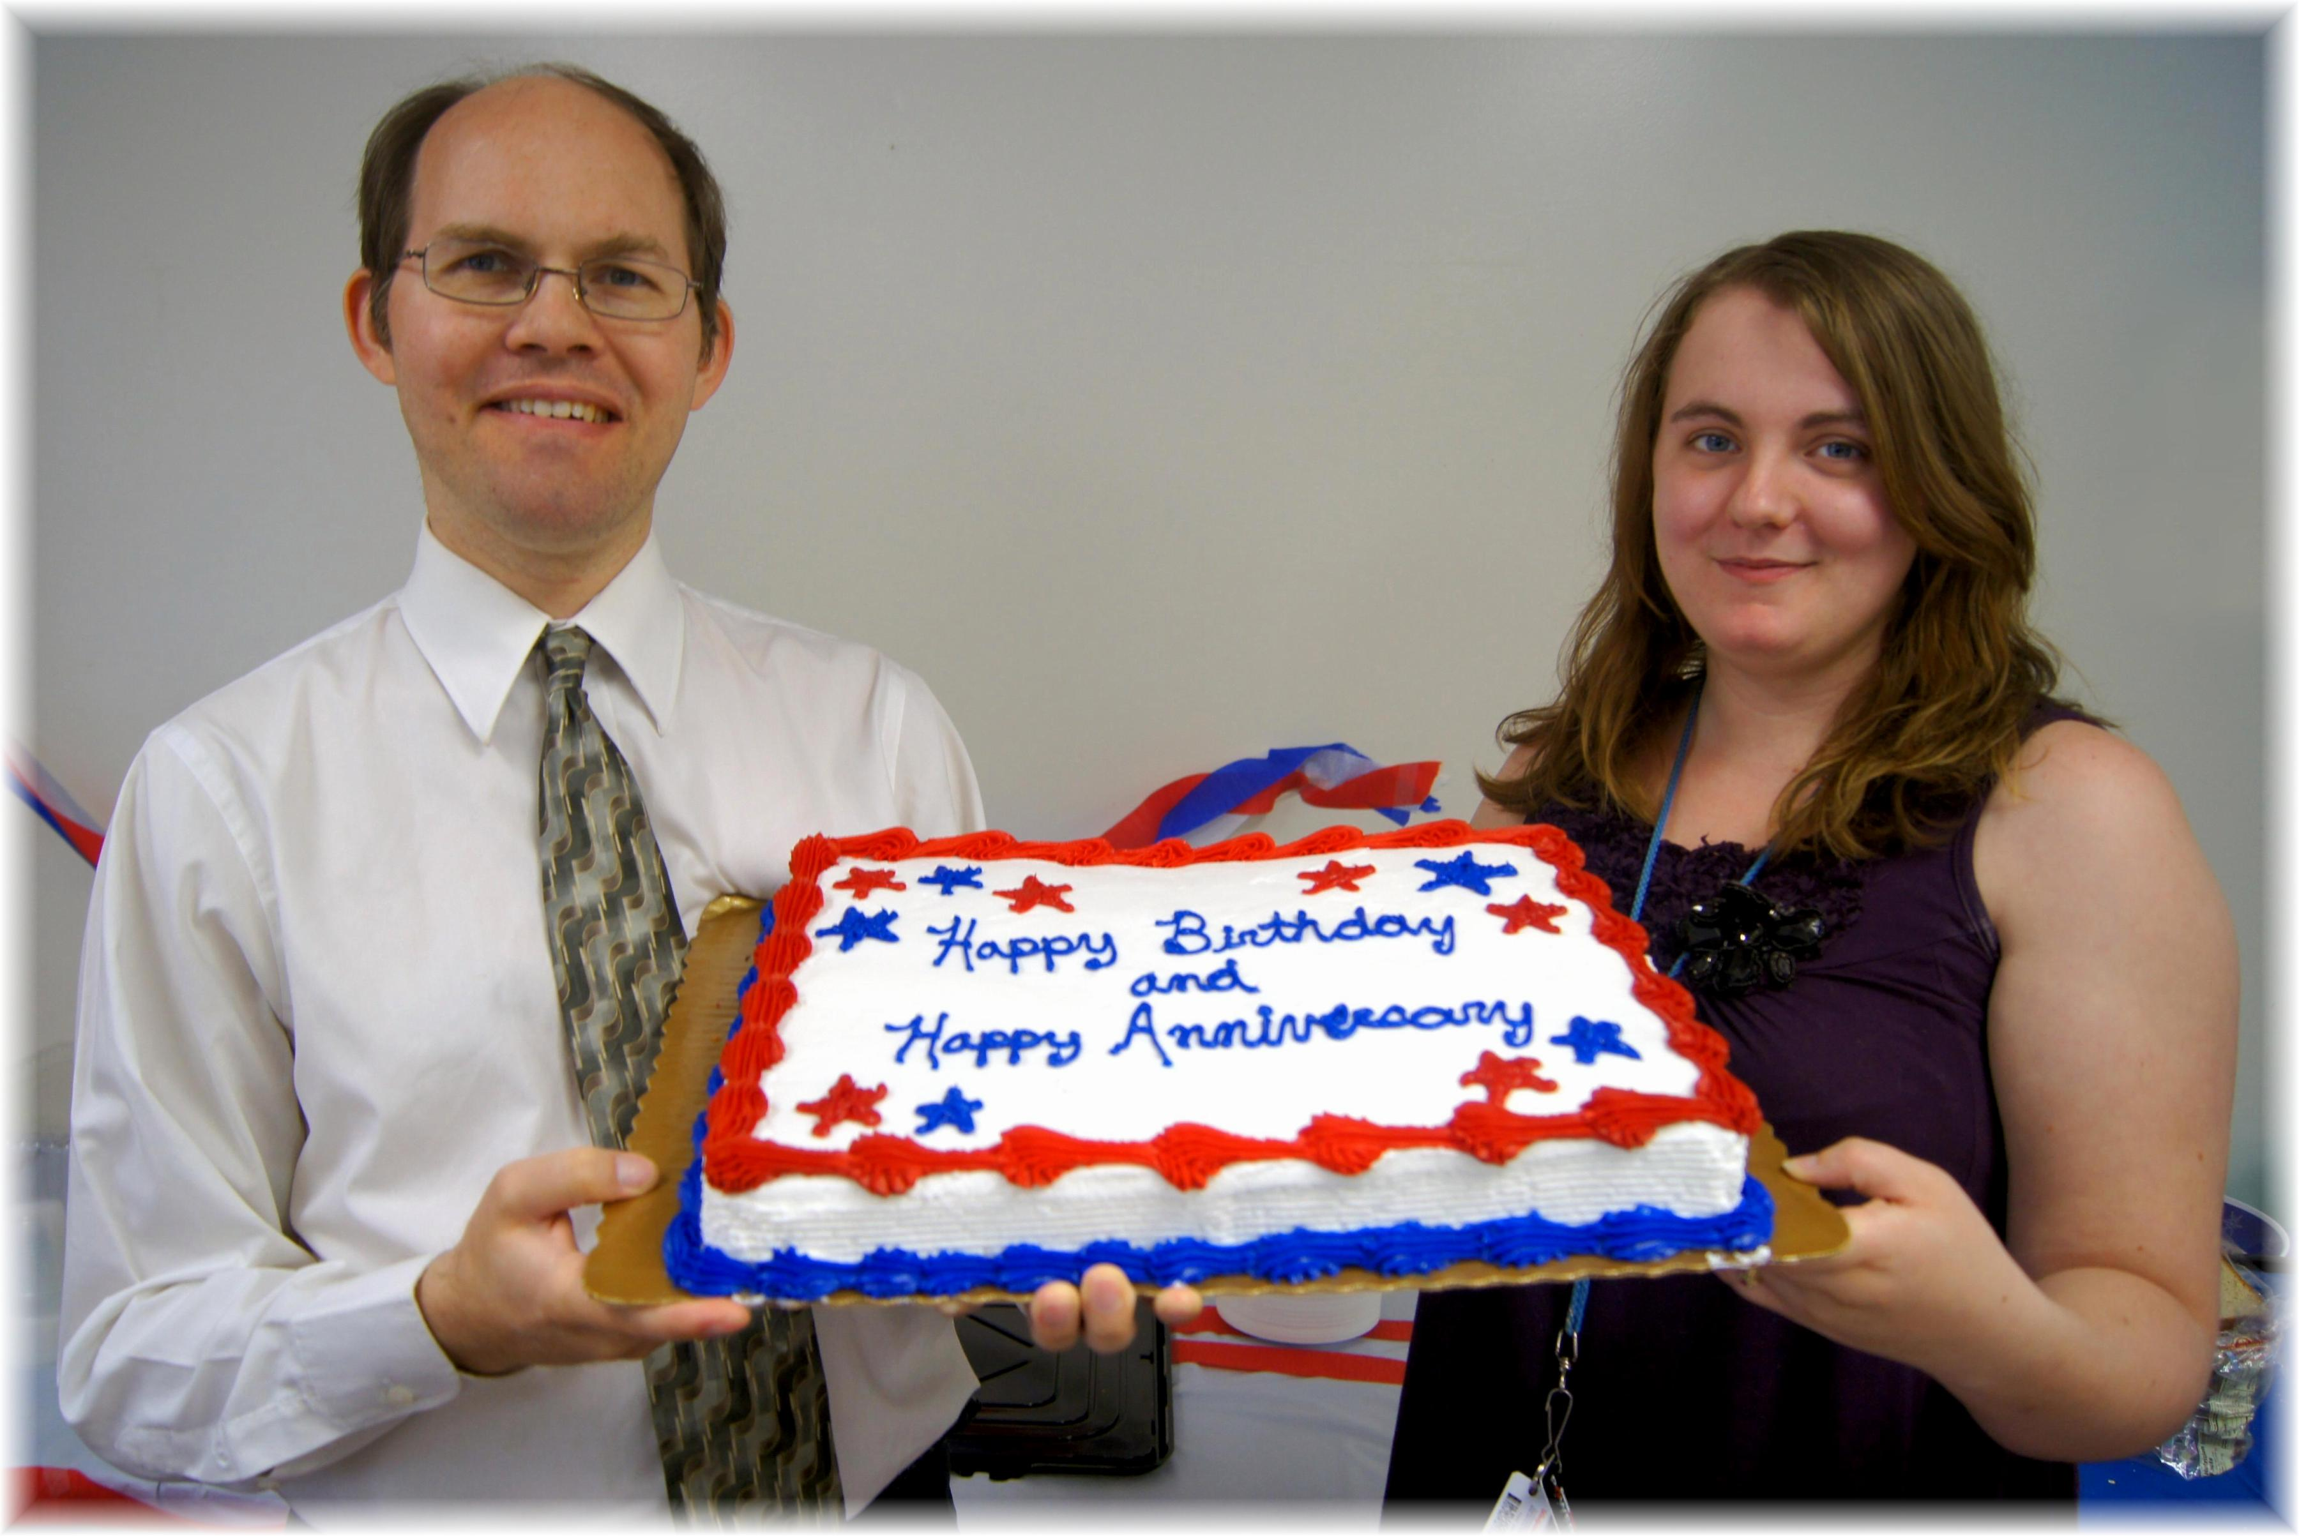
James Shaina
July Birthdays – 2013

