Lancaster Seventh-Day Adventist Church
A House of Prayer for All People

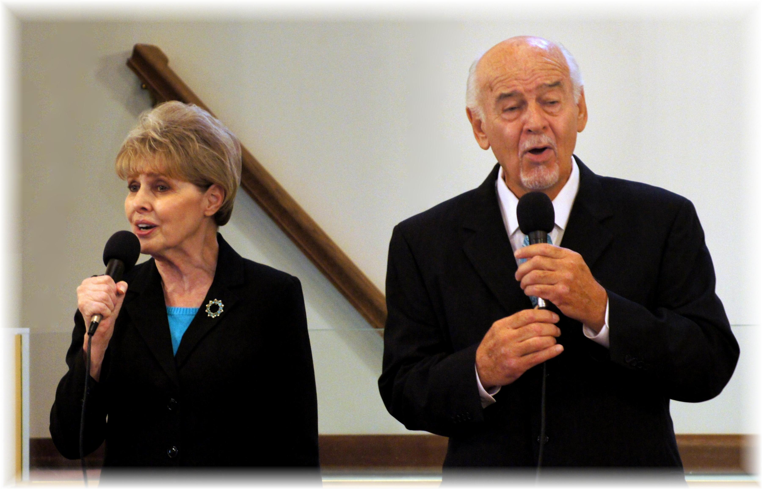
Sonnie & Herman Harp – November 2, 2013

