Lancaster Seventh-Day Adventist Church
A House of Prayer for All People

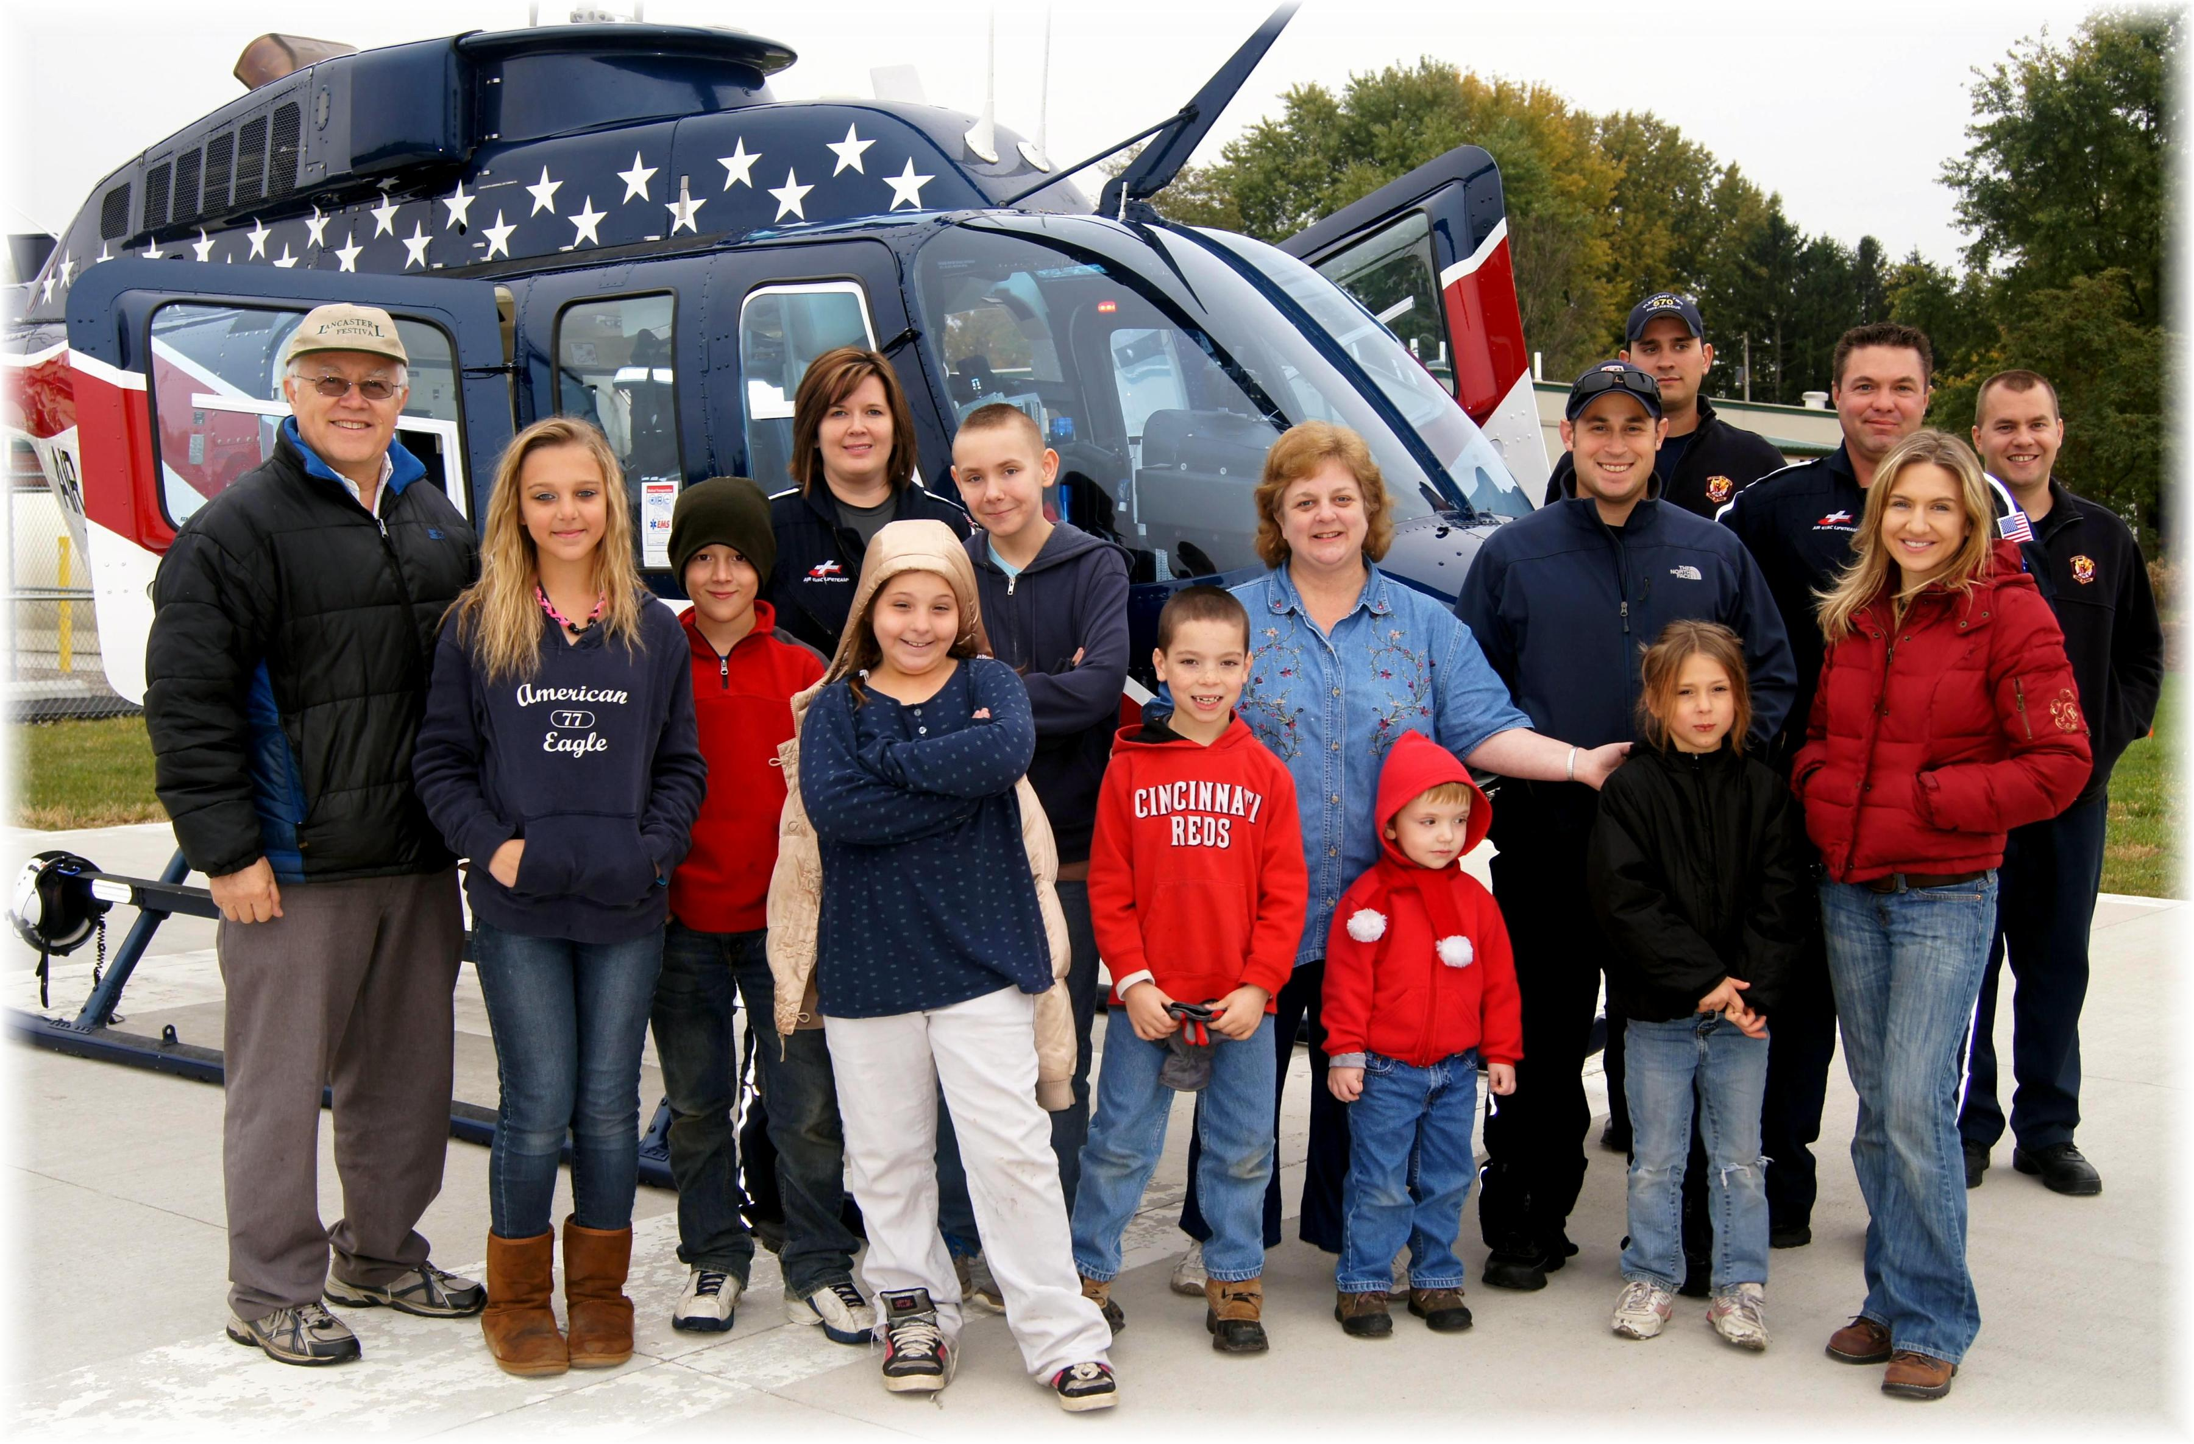
Air Evac Lifeteam ~ Field Trip ~ October 30, 2013

