Lancaster Seventh-Day Adventist Church
A House of Prayer for All People
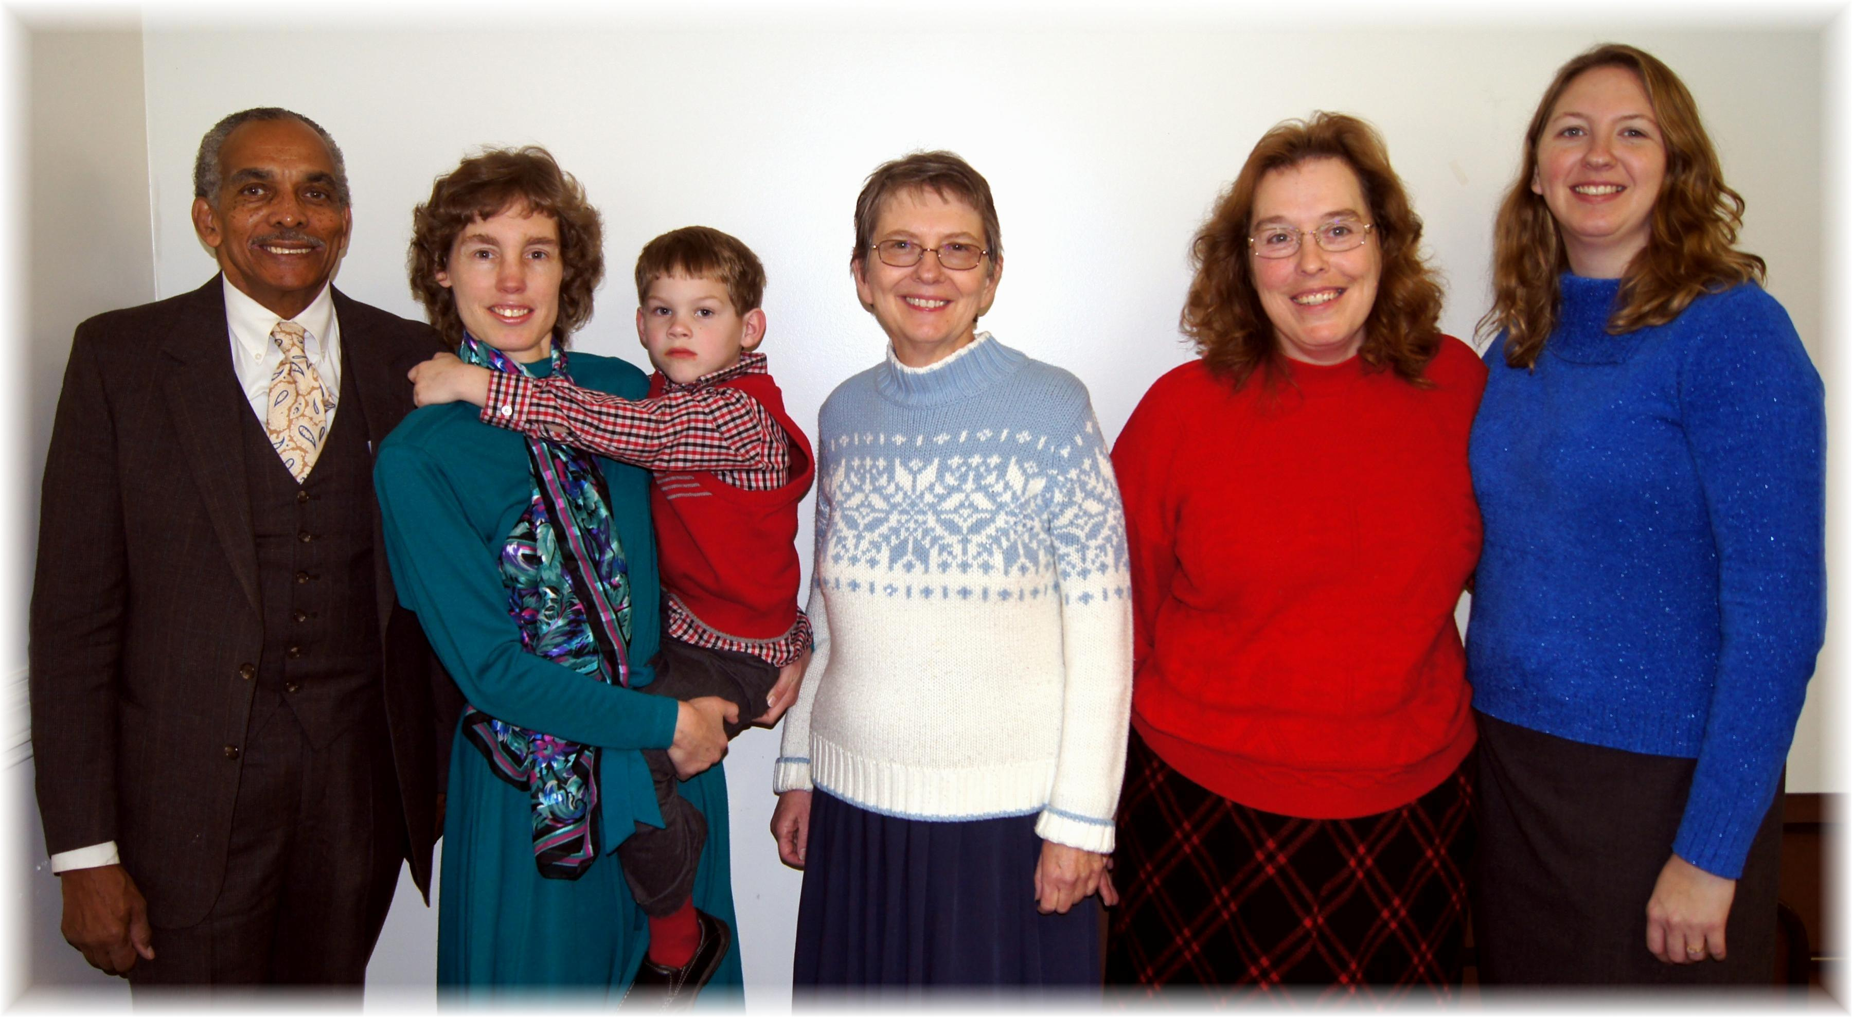
Rick, Andrew (held by Connie), Bonnie, Carol, Jennifer
January Birthdays - 2014

