Lancaster Seventh-Day Adventist Church
A House of Prayer for All People
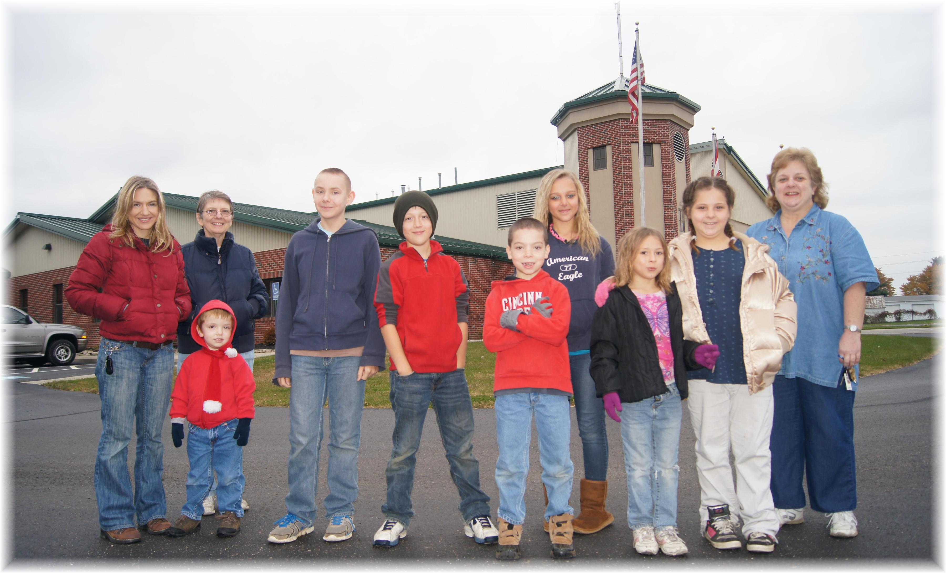
Pleasantville Fire Station Field Trip

