Lancaster Seventh-Day Adventist Church
A House of Prayer for All People

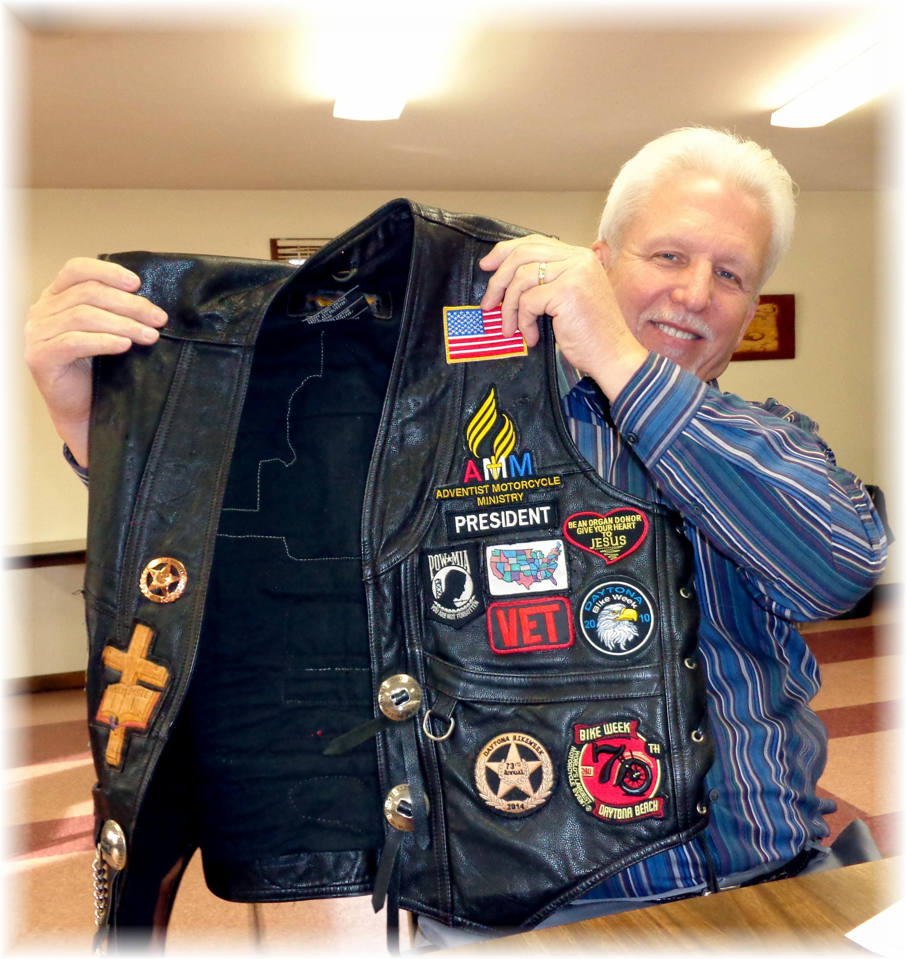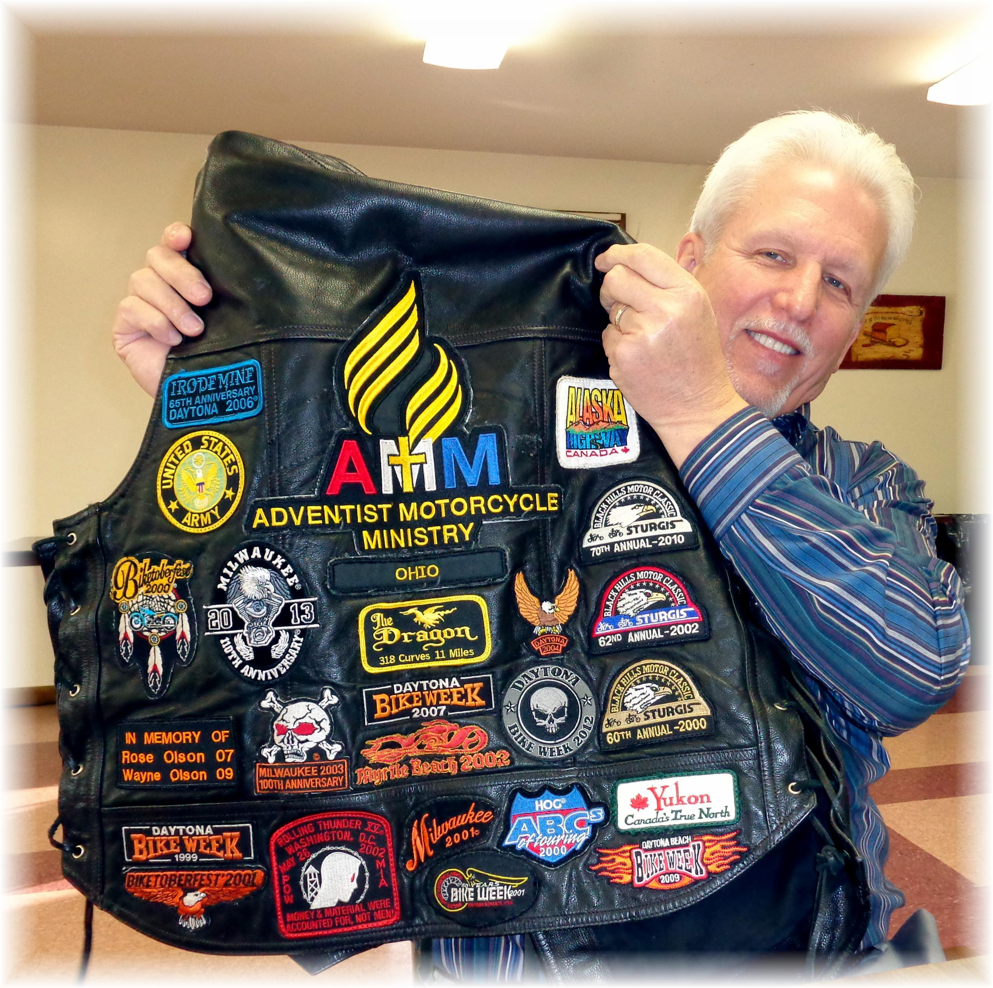
Pastor Tom’s Adventist Motorcycle Ministry Vest - 2014

