Lancaster Seventh-Day Adventist Church
A House of Prayer for All People

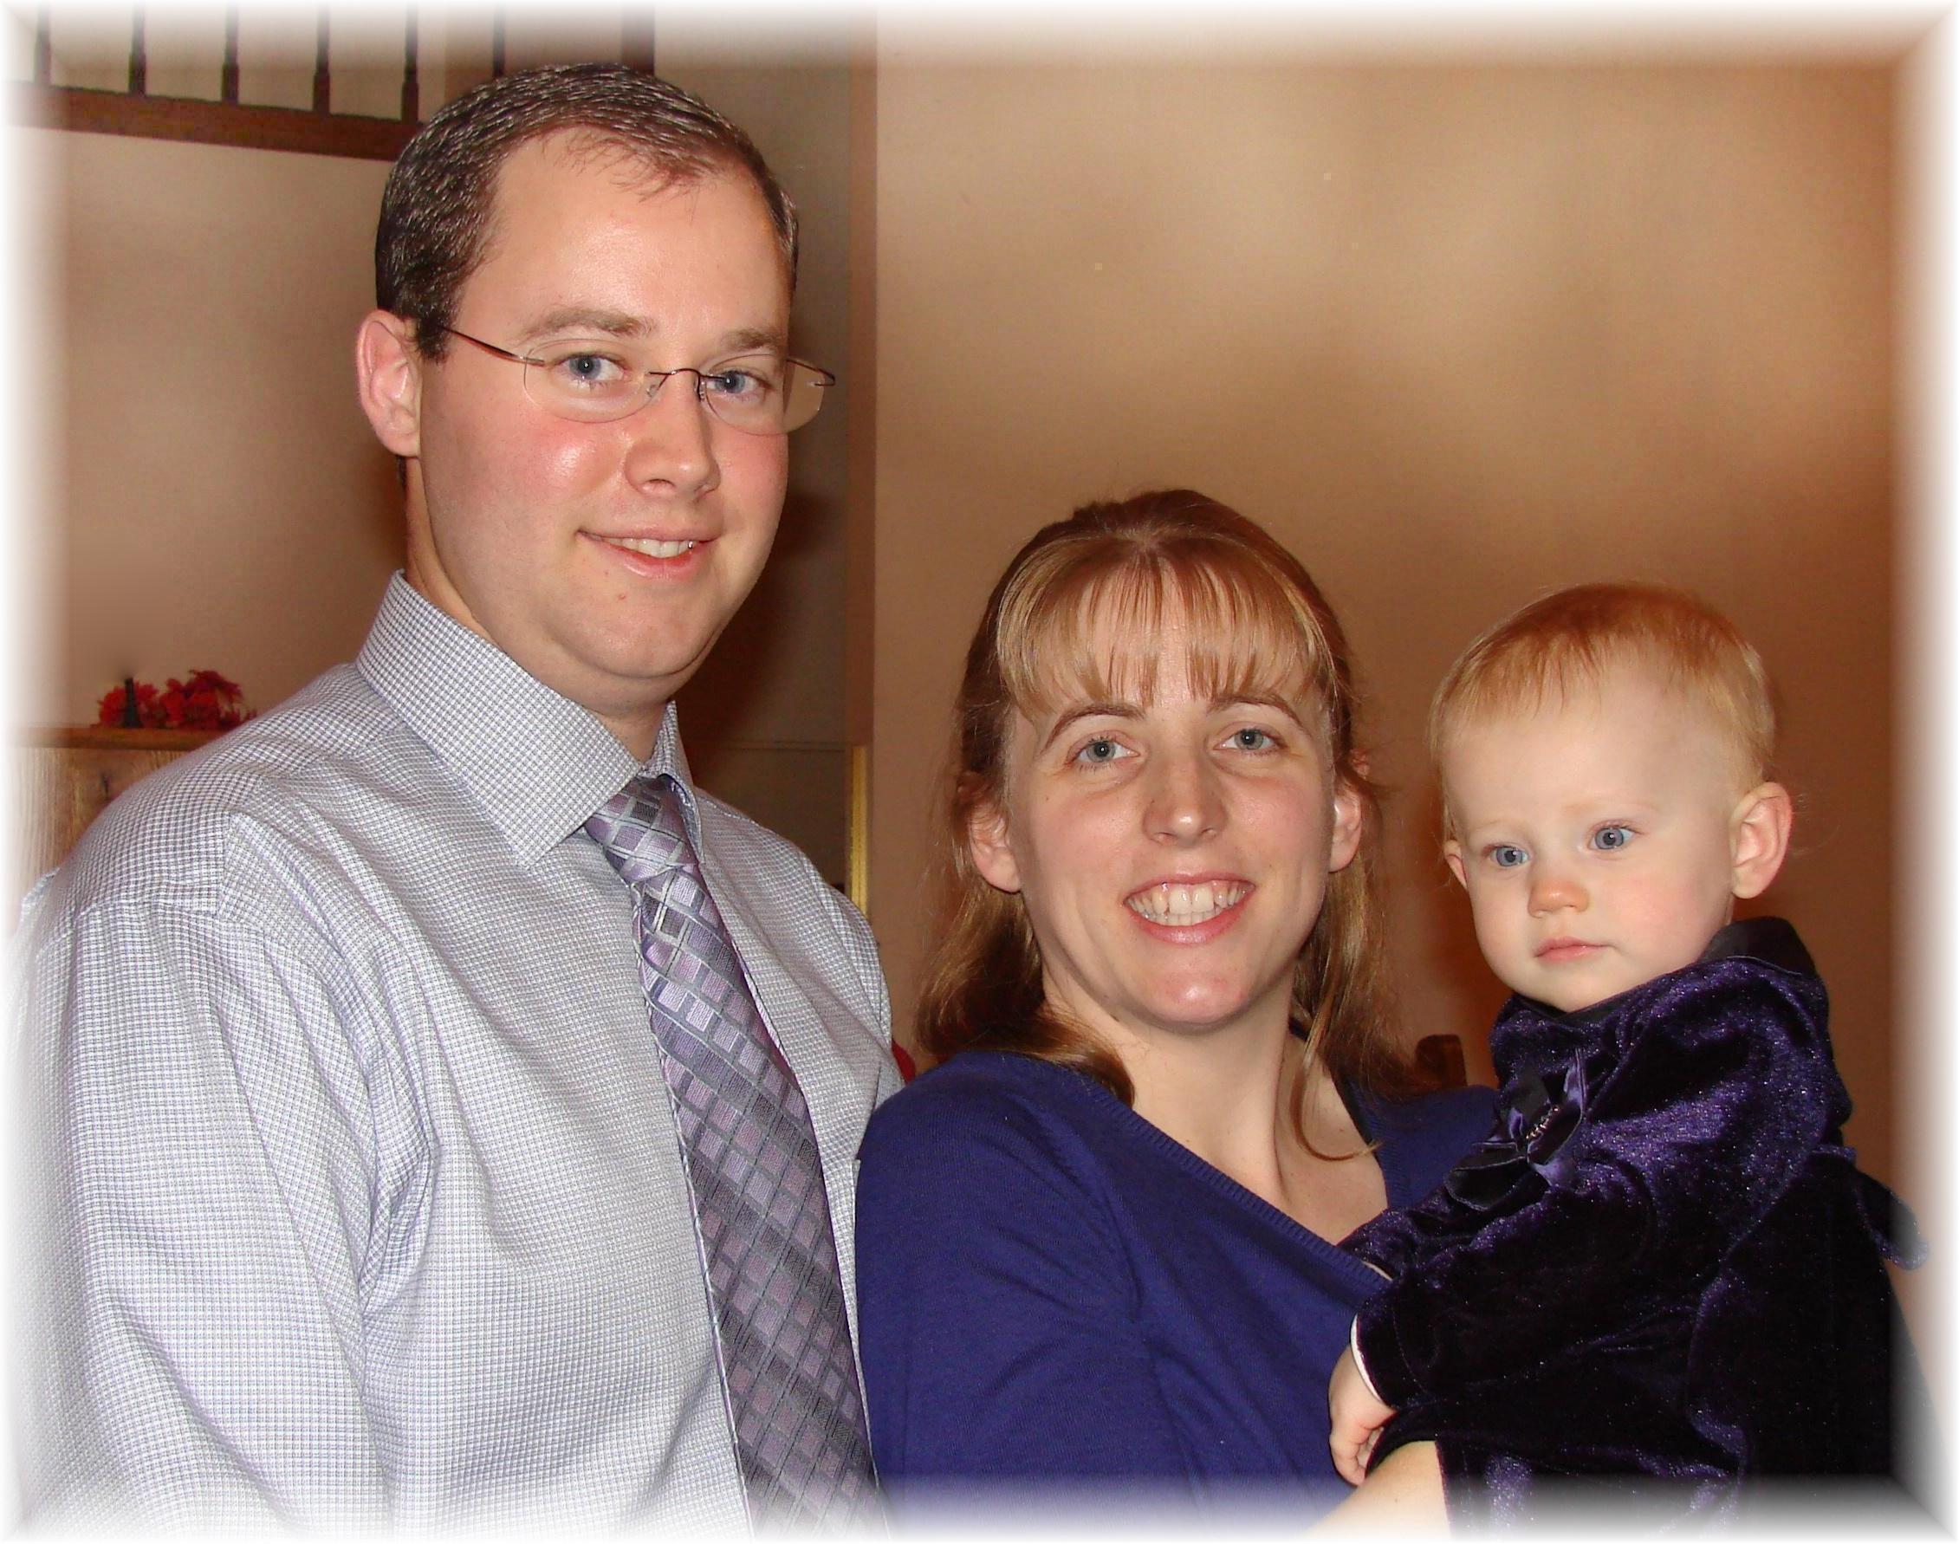
Joel, Marijke, and Chloe Schlittenhart
Baby Dedication – December 24, 2011

