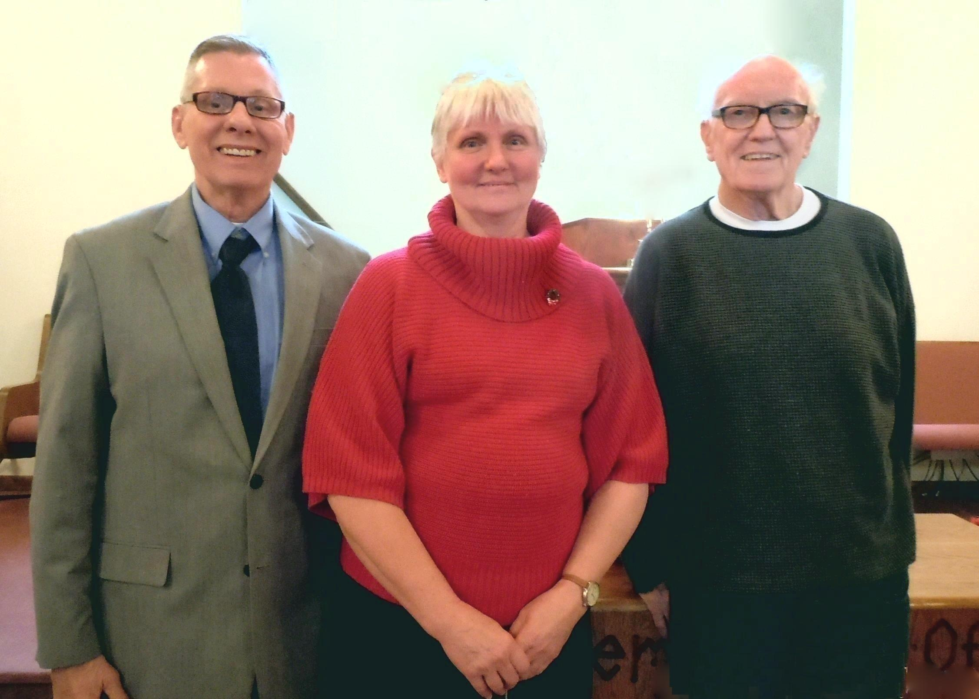
Larry Hamilton, Wanda Ray, and Jerry Loffman
Our Newest Members – December 16, 2017
Photo by Linda Downhour

