Lancaster Seventh-Day Adventist Church
A House of Prayer for All People

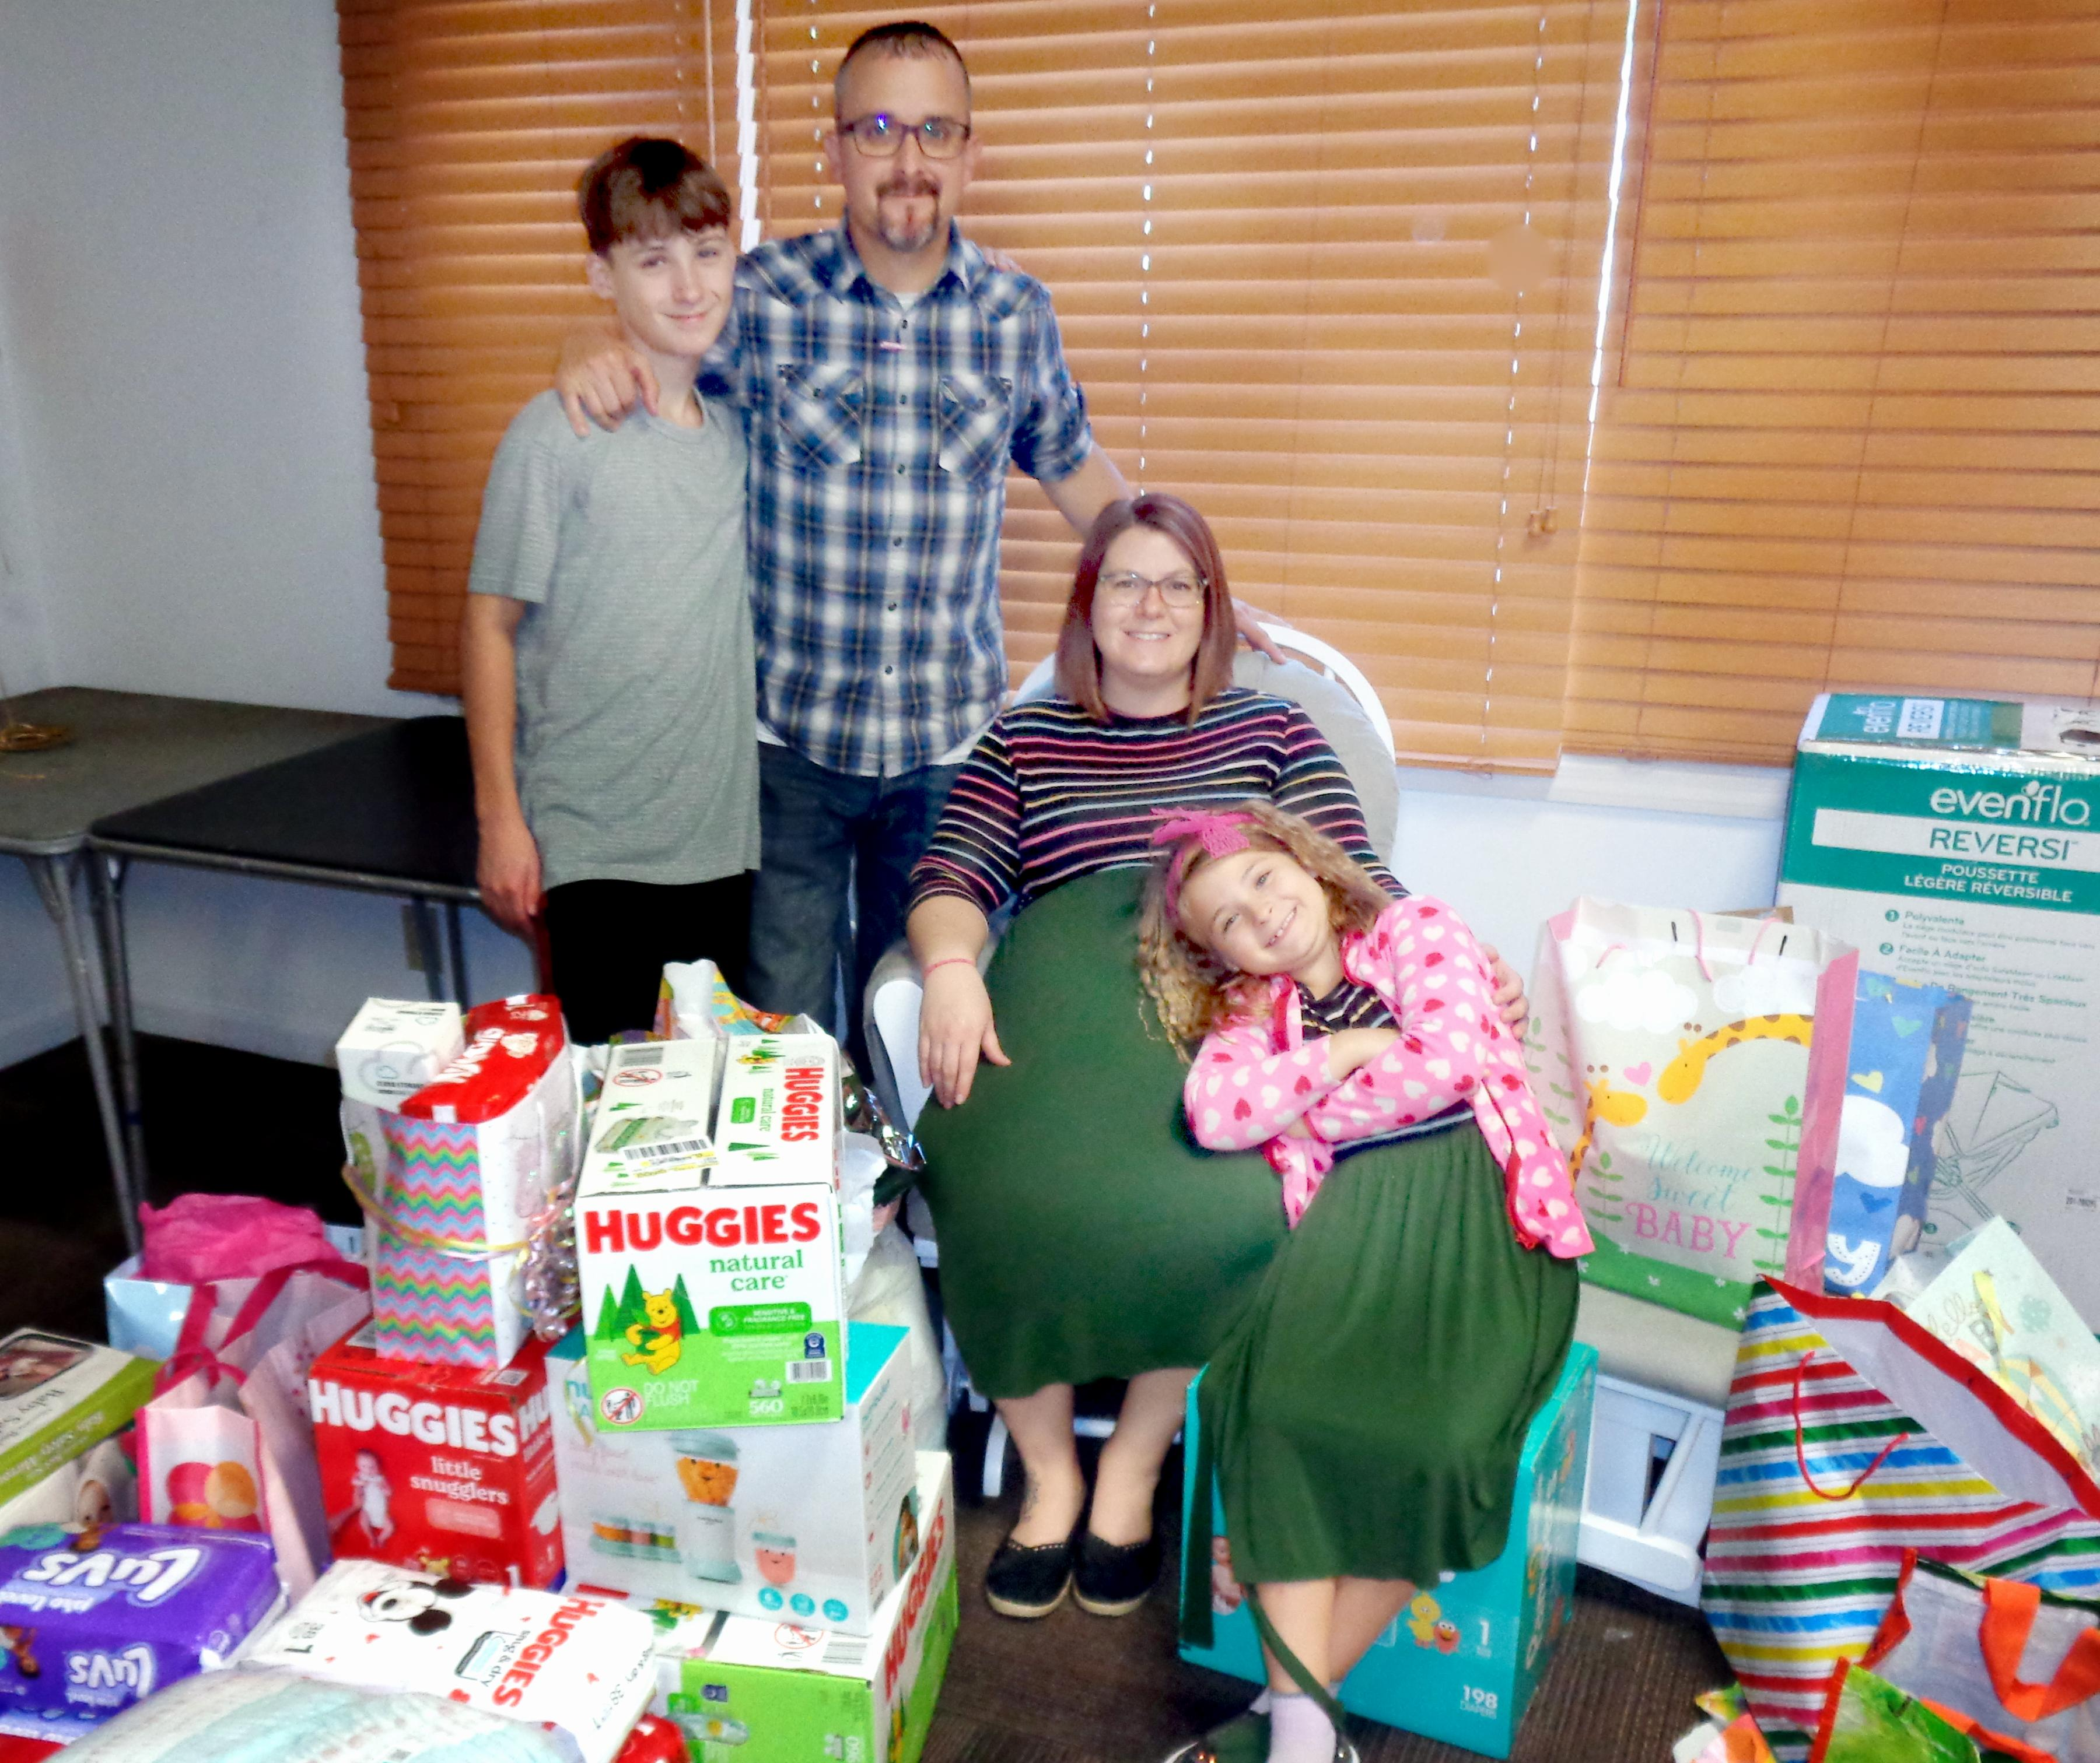
Hinkle Baby Shower for Lillian
October 2, 2022

