Lancaster Seventh-Day Adventist Church
A House of Prayer for All People

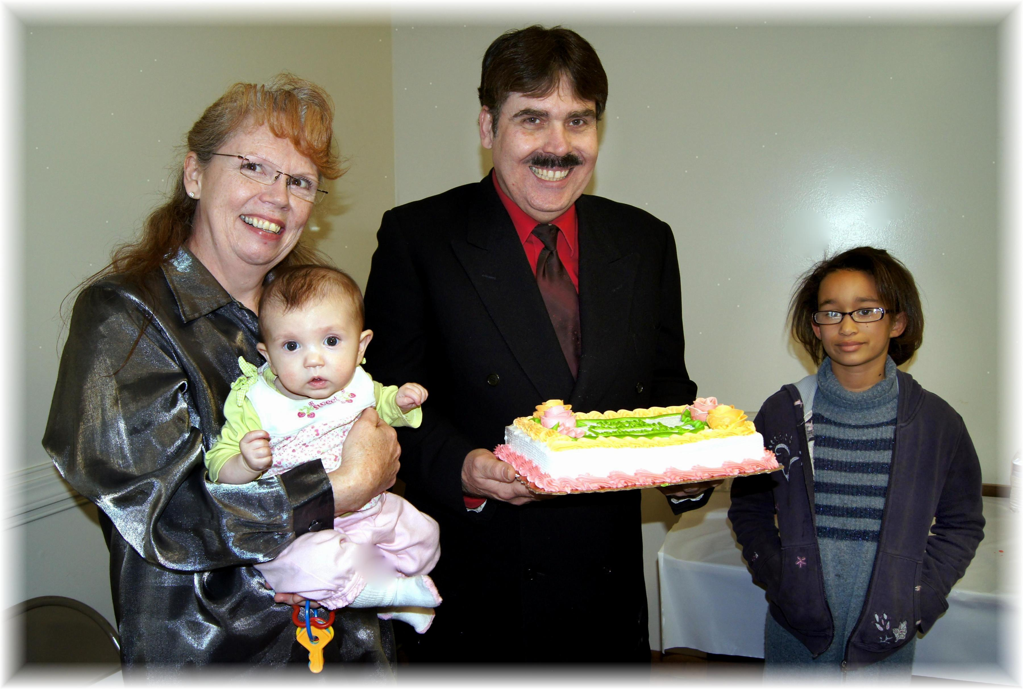
Barbara (holding Sakura), Carlton, Summer
March Birthdays - 2012

