Lancaster
Seventh-Day Adventist Church
A House of Prayer for All People

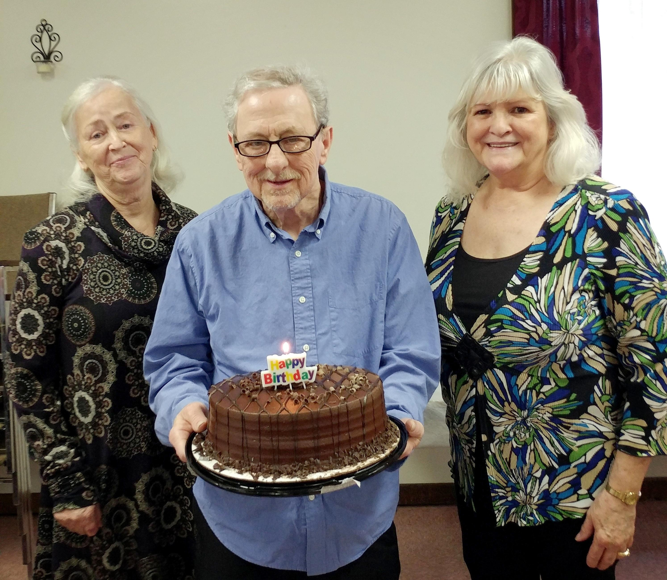

Sharon, David, Linda
February Birthdays – 2020

