Lancaster Seventh-Day Adventist Church
A House of Prayer for All People

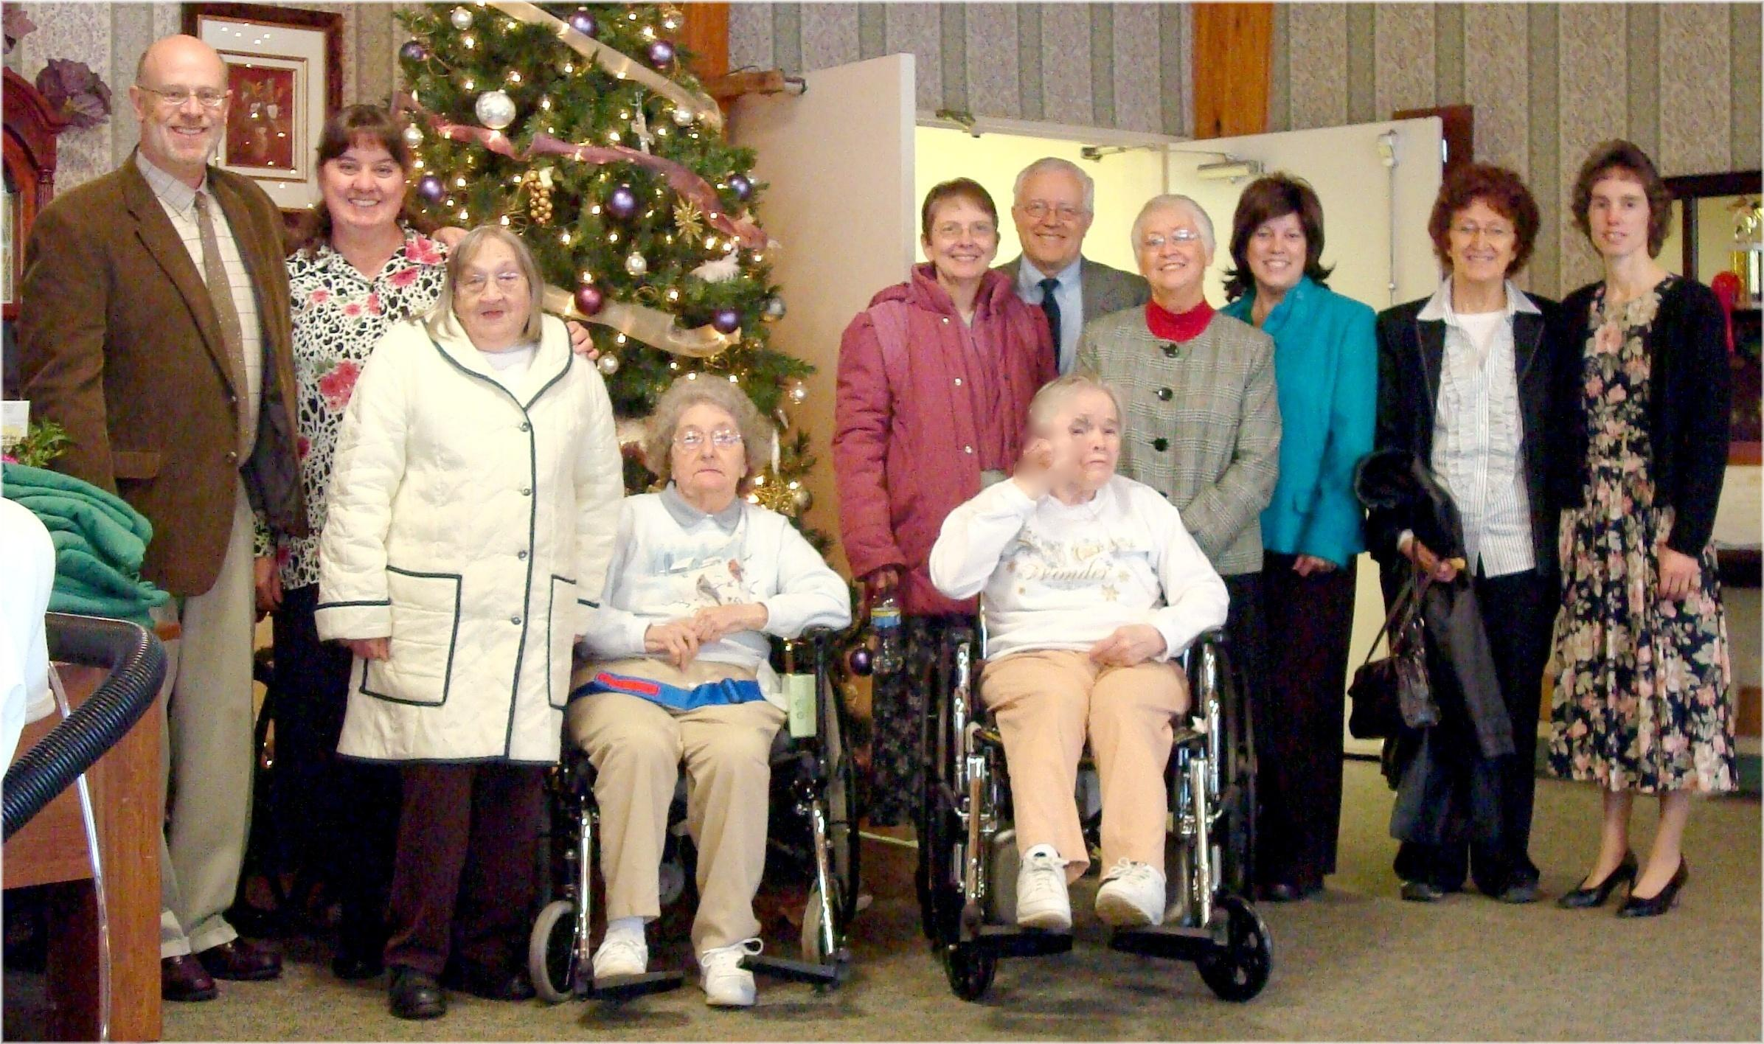
Nursing Home Visit – December 5, 2009

