Lancaster Seventh-Day Adventist Church
A House of Prayer for All People

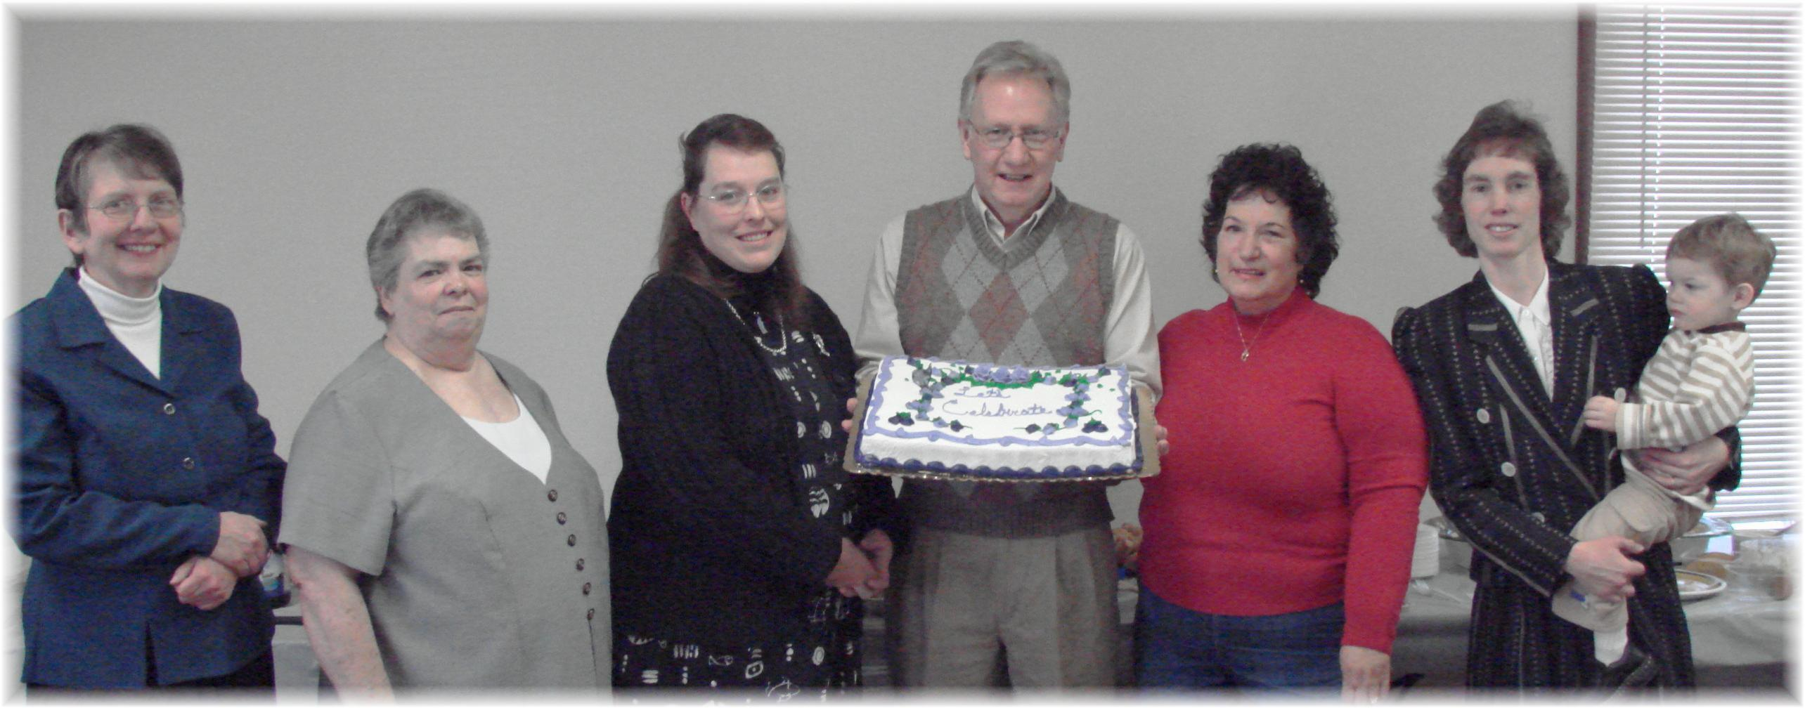
Bonnie, Evelyn, Carol, Len, Kay, Andrew (held by Connie)
January Birthdays - 2010

