Lancaster Seventh-Day Adventist Church
A House of Prayer for All People

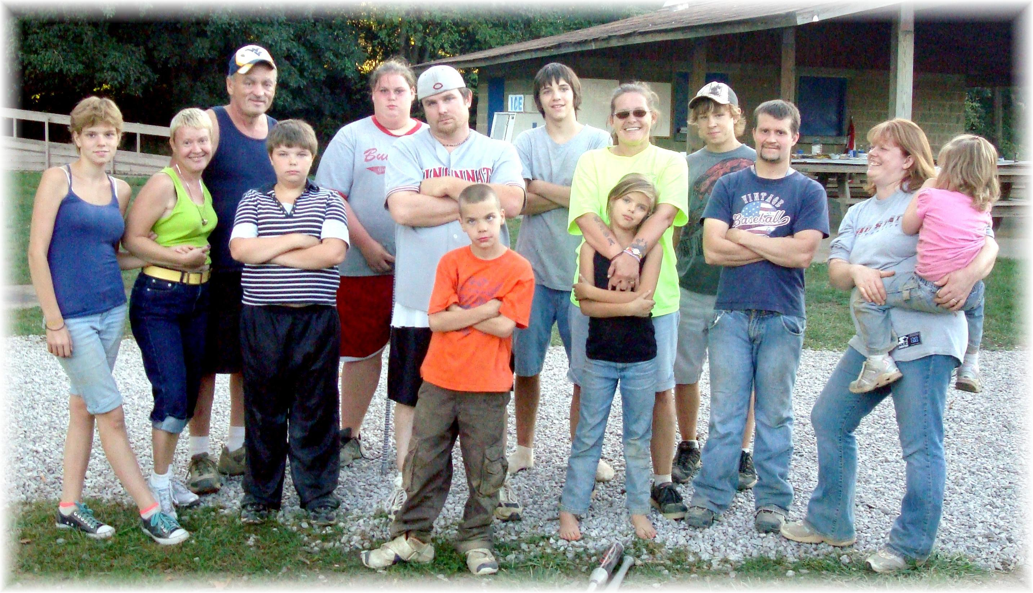
Softball Social at Martens Park -- September 5, 2010

