Lancaster Seventh-Day Adventist Church
A House of Prayer for All People

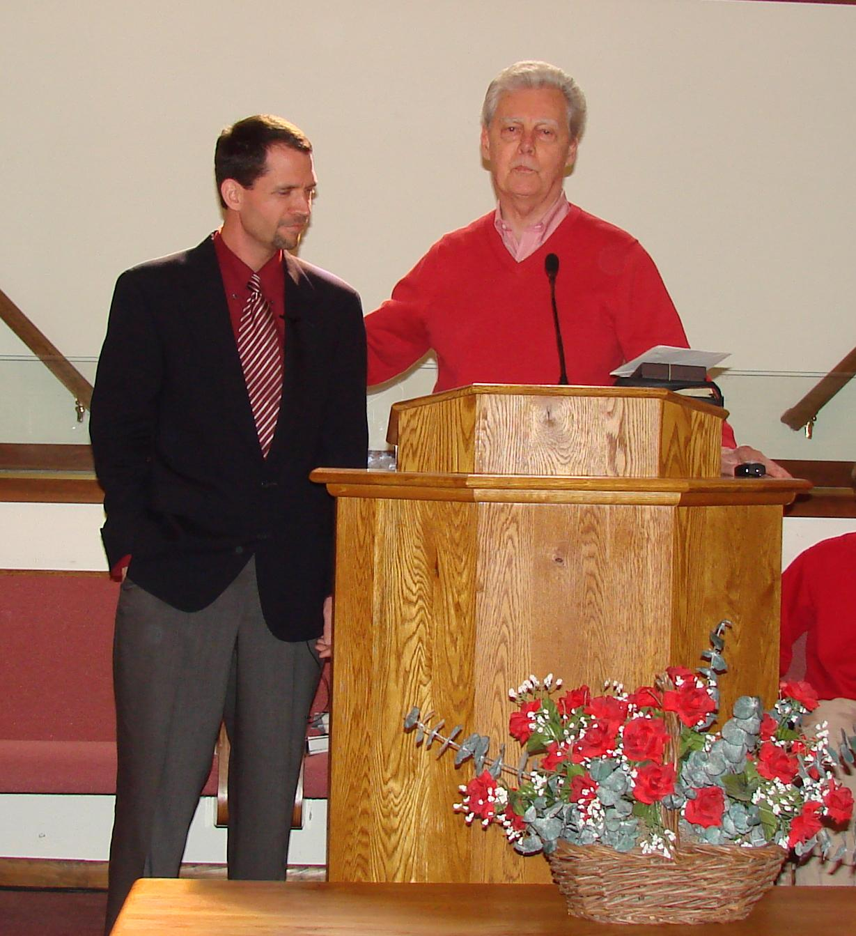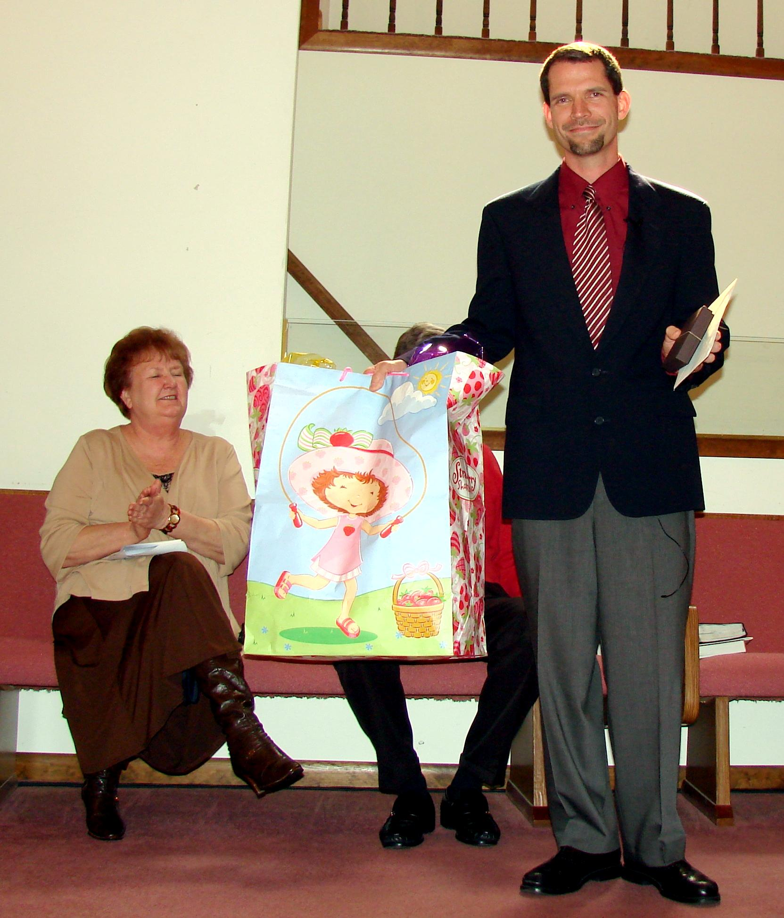

Thank you, Pastor Dean for 2 years of service. – March 26, 2011

