Lancaster Seventh-Day Adventist Church
A House of Prayer for All People

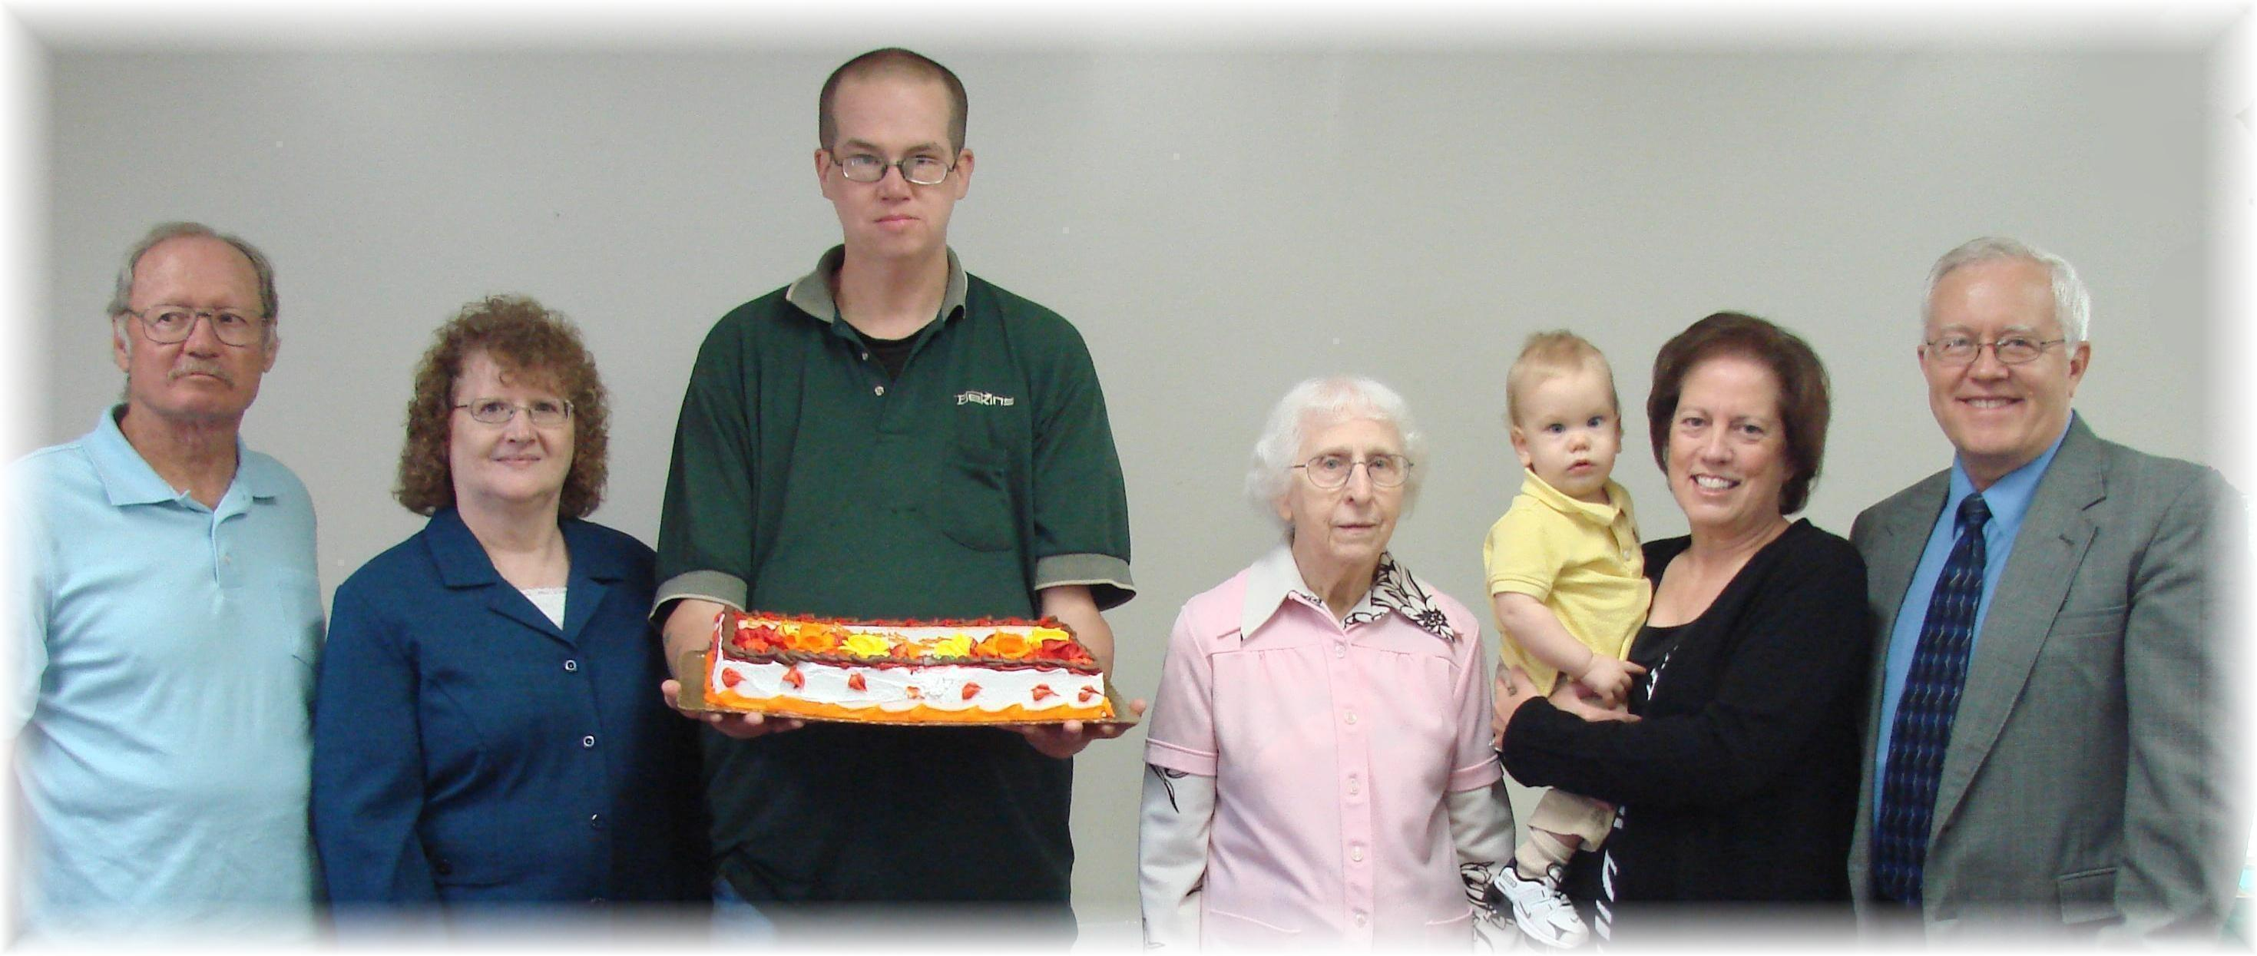
Anniversary: Paul and Cathy Matthews Birthdays: Matthew, Edith, Aden, Geri, Al
October Anniversary and Birthdays - 2011

