Lancaster Seventh-Day Adventist Church
A House of Prayer for All People

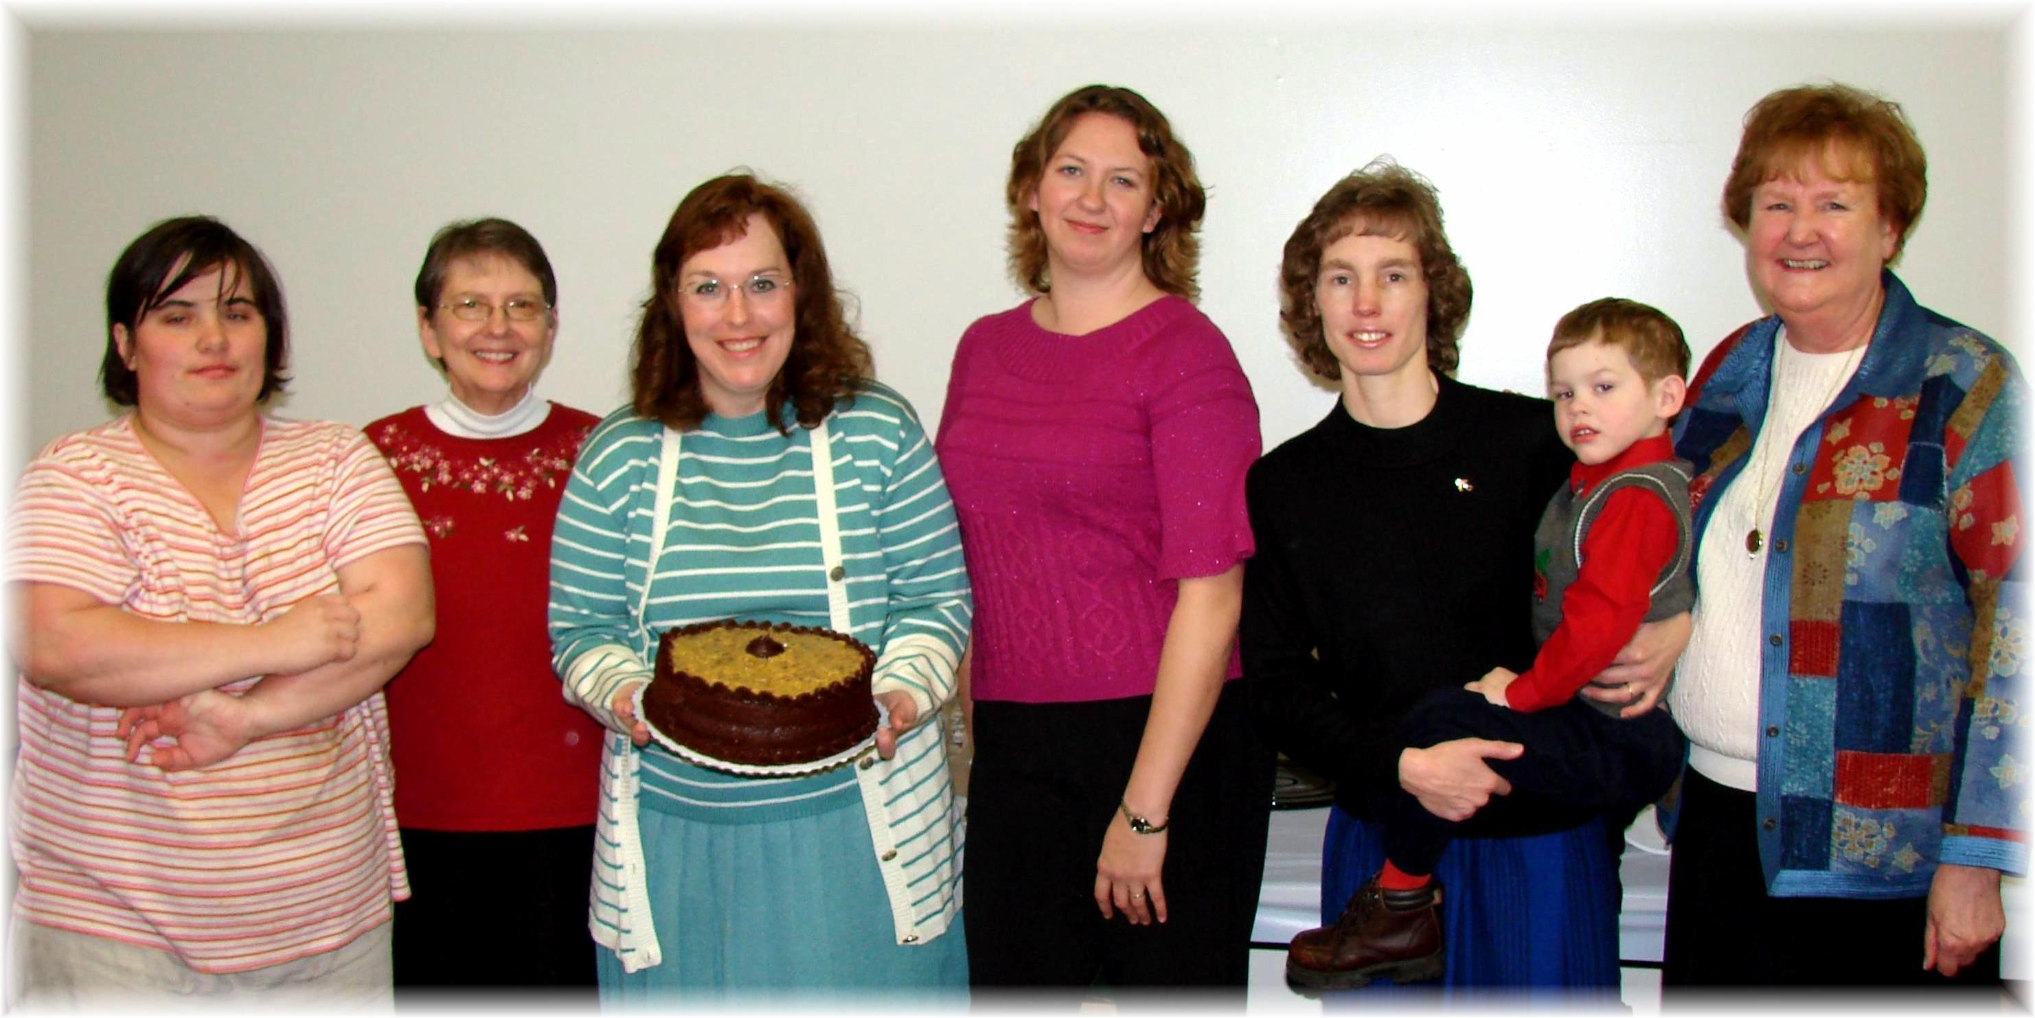
Anniversary: Becky Birthdays: Bonnie, Carol, Jennifer, Andrew (held by Connie), Linda
January Anniversary and Birthdays - 2012

