Lancaster Seventh-Day Adventist Church
A House of Prayer for All People

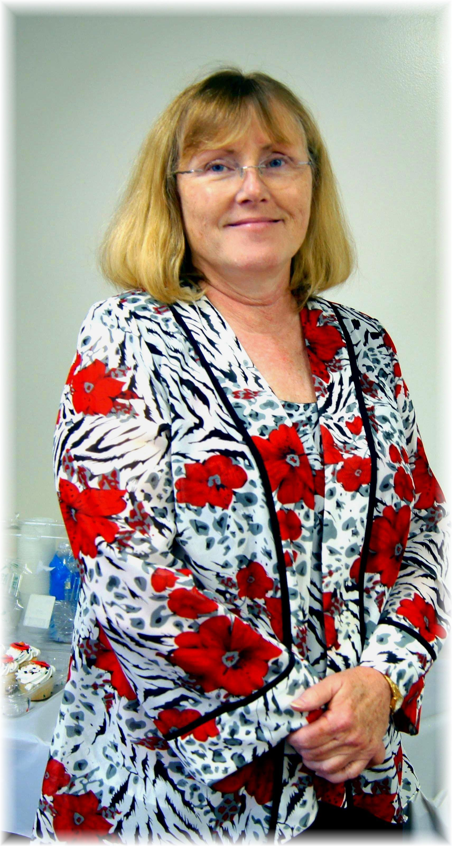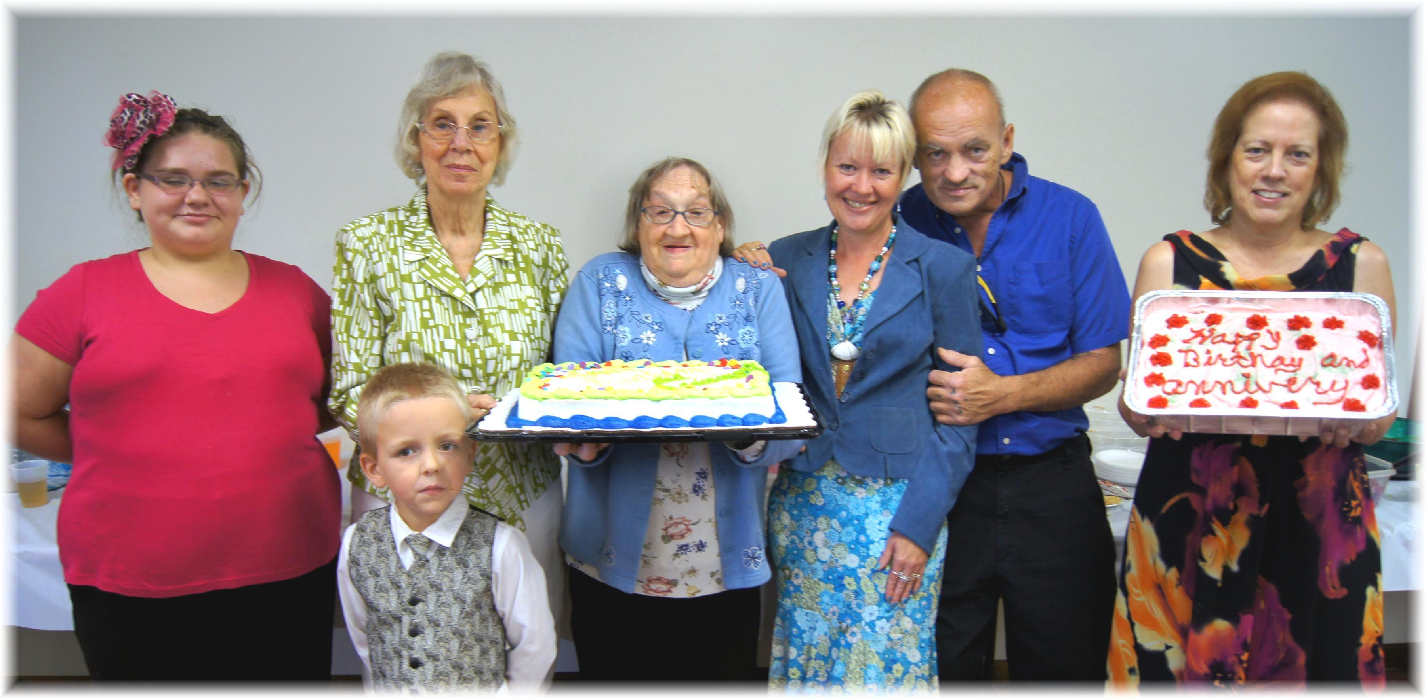

Birthdays: Christine, Brianna, David, Betty, Linda, Deena, Allen Anniversary: Geri
August Birthdays and Anniversary - 2012

