Lancaster Seventh-Day Adventist Church
A House of Prayer for All People
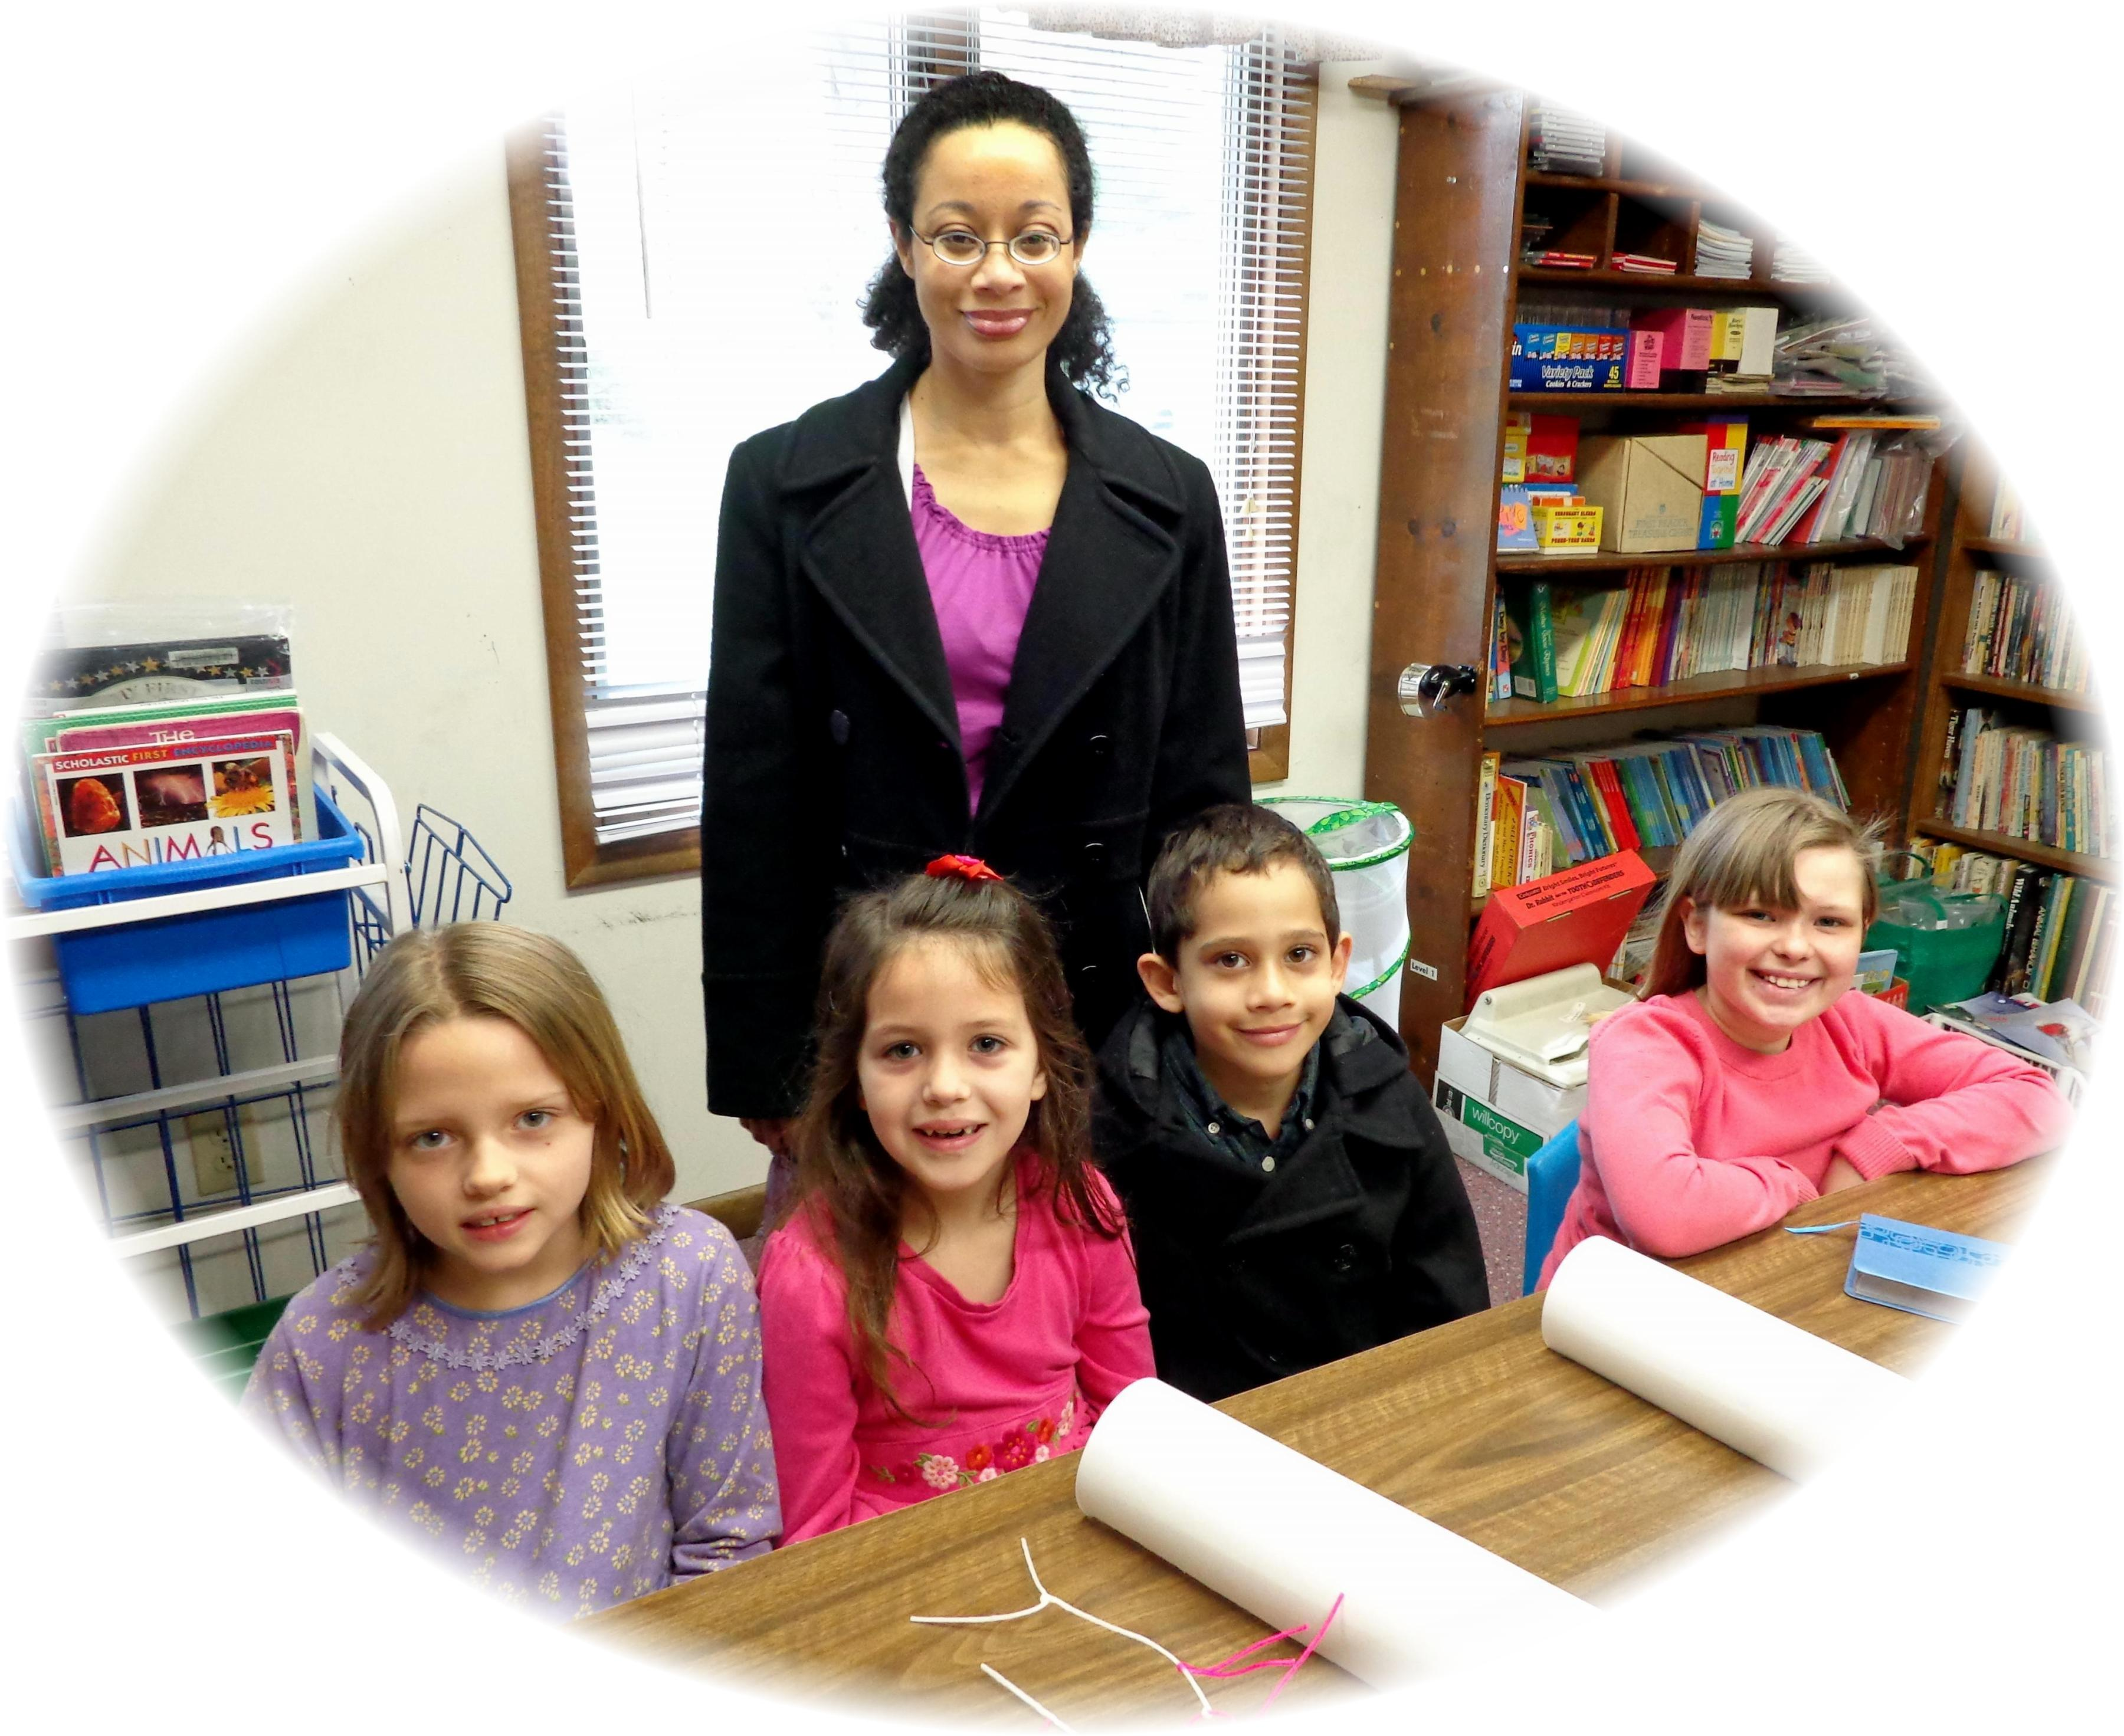
Sandra, Callie, Cesilia, Elijah, Asia
Primary Class - 2013

