Lancaster Seventh-Day Adventist Church
A House of Prayer for All People

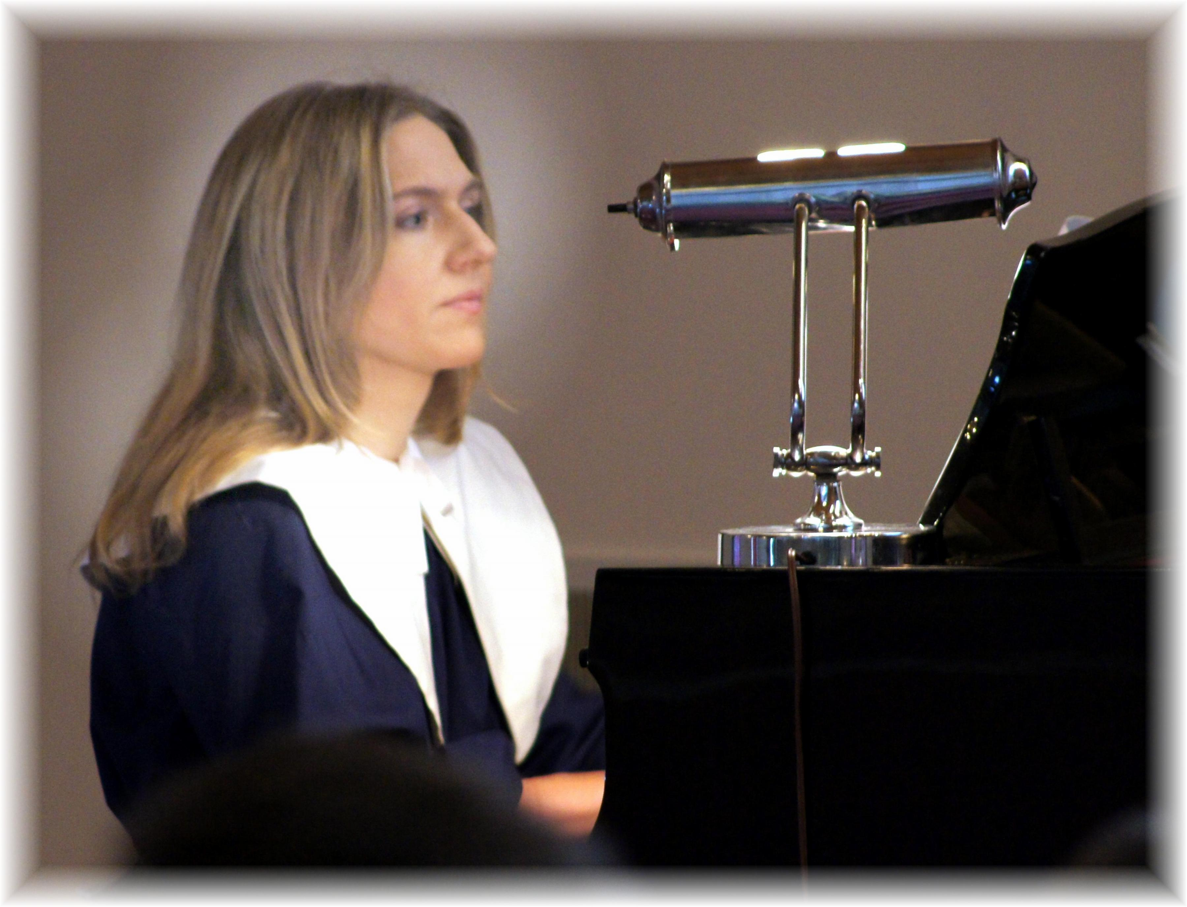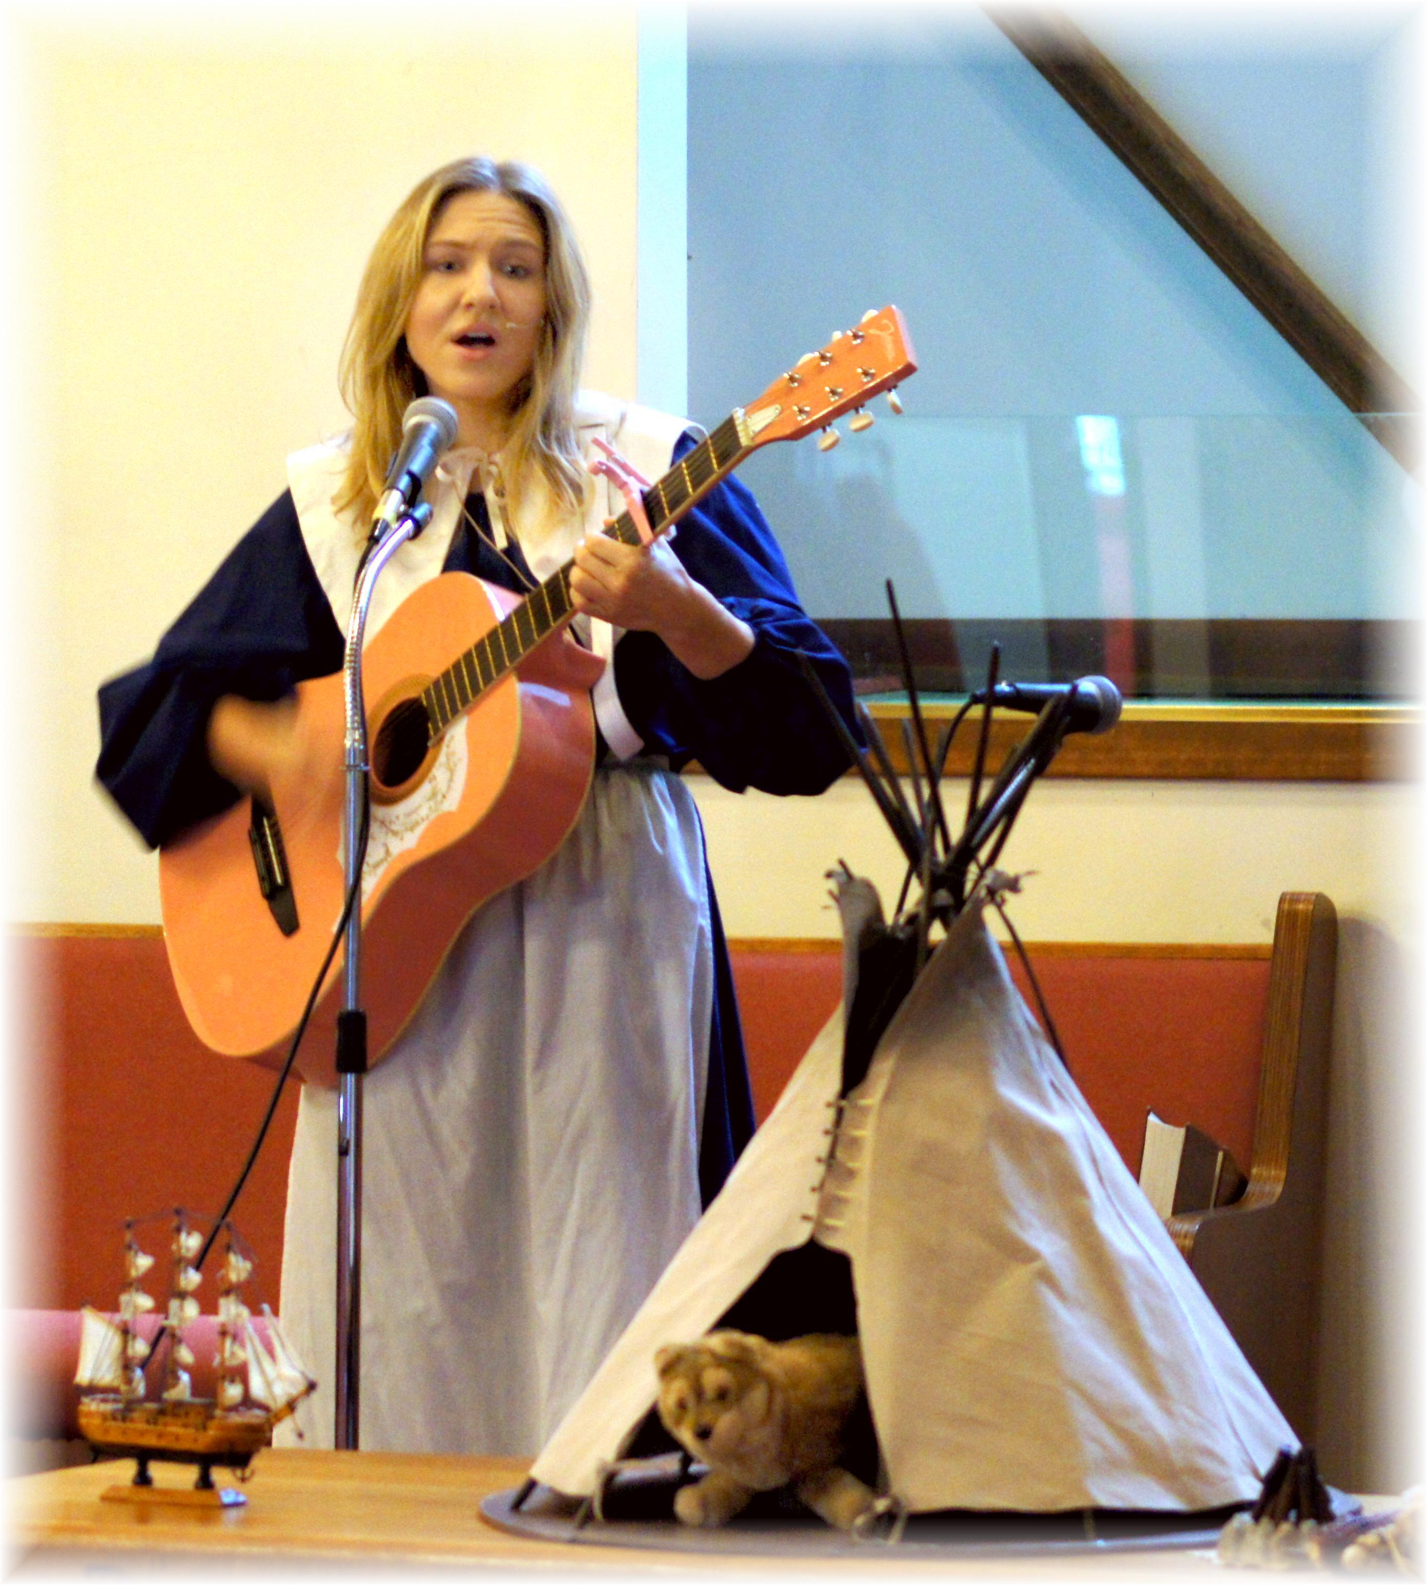
Trina’s Thanksgiving Program ~ November 30, 2013

