Lancaster Seventh-Day Adventist Church
A House of Prayer for All People

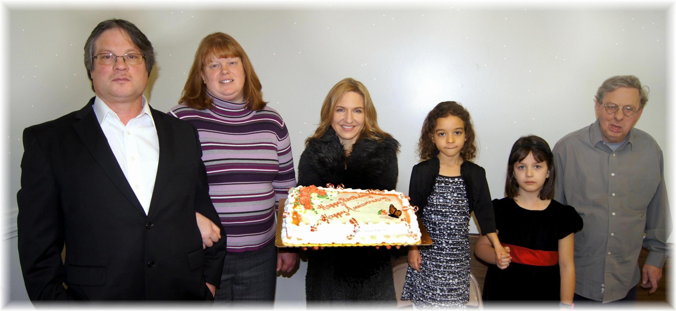
Anniversary: Jim & Tami Birthdays: Trina, Abigail, Callie, David
February Anniversary and Birthdays - 2014

