Lancaster Seventh-Day Adventist Church
A House of Prayer for All People

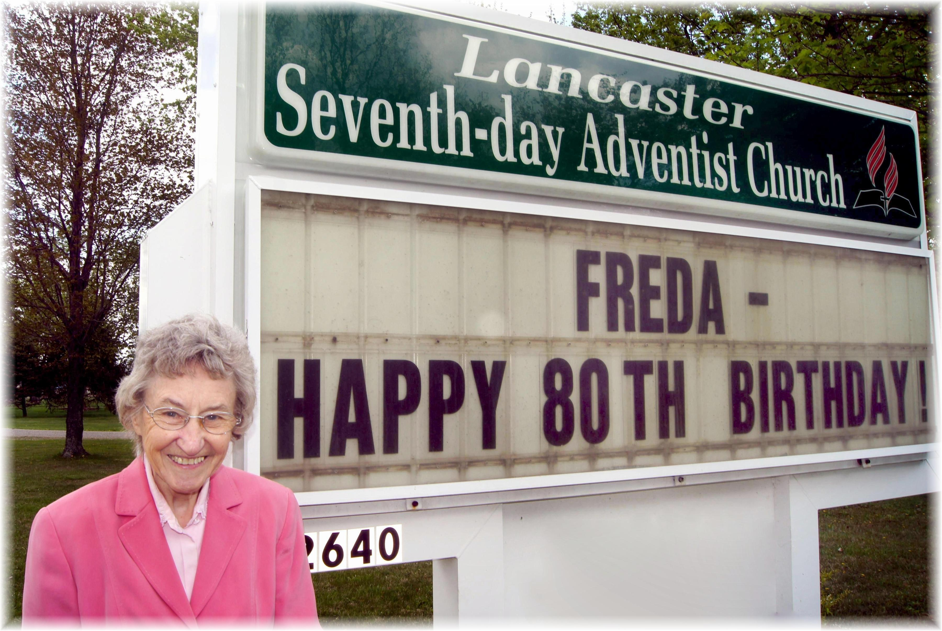
Happy 80th Birthday, Freda !

