Lancaster Seventh-Day Adventist Church
A House of Prayer for All People

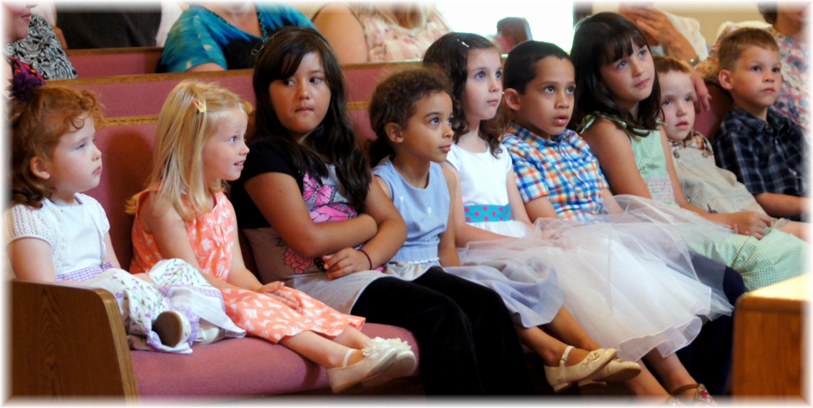
Children’s Story ~~ July 12, 2014

