Lancaster Seventh-Day Adventist Church
A House of Prayer for All People
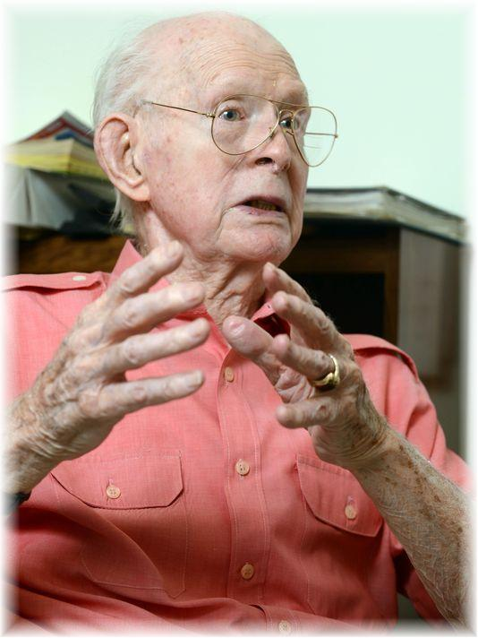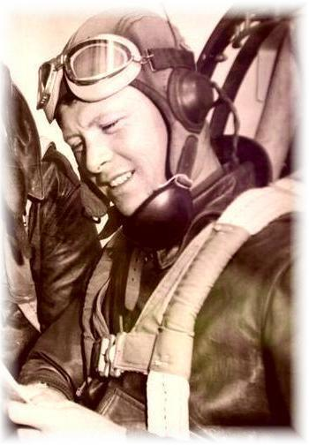
Ralph Aldenderfer – Distinguished World War II Hero
Featured in the Lancaster Eagle Gazette -- August 5, 2015

