Lancaster Seventh-Day Adventist Church
A House of Prayer for All People

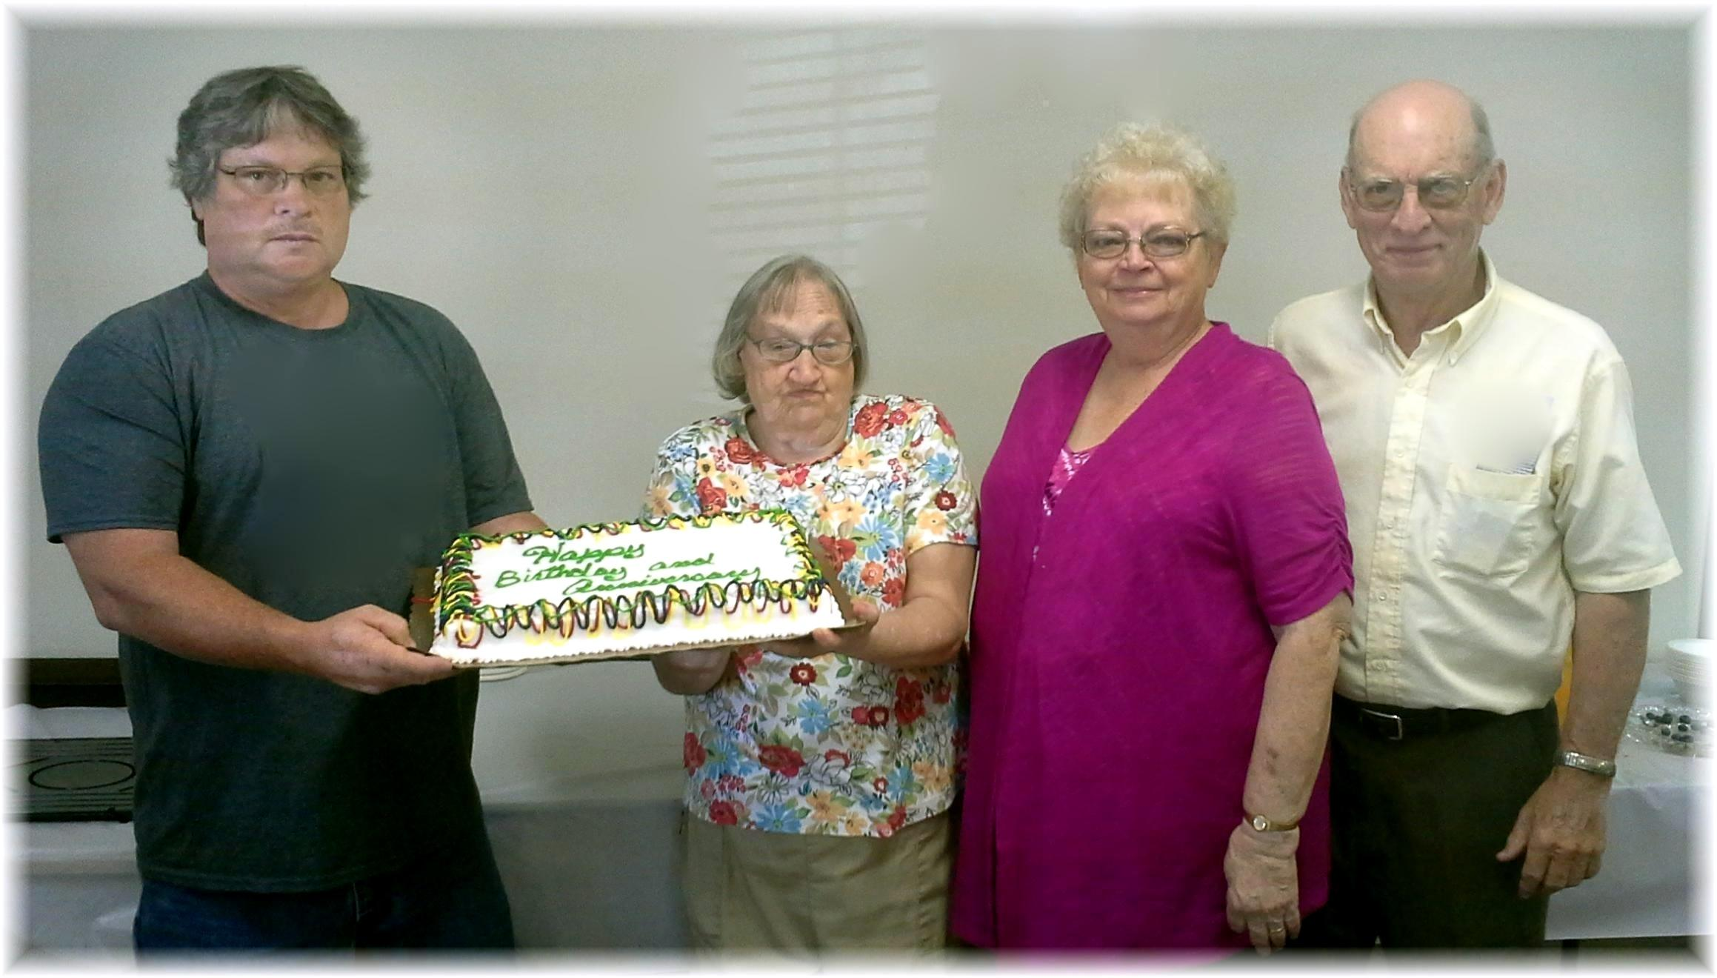
Birthdays: Jim, Linda Anniversary: Sandy & Howard
August Birthdays and Anniversary - 2015

