Lancaster Seventh-Day Adventist Church
A House of Prayer for All People

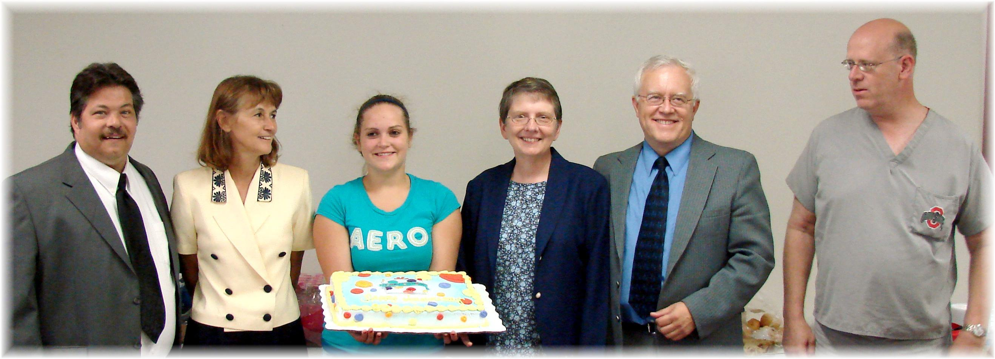

Birthdays: Roger, Barb, Jaydayle Anniversary: Bonnie & Al Birthday: Roger
June Birthdays and Anniversary - 2010

