Lancaster Seventh-Day Adventist Church
A House of Prayer for All People

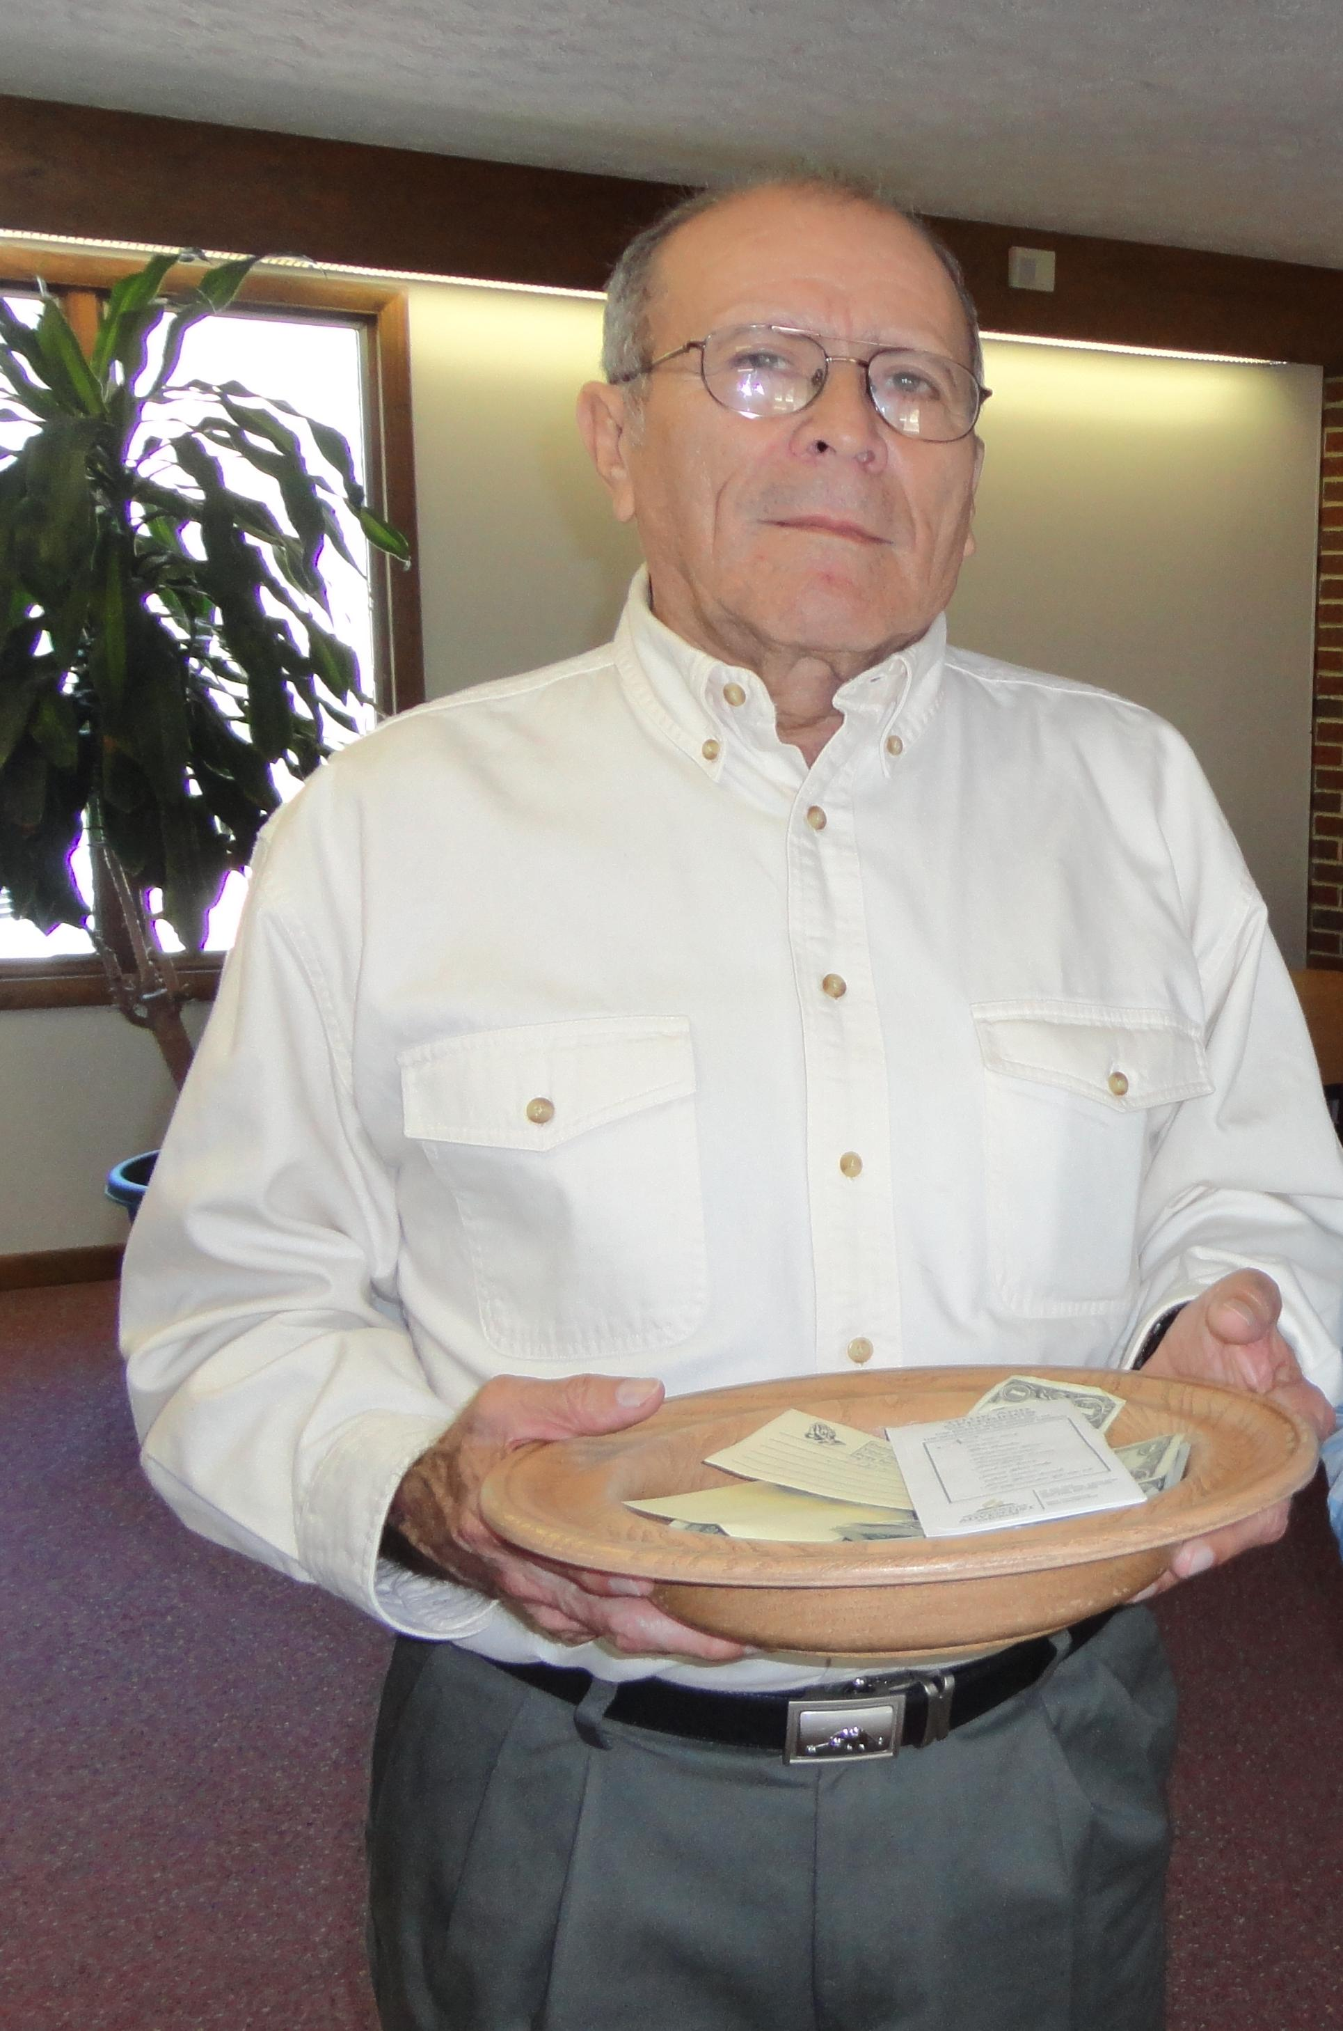--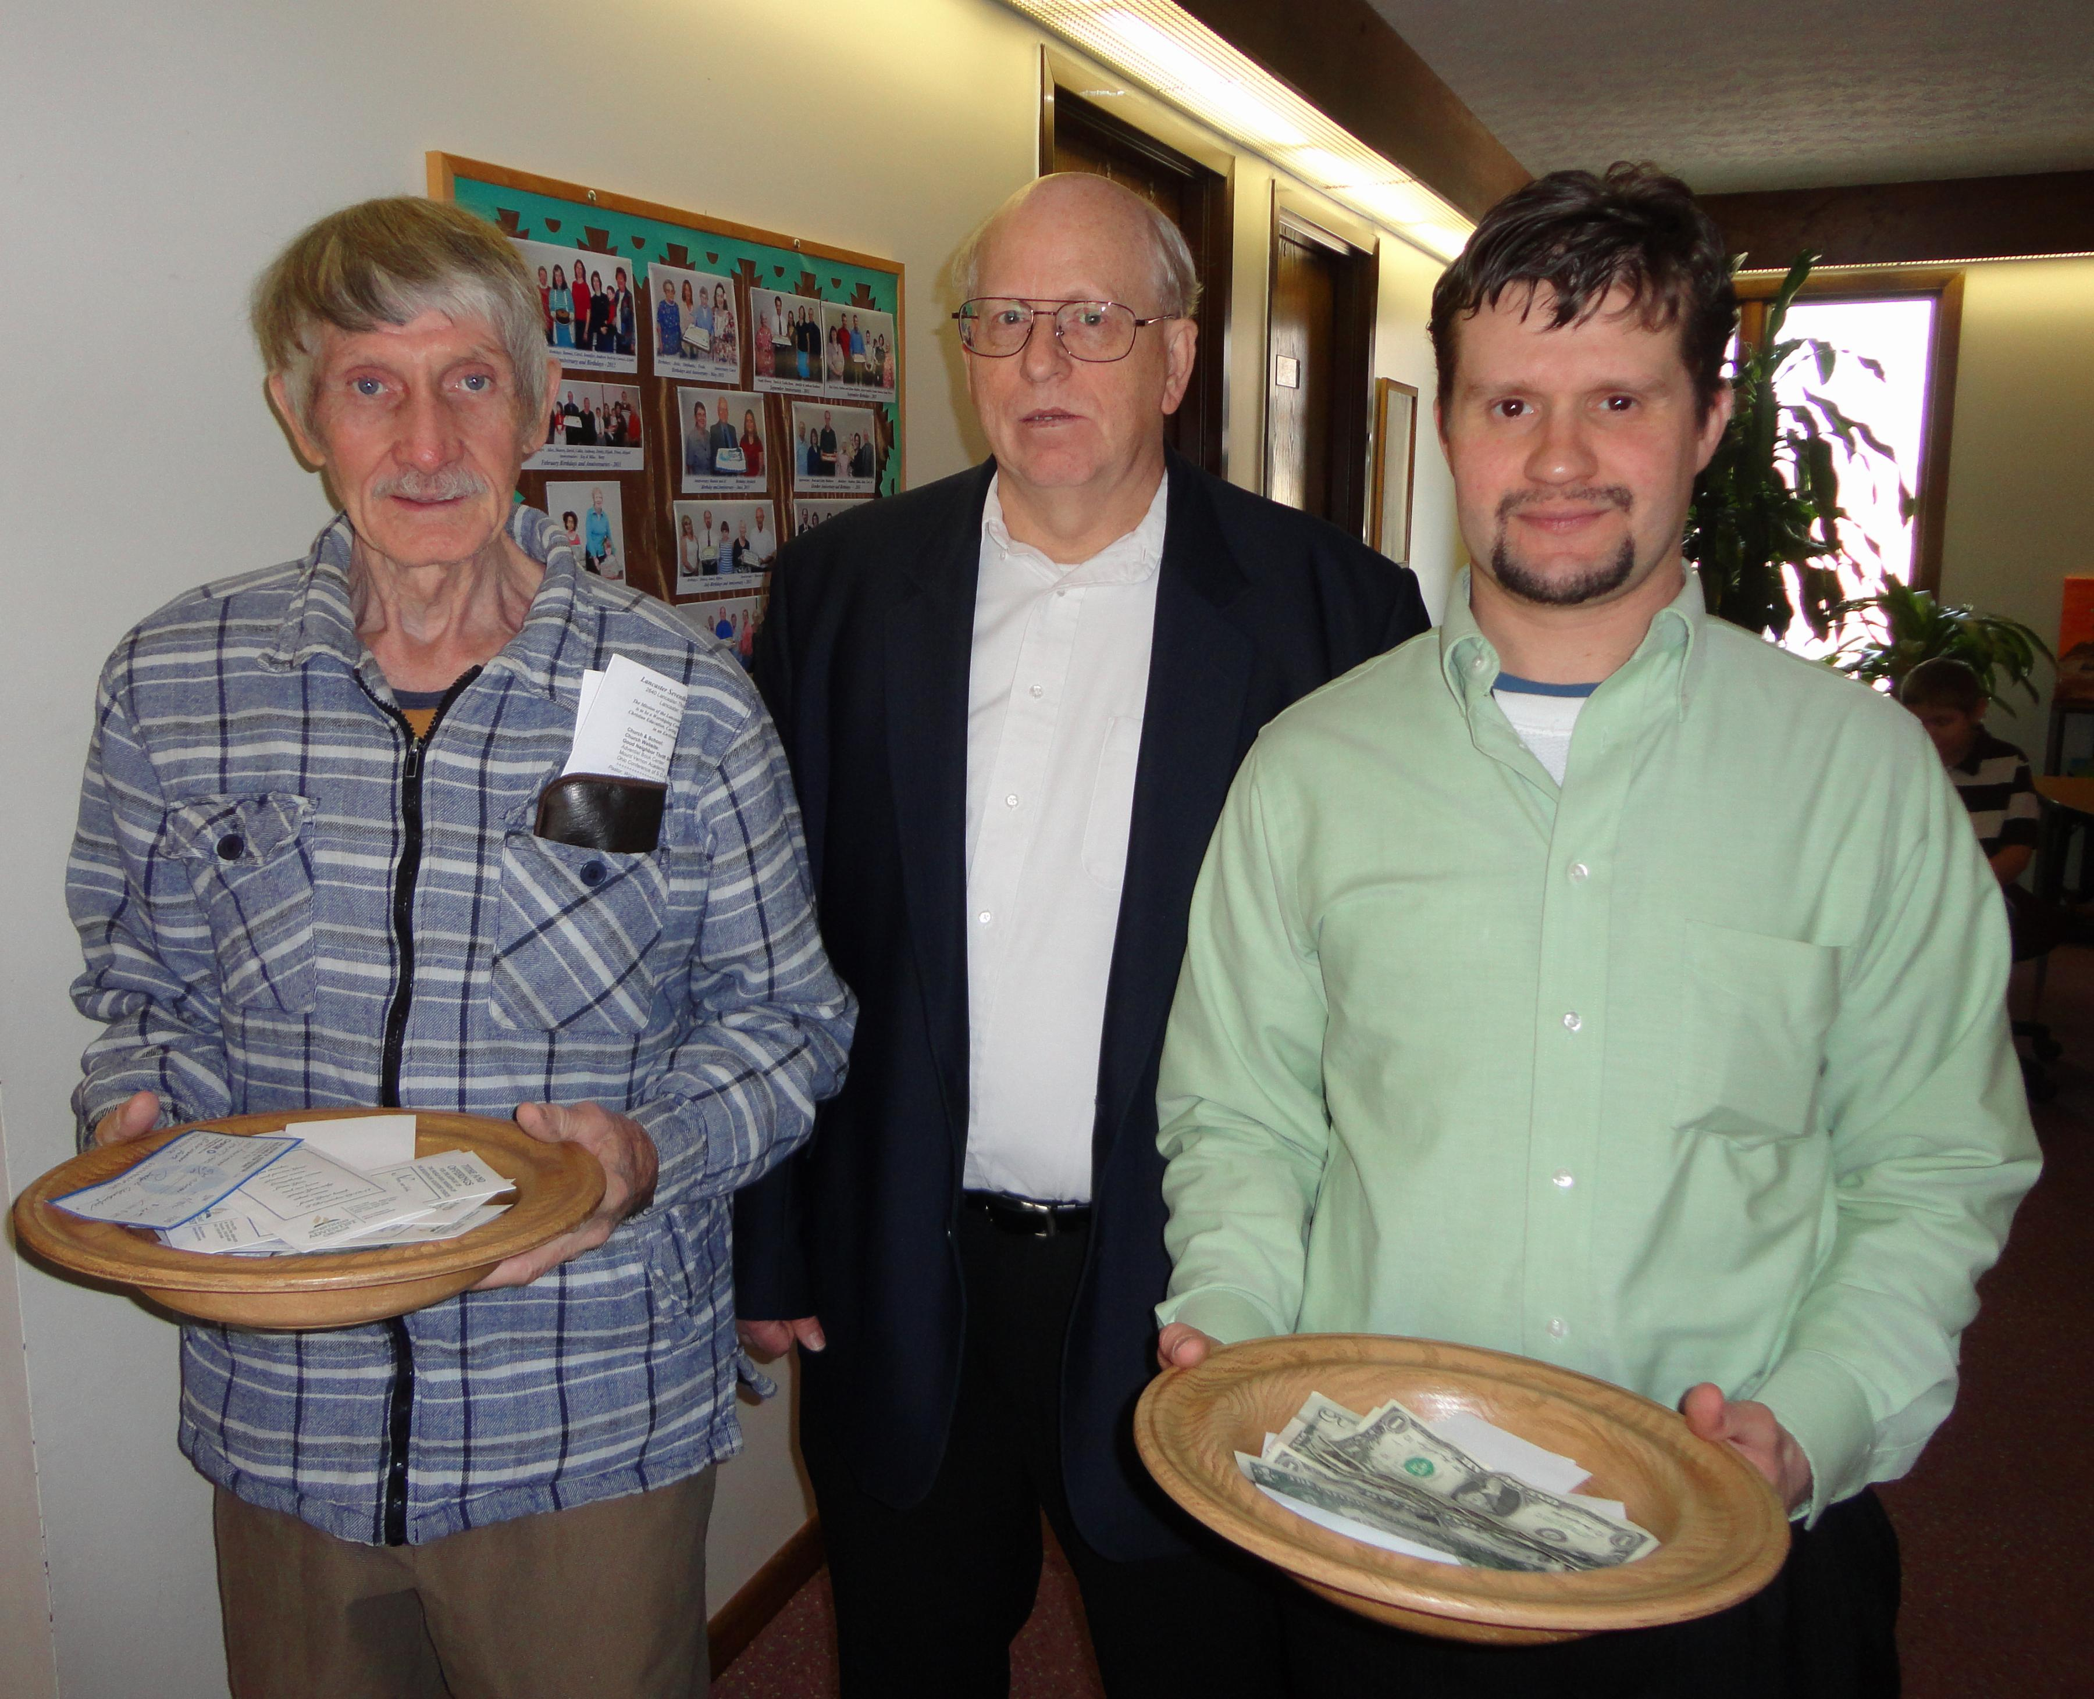
Fidel, George, Bill, Allen
Deacons Collect Tithes and Offerings - 2012

