Lancaster
Seventh-Day Adventist Church
A House of Prayer for All People

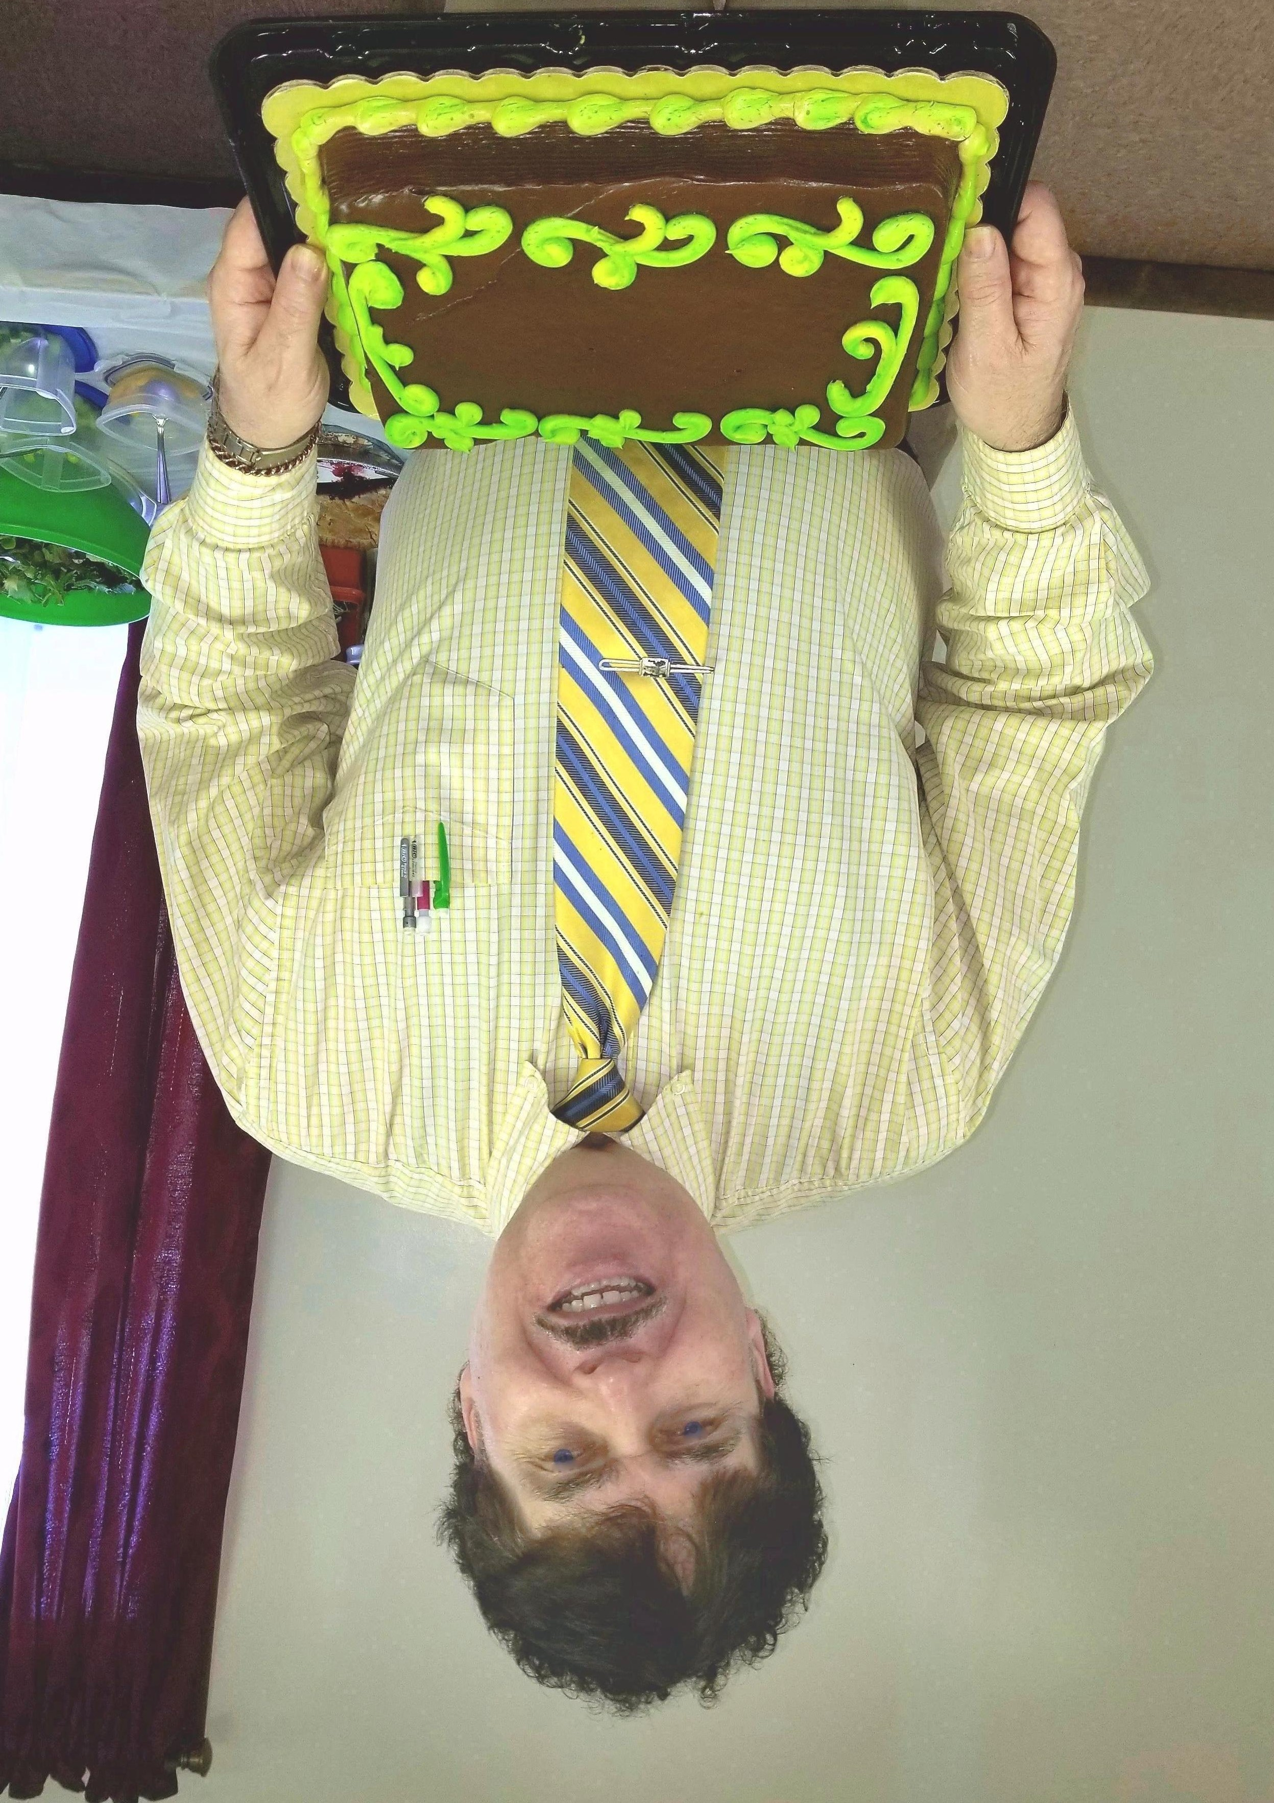
Carlton
March Birthday - 2018

