Lancaster
Seventh-Day Adventist Church
A House of Prayer for All People

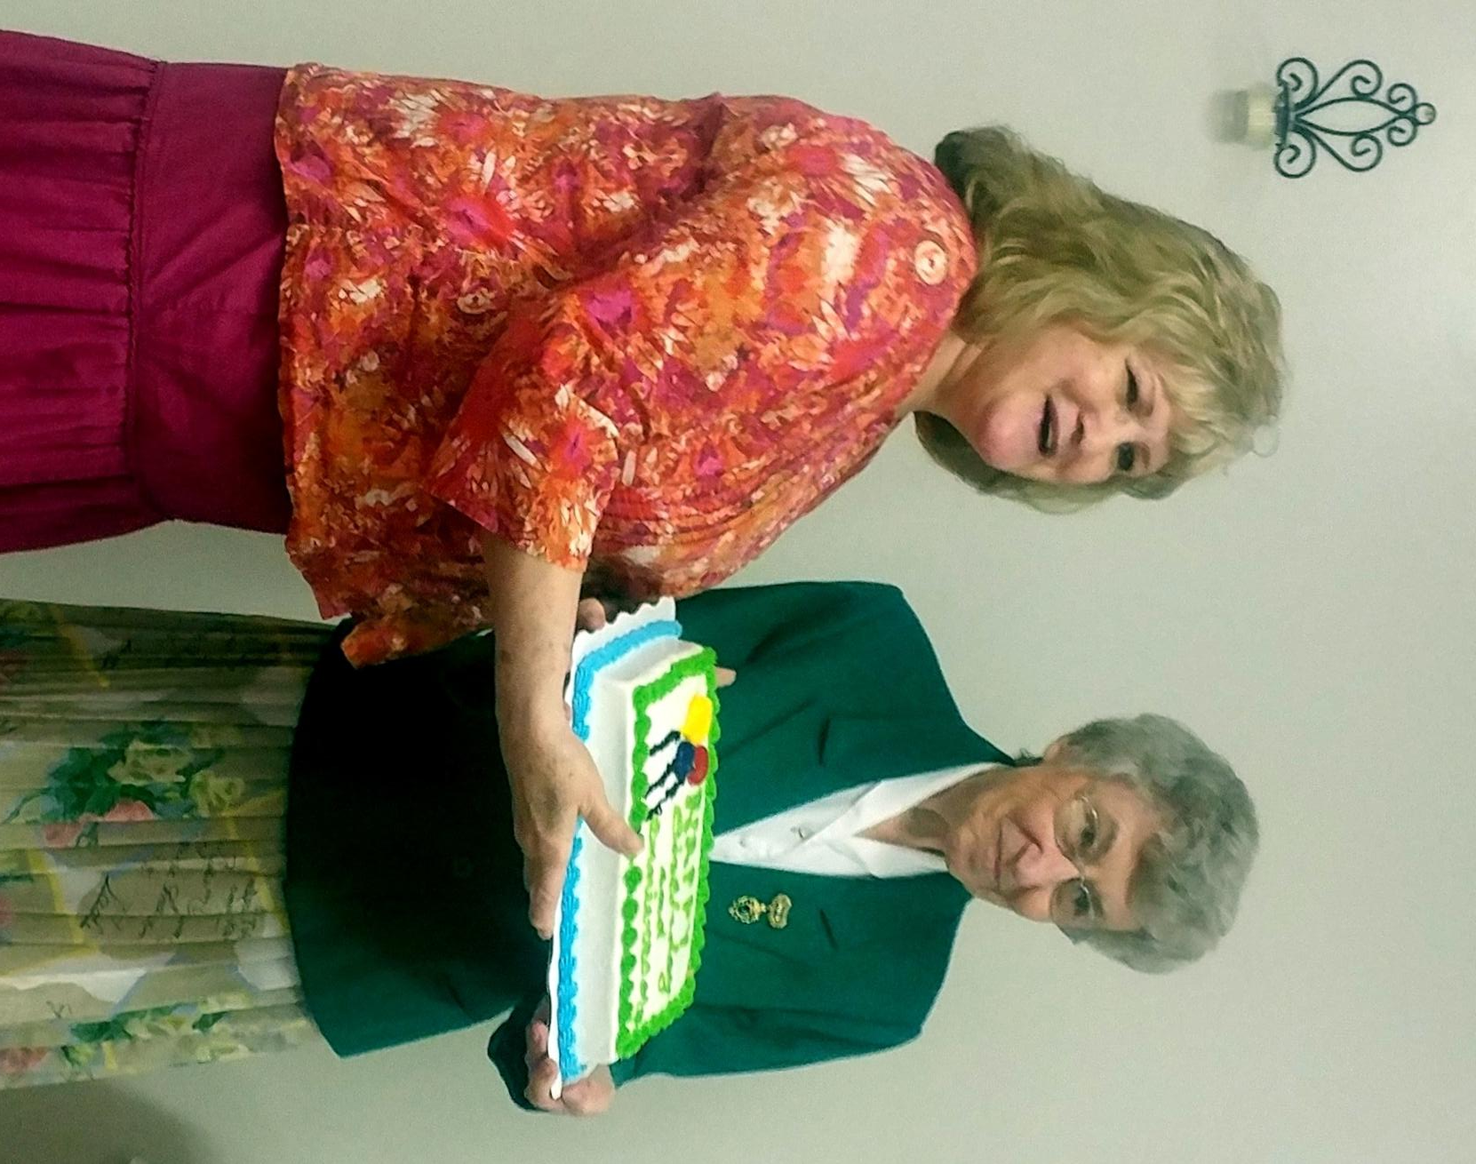
Linda - Anniversary, Freda - Birthday
May Birthday & Anniversary ~ 2018

