Lancaster Seventh-Day Adventist Church
The Mission of the Lancaster Seventh-Day Adventist Church
is to be a Worshiping Community for Gospel Witness,
Christian Education, Caring Fellowship, and Loving Service
in an Environment of Grace.
Church Phone: 740.687.4860
Church Website: LovingHope.org
Good Neighbor Thrift Store: 687.6589
Lancaster S.D.A. School: 687.1741
+++++++++++++++++++++++++++++++++++
Pastor: Pam Farley 654.8928
pfarley@columbus.rr.com c. 243.5505
Bible Worker: Freda Shultz 687.0464
fmshultz@yahoo.com c. 215.2228
Bulletin Secretary: Bonnie Schone 654.8979
imfifj@yahoo.com
Head Deacon: Darrell Shultz 681.1530
mrmom.21@juno.com c. 614.562.0317
Head Deaconess: Mary Rooker 689.1006
Head Elder: Howard Slonaker 862.4970
fhs1940@msn.com
Elder: Roger Mathewson 689.8773
rogercmath@columbus.rr.com
School Principal: Al Schone 654.8979
alschone@rocketmail.com
Team Leaders:
Outreach: Sandy Slonaker 862.4970
Freda Shultz 687.0464
fmshultz@yahoo.com c. 215.2228
Reflections: Diane Wood 987.8655
dn.wood@yahoo.com
Worship: Pam Farley 654.8928
pfarley@columbus.rr.com c. 243.5505
++++++++++++++++++++++++++++++++++
Adventist Book Center 800.765.6955
Mount Vernon Academy 740

.397.5411
Ohio Conference of S.D.A. 740.397.4665

Lancaster
Seventh-Day Adventist Church
A House of Prayer for All People

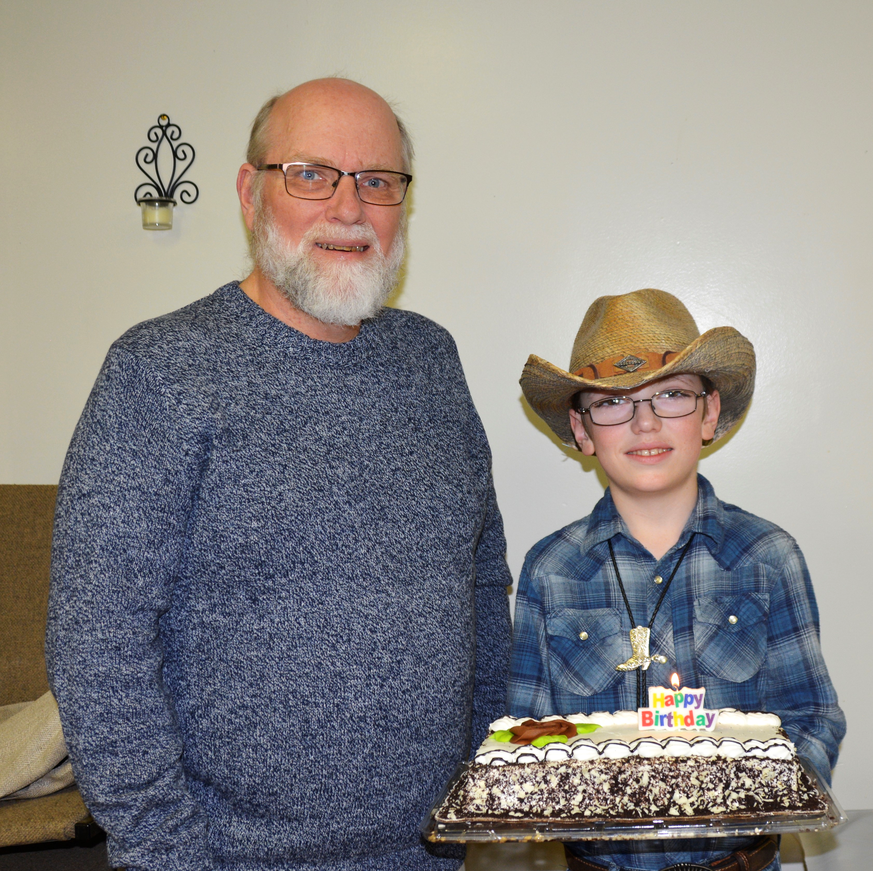
Eldon Jesse
November Birthdays - 2022

