Lancaster Seventh-Day Adventist Church
A House of Prayer for All People

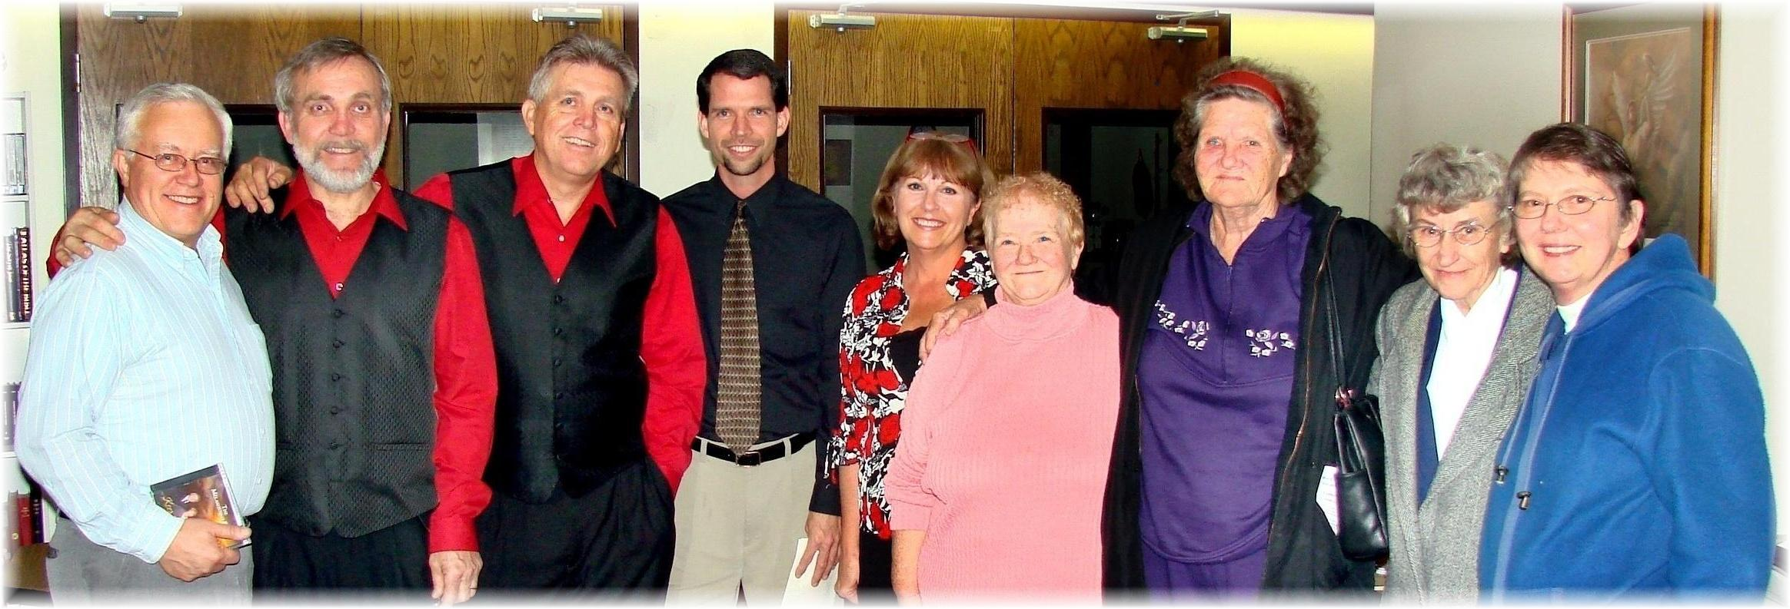
The Melashenkos in Concert and the Quiet Hour Missions Report – October 2009

